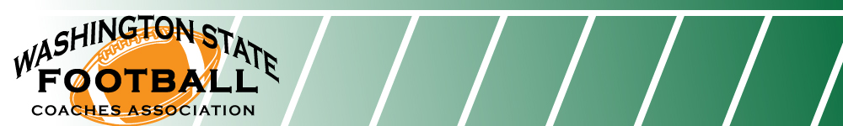November 15, 2020

To Fellow Athletic Coaches and Activity Advisors in Washington State,

First, the Washington State Football Coaches Association (WSFCA) would like to thank each and every one of you for your continued efforts in supporting our students involved in athletics and activities in our state as we navigate this unprecedented pandemic. Your time, wisdom, courage and strength is needed by our young people now more than ever and it is with this in mind that we would like to update you on a few items that will be occurring in our state as it relates to all sports and activities. As an organization, the WSFCA would like to invite all coaches and activity advisors to join us in advocating for our students to be permitted to participate in sports and extra-curricular activities this school year.
We believe in the life-changing benefits of sports and activities and assert that they are essential for our students’ academic, mental and physical well-being. We invite you to spread the word and offer support in any way that you might see fit with some of the activities listed below. Thank you in advance.

November 16 or 17: District Head Football Coach meetings will be held via zoom. You should be hearing from a representative regarding the date and time of your meeting. If not, feel free to reach out to one of the following in order to receive information:

President: Mark Keel (Central Kitsap) District 5: Wiley Allred (Royal)
District 1: Dan Teeter (Lakewood) District 6: Scott Devereaux (Wenatchee)
District 2: Monte Kohler (O’Dea) District 7: Mike Morgan (Colfax)
District 3: Jeff Weible (North Kitsap) District 8: Terry Cloer (Mt. Spokane)
District 4: Adam Mathieson (Mountain View) District 9: Scott Biglin (Kamiakin)

November 19: Begin letter writing/email campaign to leadership in Olympia (to be completed by December 1)

- Coaches/advisors send notice to parents, players, alumni, etc., encouraging them to send correspondences to Olympia detailing the positive impact of educationally based athletics/activities in the lives of our youth, and why we believe that we can safely provide such opportunities if simply given the chance to do so.
- Correspondence may be sent to the following locations (DOH and Governor’s Office):

  - https://www.doh.wa.gov/AboutUs/Leadership

  - https://www.governor.wa.gov/contact/contact/send-gov-inslee-e-message

  - https://app.leg.wa.gov/DistrictFinder/

November 24 or TBD: WSFCA board of directors or their designee coaches will work with local media outlets in order to communicate a message of support for our students, presenting a unified voice that we believe in protecting the most vulnerable people in our communities, while simultaneously advocating for our students.

December 5: Produce public service announcements via Twitter wherein students encourage folks to wear masks so that students may participate! Blast out on the 5th and use common hashtags: #Safe2Play #MaskUp

TBD: Coaches, advisers, parents, students, and supporters will gather in Olympia, at the steps of the capital building, in order to show support to our students as we encourage state leaders to permit them to participate in educationally based athletics and activities in our state.

Please Note: this event has a date of TBD in light of present restrictions that are being put in place statewide, as our goal is to build a unified, bipartisan, nonviolent movement to advocate for students to participate in a safe manner (WCCA).
Sincerely,

WSFCA

