
Sponsorship Proposal for
Championship
Miss Xpose Fitness
2017

About Miss Xpose Fitness

The Miss Xpose Fitness Competition allows women of all ages and sizes to perform in the original Pole Dancing Fitness Competition in the U.S.

In 2016, family and friends came out to cheer on all of the competitors as they competed for the title of Miss Xpose Fitness. The top six competitors competed in the Championship. The finalists were each crowned with tiara and given pageantry sashes. Sponsorship logos were displayed in the programs as well as in our monthly newsletter, which goes out to thousands through out Maryland.

Xpose Fitness and guests raised thousands of dollars at the Preliminary Competitions and the Championship. Proceeds from the Competition in 2017 will be going to Breast Cancer research for the tenth year in a row.

In the past, this event has been featured on three television networks, in two prime Baltimore newspapers and more than 600 guests drove from all over to see this amazing show.

The Miss Xpose Fitness 2017 Championship will be held at Luckies,
Powerplant Live in Baltimore’s Inner Harbor!!

About Xpose Fitness

Xpose Fitness is a fitness studio where women can express themselves through an exotic dance-based workout. Xpose Fitness offers floor/chair classes, which is a full body workout. It is low impact and incorporates a yoga mat and chair. Xpose Fitness also offers the pole dancing workouts, ranging in levels from beginner to advanced. The Xpose Fitness workout really allows women to feel sexy and confident, while improving their strength training and flexibility. We have recently added Ball Class, focusing on cardio and core strengthening. Our Sexy Stretch integrates sensual movements with stretching techniques to increase flexibility.

Women ages 18 to 80 have been known to visit Xpose Fitness’ on a regular basis and with a clientele of over 15,000 women in the Baltimore and surrounding area, Xpose Fitness has become a household name.

Why Sponsor

Corporate sponsorship is the main source of funding for the Miss Xpose Fitness Competition and companies have found this event to be a great marketing tool. Proceeds of this event will go to Breast Cancer Research.

Strengthening your company brand through effective visibility is a great business strategy. By sponsoring the Miss Xpose Fitness Championship, we can assure your company will receive:

- Maximized Brand Awareness
- Increasing Brand Loyalty
- Introductions of New Products/Brands to the Market
- Networking of Companies Just Like Yours
- Promotions inside Luckies of Baltimore

“It was a lot of fun and we got several bookings.
It was very profitable to be a part of this competition,”
says Sharon Schultz from BeautiControl, an In-Home Spa Service.

Media

There will be press releases that will go out to newspapers, television networks and magazines to cover this amazing event. We recently added a webpage dedicated completely to the Miss Xpose Fitness Competition.
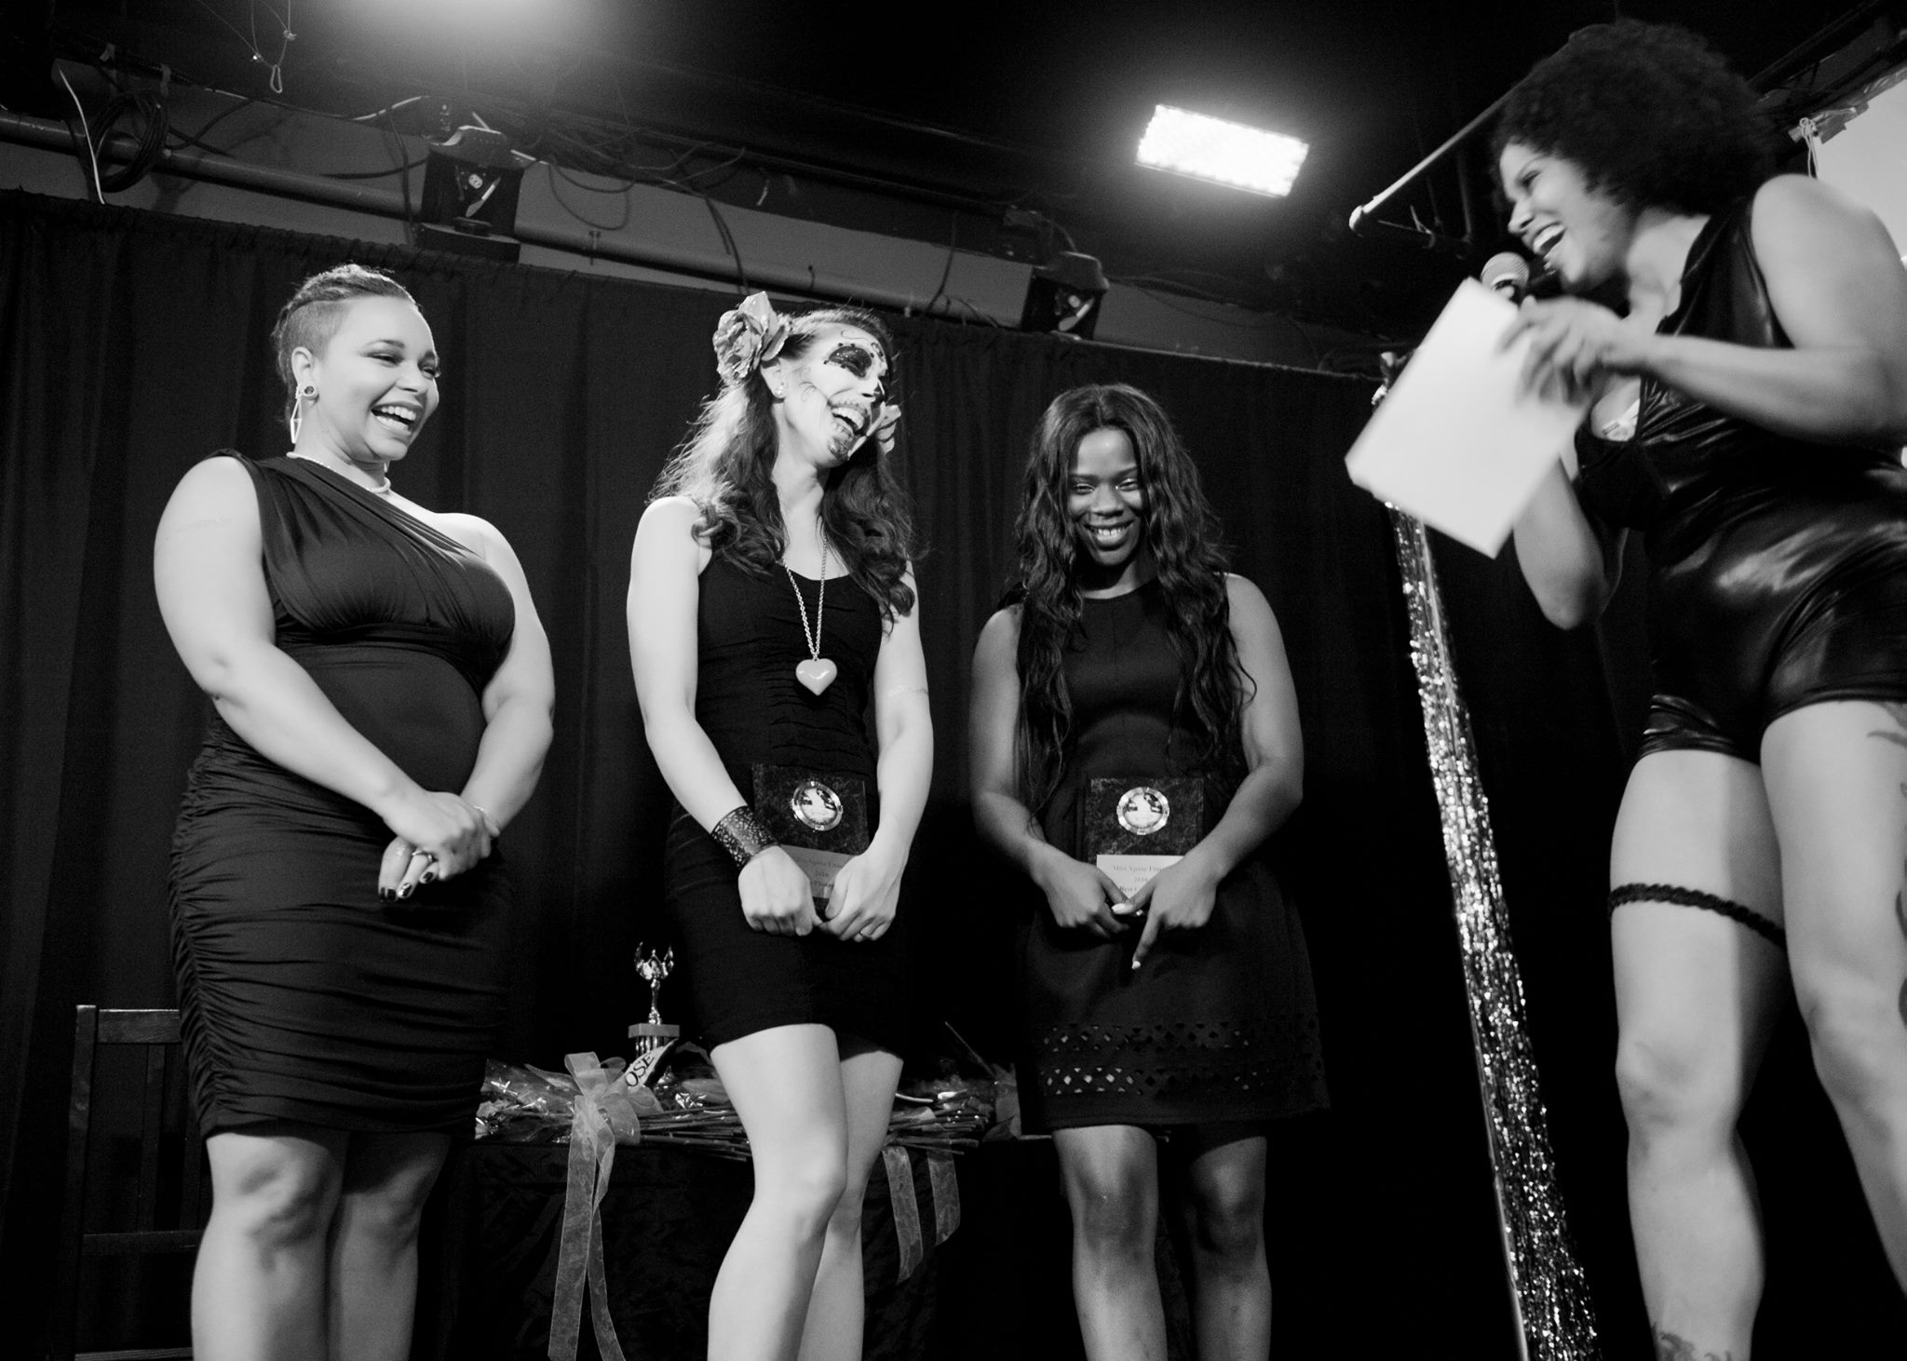
Top three contestants with emcee Leanna from Miss Xpose 2016.
Photo by random.eye.candy
Miss Xpose Fitness 2017 Sponsorship

Please fill out the below form and email to:
Attn: Tegan Williams
Tegan@xposefitness.com
410-661-1301

We would like to offer the following sponsorship:

⁯Platinum Donation of $750 in Products and/or Services
Receives a Full Page ad in the program book, Company is mentioned on stage, and an ad in the May Xpose Newsletter that goes out to over 20,000 women across Maryland.

⁯Gold Donation of $500 in Products and/or Services
Receives a Half Page ad in the program book, Company is mentioned on stage and a plug in the May Xpose Newsletter that goes out to over 20,000 women across Maryland.

⁯Silver Donation of $250 in Products and/or Services
Company is mentioned on stage and a plug in the May Xpose Newsletter that goes out to over 20,000 women across Maryland.

⁯Bronze Donation of $100 and under in Products and/or Services
Listed as a sponsor in program book and mentioned on stage.

Please give a detailed explanation of the products and/or services that you will be donating to the winner’s prize package: ________________________________________________________________________________________________________________________________________________________________________________________________________________________


Our contact person for the sponsorship is:
Name _______________________________
Department __________________________

Contact Details
Telephone ___________________________
Email _______________________________
Cell _________________________________

Yours Sincerely,

________________________________
Signature

________________________________
Date

