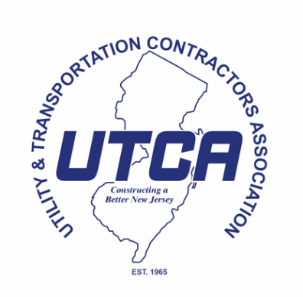

FOR IMMEDIATE RELEASE CONTACT: Chris Donnelly
December 10, 2024 732-280-9600

UTCA STATEMENT ON KEVIN CORBETT LEAVING NJ TRANSIT

WALL – Utility and Transportation Contractors Association (UTCA) Executive Director David Rible and Chief Executive Officer Robert Briant issued the following statements today regarding the announcement that Kevin Corbett is leaving NJ Transit and will be replaced by Kris Kolluri:

UTCA Executive Director David Rible
“Kevin Corbett took on one of the most difficult jobs in state government and tackled the challenges head on. His record of service speaks for itself and he was always willing to listen and work cooperatively with others on mass transit issues in New Jersey. We wish him the best on his next endeavor and look forward to working with Kris Kolluri, who might know more about transportation than anyone in the state.”

UTCA Chief Executive Officer Robert Briant
“Kevin Corbett has been a dedicated public servant in every sense of the word. We are deeply appreciative of his time at NJ Transit. Higher education’s gain is New Jersey transportation’s loss. Kris Kolluri has an unparalleled background in the transportation sector. We welcome the opportunity to work with him again and are ready to assist him in any way we can.”

About UTCA
UTCA of New Jersey is a non-profit trade association headquartered in Wall, New Jersey. UTCA represents approximately 1,000 member firms in the public and private sectors, active in all phases of heavy, highway, utility, and marine construction, as well as site work including remediation of brownfields and contaminated sites. For more information, log on to http://www.utcanj.org and follow on Twitter @UTCANJ.

###

