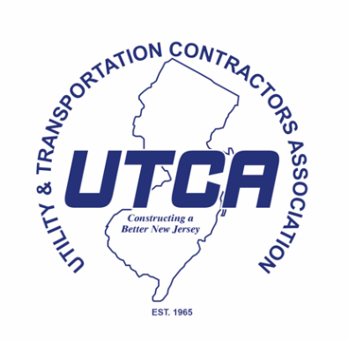

FOR IMMEDIATE RELEASE CONTACT: Chris Donnelly
January 30, 2026 732-280-9600

UTCA STATEMENT ON NOMINATION OF KEVIN JARVIS AS DOL COMMISSIONER

WALL – Utility and Transportation Contractors Association (UTCA) Chief Executive Officer David Rible issued the following statement today regarding the announcement that Governor-elect Sherrill will nominate Kevin Jarvis to serve as Commissioner of the New Jersey Department of Labor:

“Kevin Jarvis has extensive experience and impressive knowledge on labor issues. He’s a professional’s professional who has spent years immersed in the topics that the Department of Labor handles every day. We commend Governor Sherrill for this decision, look forward to working with Kevin and stand ready to assist him in strengthening New Jersey and our industry. We also thank Rob Asaro-Angelo for his years of service and partnership as commissioner and wish him the best in his future endeavors.”

About UTCA

UTCA of New Jersey is a non-profit trade association headquartered in Wall, New Jersey. UTCA represents approximately 1,000 member firms in the public and private sectors, active in all phases of heavy, highway, utility, and marine construction, as well as site work including remediation of brownfields and contaminated sites. For more information, log on to http://www.utcanj.org and follow on Twitter @UTCANJ.

###

