MV Mediation Celebrates Women’s History Month with a
Spotlight on Several Women who have
Made an Impact during Our 40 - Year History

It’s Women’s History Month! As MV Mediation is also celebrating its 40th Anniversary this year, we are putting a spotlight on some of the amazing women who have contributed to MV Mediation’s history of service to the island community.

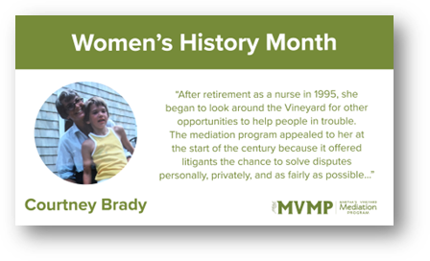

Courtney S. Brady, who died January 15, 2024, was drawn to what might be called urgent situations.

As her family members recount, she felt intuitively that she had what it took to deal with emergencies and conflicts in the world around her, and shortly after moving to the Island as a year-round resident in 1975, she trained to serve as an EMT on what was then the Edgartown Volunteer Ambulance Association, then went back to school and became a part-time nurse at Boston City Hospital.

After retirement as a nurse in 1995, she began to look around the Vineyard for other opportunities to help people in trouble. The mediation program appealed to her at the start of the century because it offered litigants the chance to solve disputes personally, privately, and as fairly as possible, without having to go into a courtroom and have judgments handed down that made victors of some people and losers of others. She also liked the idea of working with another mediator to help resolve issues, because together they learned lessons and skills that were built upon those they had learned in the classroom.

Courtney joined the board of the mediation program in approximately 2010, and from this position, she came to appreciate the work even more. Confidentiality prevented her from ever saying anything to her family about the cases she handled over the course of twenty years, but her offspring could tell just by the way she came home through the door at the end of the day whether a mediation effort had been successful or not.

Ill health forced her retirement from the board in 2020, but her interest in conflict resolution never flagged, and a certificate of appreciation from the board for her work hangs in her bedroom to this day.

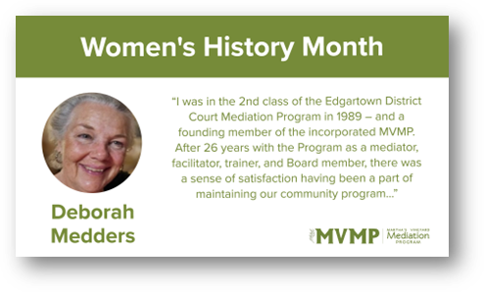

“I was in the 2nd class of the Edgartown District Court Mediation Program in 1989 – and a founding member of the incorporated Martha’s Vineyard Mediation Program. After 26 years with the Program as a mediator, facilitator, trainer, and Board member, there was a sense of satisfaction having been a part of maintaining our community program to that point when it began to receive State funding to support paid staff and expansion of programs. And I applaud those who have continued to build and thrive with the Program’s work and partnerships in our Vineyard community.”

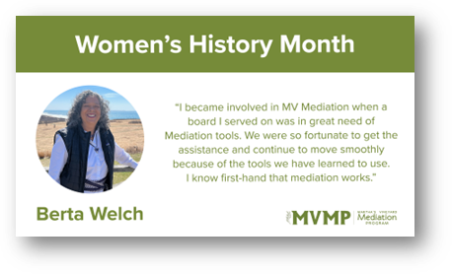
"I became involved in MV Mediation when a board I served on was in great need of Mediation tools. We were so fortunate to get the assistance and continue to move smoothly because of the tools we have learned to use. I know first-hand that mediation works."

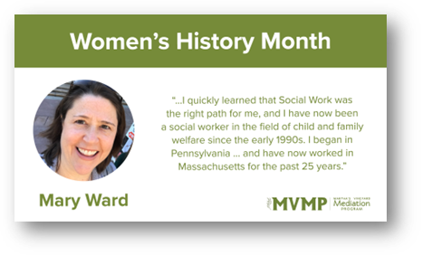
For Women’s History Month and National Social Work Month, and we want to make a special mention of Mary Ward, MSW, LICSW! Mary says, “Although I graduated from college with a business degree, I quickly learned that Social Work was the right path for me, and I have now been a social worker in the field of child and family welfare since the early 1990s. I began in Pennsylvania in the greater Philadelphia area and have now worked in Massachusetts for the past 25 years. The work has focused on [providing] strengthening support, resources, safety, and resiliency of families. For the past 10 years, this work has included a focus on preparing prospective foster and adoptive parents to provide a permanent home for children in situations when kinship resources are not available for full-time care. After personal and professional exposure to the amazing benefits of Mediation over the years, I held onto the aspiration to become a mediator myself. In 2022 I discovered MV Mediation and enrolled in the basic training, and very quickly this experience solidified my interest and commitment to continuing my journey as a mediator. As a new mediator, I have benefited greatly from the supportive - and what I consider rigorous - education and coaching through Martha’s Vineyard Mediation. In addition to the core mediation, I have received further training such as housing and eviction mediation, as well as conflict in the workplace, and there are many more opportunities I plan to participate in in the future. Throughout my experience, there has been consistency in explaining the Mission and Values, and this is also reflected in the professional, kind, supportive, competent, and on-point facilitation I have observed as a trainee, apprentice, and now as a mediator on the roster.”

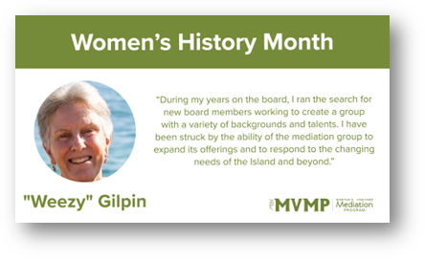
Weezie says, “Before moving to the Vineyard full-time I worked as a counselor and a dean of students in several schools. When I read about MVMP's training in mediation, it felt like a natural complement to the skills I developed in those jobs. After completing the course, I observed several small-claims court mediations and, although impressed by the work, knew that it was not the right match for me. The skill of remaining neutral and guiding the participants toward resolution was especially challenging for me. That gave me a deep respect for our mediators and their skills. When I was asked to be on the MVMP board, I was excited to contribute to the program in another way. During my years on the board, I ran the search for new board members working to create a group with a variety of backgrounds and talents. Since then, I have been struck by the ability of the mediation group to expand its offerings and to respond to the changing needs of the Island and beyond. The increase in housing cases has utilized the mediators' strengths throughout the pandemic and beyond. All of this makes me proud to be associated with MVMP.”

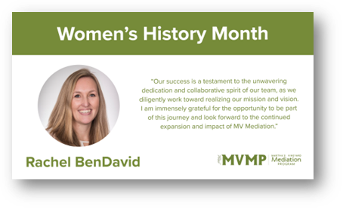
“In June of 2018, I had the privilege of joining the board of MV Mediation, thanks to the invitation from my friend and former colleague, Bill Jacob. From the moment Bill introduced me to the mission and passion behind MVMP, memories of my junior high Peer Leadership and Conflict Resolution training flooded back, reminding me of the invaluable life lessons learned. Without hesitation, I eagerly accepted the opportunity to contribute to MVMP's journey.
Over the years, my involvement deepened, culminating in joining the Executive Committee in 2020 and later being nominated for the esteemed position of Board President in 2023. It has been a profound honor to serve alongside dedicated individuals and witness the remarkable growth of this organization. Our success is a testament to the unwavering dedication and collaborative spirit of our team, as we diligently work toward realizing our mission and vision. I am immensely grateful for the opportunity to be part of this journey and look forward to the continued expansion and impact of MV Mediation.”

