MUUSJN Highlights of 2022

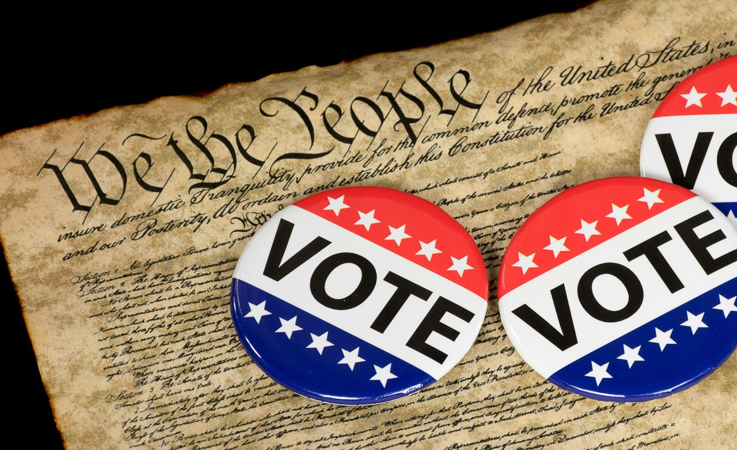
GET OUT THE VOTE
- Advocated for fair redistricting by providing education about the process and encouraging people to testify at public hearings.
- Mobilized UUs and other volunteers who gathered over 2,600 signatures that helped put the Promote the Vote proposal on the November ballot to protect voting rights in Michigan.
- Sent 37 action alerts to our statewide network of activists to promote voting, combat disinformation, and mobilize volunteers.
- In partnership with the UU Funding Program, Michigan United, and Interfaith Power and Light, volunteers and consultants made 4,675 calls and sent texts to over 560,200 Michigan residents providing voting information and encouragement to vote.
- Recruited and trained a network of volunteers to do relational organizing.
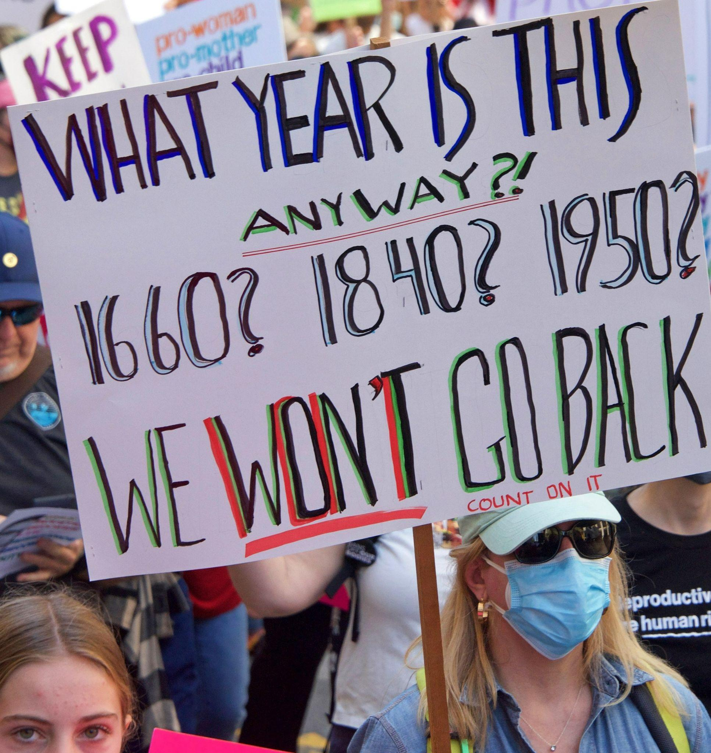
REPRODUCTIVE JUSTICE
- Our Interfaith Reproductive Justice Coalition regularly joined forces to advocate for the rights of women, voters, and LGBTQ+ people.
- Mobilized UUs and other volunteers who gathered over 5,900 signatures that helped put the Reproductive Freedom for All proposal on the November ballot.
- Provided “Ballot Proposal Deep Dive” training for congregational groups and community organizations.
- Provided Relational Organizing training and recruited volunteer leaders.
- Combated disinformation by flooding social media with factual posts.
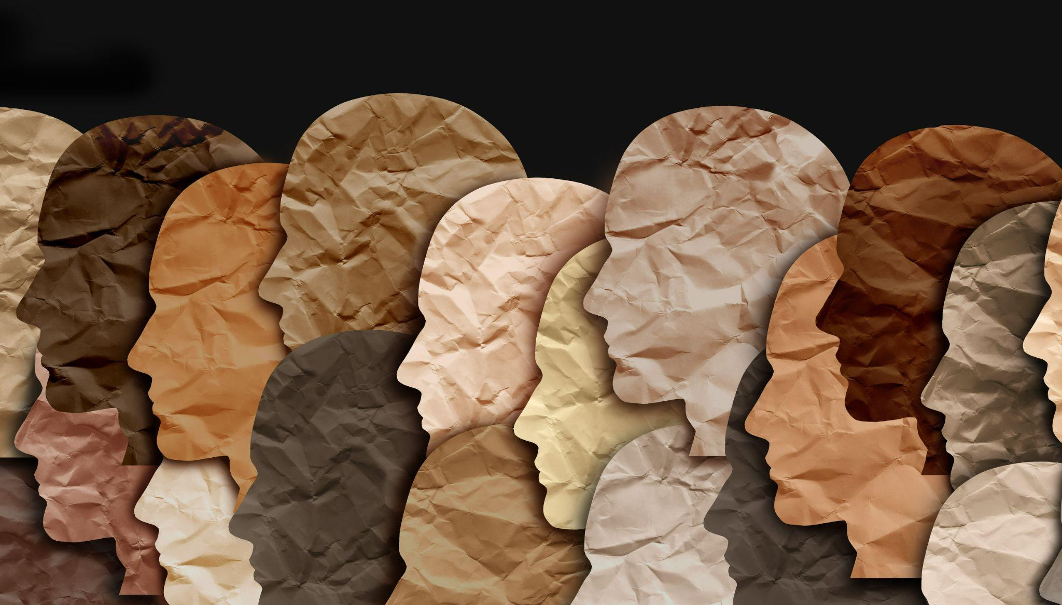
- Spearheaded the writing and filing of an amicus brief in support of lawsuits by Governor Whitmer and Planned Parenthood seeking to nullify Michigan’s 1931 abortion ban law. This brief makes the case that the law allows some religious groups to impose their beliefs about reproductive choice on other people of faith and, as such, is religious discrimination in violation of the Michigan Constitution.

RACIAL JUSTICE
- Created an Interfaith Racial Justice Task Force who identified racial justice priorities.
- Organized a “Fly on the Wall” forum that conducts a conversation about race in a setting where white people listen without comment.
- Provided information about the UU 8th Principle that calls for “working to build diverse multicultural Beloved communities” and “dismantle racism and other oppressions.” Encouraged UU congregations to learn about and embody this principle.
- Hosted a forum to educate voters on how the election could affect school board positions on Critical Race Theory.
Photo: freshidea via AdobeStock

___________________________________________
Unless otherwise specified, use of photos is authorized through dreamstime.com
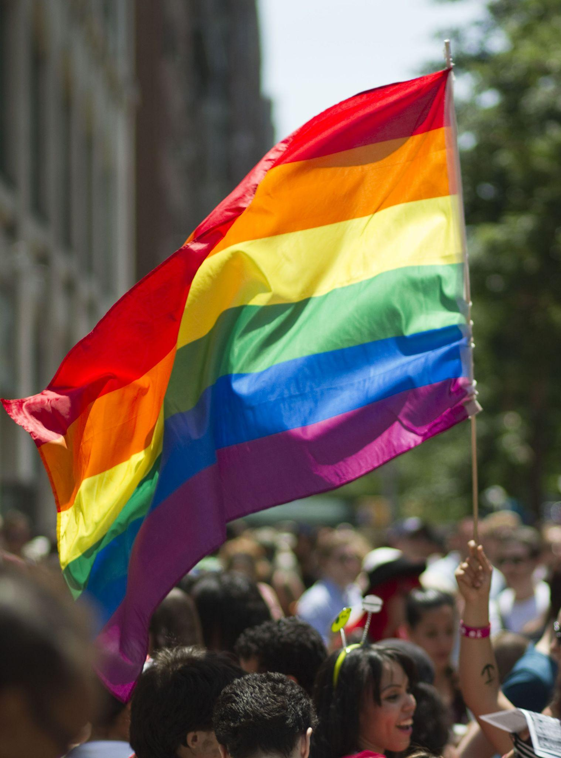
LGBTQ+ JUSTICE
- In concert with MUUSJN’s Interfaith Reproductive Justice Coalition, monitored and took positions on LGBTQ+ issues.
- Published a monthly newsletter that serves to educate and advocate for policy initiatives such as the Equality Act.
- Continued working with UU congregations in their Welcoming Congregation renewal efforts.
- In partnership with Inclusive Justice, organized a statewide rally for LGBTQ+ rights.
- Organized forums addressing LGBTQ+ discrimination, voting rights, and how to advocate for the dignity of LGBTQ+ students at school board meetings.
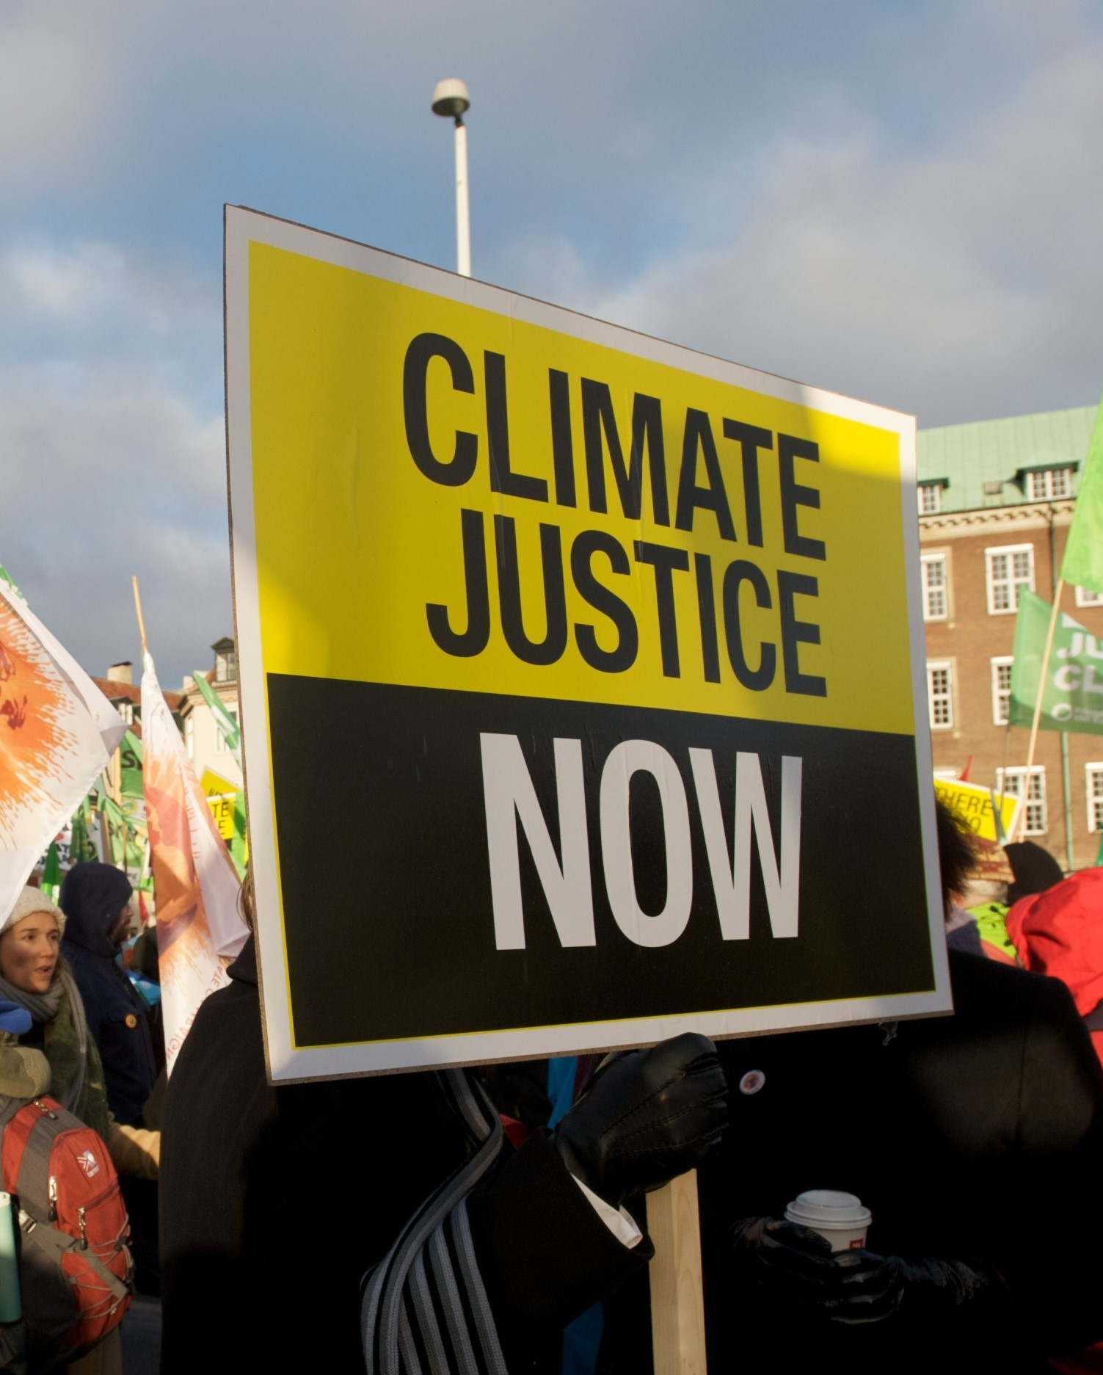
WATER/ENVIRONMENTAL JUSTICE
- Worked with the People’s Water Board to protect the right to clean, affordable water, particularly for low-income people.
- Conducted MUUSJN Environmental Task Force meetings to facilitate sharing of ideas and actions among UU congregations.
- Worked with Michigan Alliance for Justice in Climate (MAJIC) to monitor and take positions on multiple environmental justice issues.

ECONOMIC JUSTICE
- In our continuing fight for a minimum wage increase, collected thousands of signatures for the Raise the Wage ballot proposal, which will appear on the 2024 ballot.
- As part of the MI Time To Care Coalition, brought a lawsuit against the State of Michigan demanding that the law requiring paid leave be put into effect. This case is ongoing.
- In coalition with Michigan Liberation, working to reform the cash bail system.
- Mentored three Economic Justice Alliance of Michigan (EJAM) Fellows.

Your support sustains our work in these critical justice areas and others as they arise.
Help us make a strong impact in 2023.
MUUSJN memberships are tax deductible. Memberships paid now are deductible for 2022.

MEMBERSHIP LEVELS  Regular: $25  Family: $40  Silver: $50  Gold: $100  Champion: $200+  Congregation: $100 or shared plate  Organization: $100+ | PAYMENT METHODS  Visit uujustice.org/become-a-member to make a payment via PayPal or credit card  Write check payable to MUUSJN and mail to  Randy Block, Director  MUUSJN  4220 Arlington Dr., Royal Oak, MI 48073

MUUSJN website change …
“Pay dues on Paypal” needs to be changed to “Pay dues via PayPal or credit card”

