- Give up a favorite app, just 1.
- Give up selfies for Lent
- Give up video games (phone, consoles, tablets)
- Put the kid tablets away for the length of Lent
- Give up acronyms/abbreviations (Example: lol, brb, ikr, otw, eta)
- Give up the “like” button on Facebook and Instagram. Replace it with meaningful comments on your friend’s posts.
- Give up emojis for Lent 😛
- Give up Pinterest. We can’t argue that it’s essential like some of these others we use.
- Give up YouTube completely. Learn things from books.
- Limit picture and video taking- learn to live in the moment. Set a certain allowance number for each day or event you attend (like 1 or 2 pictures only)
- No screens in bed
- Give up screens in the bedrooms (including adults), or limit screens only to the living room.
- Give up Bluetooth or earbuds
- No screens in the car
- Give up using photo filters on Instagram or Snapchat.
- Give up tv/movies completely, or choose certain day(s) of the week to do so. Areas to consider could include YouTube, Netflix, Amazon TV, Redbox, or theater movies.
- Give up your favorite TV show
- No screens at mealtimes
- A certain time in the afternoon/evening when the family is home and everyone goes screen free
- Give up charging your phone during the day- you have to limit yourself to just the time your battery allows each day
- Give up your favorite music playing app. Listen to the radio.
- Give up music in the car completely. Ride in silence, and use the extra time for prayer and reflection. Or limit yourself to Christian music or talks in the car.
- Give up hashtags #canyouhackit
- Give up posting pictures onto your social media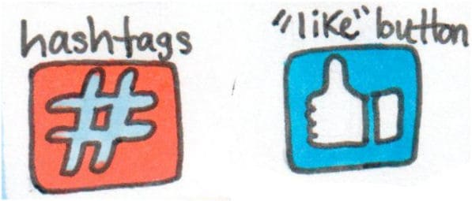
- Give up reading non religious blogs (haha) 😉
- Give up Alexa or similar voice commanded devices
- Turn off notifications for social media devices for the duration of Lent
- Turn notifications off of non-essential apps for your smart watch
- Give up the smart watch
- Put your phone on “airplane mode” or “do not disturb” for certain times of the day
- Consider limiting social media. Give up a social media app such as Facebook, Instagram, WhatsApp or Snapchat. If that’s too extreme for you, give it up for specific days of the week or certain time frames. Or limit them with a parental control app that sets time restraints on certain apps.
- Even if you continue to check social media, you can give up actually posting and/or sharing stuff. This could teach the discipline of listening instead of being heard.

