The 55th NCKPC National Annual Gathering
May 12 (Tue)- 15 (Fri), 2025
Venue: Sheraton Hotel, Houston Airport, TX, Houston Airport Code: IAH
(Houston George Bush International Airport)
Note: Although Houston has other airports, please ensure you use IAH.
Registration Guidelines: When completing the registration form, please carefully review the following:
- Participant Registration Fee: $400 per person/ Spouse: Additional $300
- First Deadline: January 31
- Final Deadline: February 28
- Late Registration: $50 additional fee applies starting February 1st
- Refund Policy: No refunds after March 1st
- Transfer Policy: Registration fees are non-transferable
- Children’s 18 and under : Registration Fee: Free for minor children sharing the same room with the registrant
  - Commuters (no lodging/registration fee of $400): Daily participation fees vary
  - Exception: Mission organization exhibitors commuting daily will receive one free meal per day
Cost Information
- Single room request: $100 per night (additional $300 for 3 nights/4 days)
- Extra nights before or after the event: $110 per night (same rate for singles, couples, registrants, and minor children). Meals are not included.
  - Meals on May 12 (before dinner) and May 15 (after breakfast) are at personal expense.
  - Extra nights available: May 12 (the day before the conference) and May 15 (the day after the conference).
  - Please indicate the dates clearly on your registration form.
Scholarship Information
- All registration fees must be paid first. Scholarship reimbursements will be announced during the conference.
- KARMSS members: $100 support per person (up to 30 people) during the conference.
- Small Church Pastors and Spouses: For churches that have paid the 2025 annual dues and have 50 or fewer active members, pastors and their spouses will receive full registration fee support for up to 30 people, on a first-come, first-served basis.
Local Tour
- NASA Tour: Thursday, May 14 (morning)
- Fee: $75 per person (includes lunch and transportation)
Registration Methods
- By Mail
  - Payable to: NCKPC
  - Mail to: Mrs. Jean Park
1409 Bethany Dr., Greensboro, NC 27455
Email: jp2963@gmail.com Phone: (336) 263-2963
Payable to: NCKPC  Mail to :  Mrs. Jean Park  1409 Bethany Dr.  Greensboro, NC 27455  Email:jp2963@gmail.com  (336) 263-2963 | 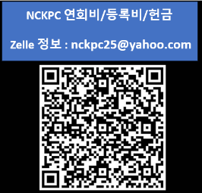  Registration fees may also be sent via Zelle. In this case, registration forms must be sent by email or mail to Mrs. Jean Park.
  - Registration fees may also be sent via Zelle. In this case, registration forms must be sent by email or mail to Mrs. Jean Park.

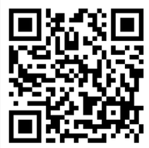
- Online Registration
https://forms.gle/5FXZUswS5sLKGvRd8
Hotel Shuttle Bus Information
- Houston Airport Code: IAH
- Upon arrival at the airport, please call the hotel immediately to request pickup. (Hotel main number: 281-442-5100)
- From the hotel to the airport, the shuttle runs every 30 minutes, 24 hours a day.
- Near the luggage claim area, look for the Hotel Shuttle sign on the ceiling and wait at the designated pickup location.
- Distance from airport to hotel: approximately 3 miles.

