Middlesex County Resources Updates due to COVID-19
September 2021
We are updating resources on a weekly basis, please refer to the date on top of this page to ensure information is up to date or visit our website at www.cjfhc.org and click on ‘County

- COVID-19 Call Center/Hotlines - NJ Coronavirus Call Center (24/7) - 1-800-222-1222 or 1-800-962-1253
- COVID-19 -Vaccine Eligibility - Middlesex County’s Department of Public Safety & Health and Office of Health Services, in partnership with the New Jersey … HUD 202 Supportive Housing for the Elderly Program residences http://www.middlesexcountynj.gov/Government/Departments/PSH/Pages/COVID-19--Vaccine-Eligibility.aspx
COVID-19 Emergency Rental Assistance Program
- Online applications for Phase II of the #COVID19 Emergency Rental Assistance Program for New Jersey residents.
- Applications can be submitted ONLINE at: https://njdca.onlinepha.com

- Middlesex County Office of Health Services-732-745-3100, press 1 for call center- Local COVID-19 Hotline for Middlesex County residents
- Middlesex County Resource Link http://www.middlesexcountynj.gov/Government/Departments/PSH/Pages/COVID-19-Resident-Resources.aspx
- Middlesex County Resources -http://www.middlesexresourcenet.org/
- Coronavirus & Pregnancy (English)- https://www.cdc.gov/coronavirus/2019-ncov/prepare/pregnancy-breastfeeding.html?CDC_AA_refVal=https%3A%2F%2Fwww.cdc.gov%2Fcoronavirus%2F2019-ncov%2Fspecific-groups%2Fpregnancy-faq.html
- Coronavirus & Pregnancy (Spanish)- https://www.cdc.gov/coronavirus/2019-ncov/symptoms-testing/symptoms-sp.html
- Resources for Undocumented / Uninsured Resident (COVID_19)

Food Insecurity

- Food Banks
https://www.foodpantries.org
Due to low food supply, please visit website to confirm hours of operation.

- Cathedral Community Development Corporation (CCDC)
282 McClellan St
Perth Amboy, NJ 08861
Main phone - (732) 826-0447 (Open only for emergency, please call and leave a message at 908-848-3219). The charity is part of a Middlesex County coalition that has clothes, food, referrals to the WECARE card pantry network, and more.

- Community Food Bank of Central NJ
https://cfbnj.org – Middlesex County Food Security Program, has database for all pantries as well.

- Distribution of Food
Perth Amboy High School & Robert N. Wilentz School in Perth Amboy, Monday thru Friday 8:00am -11:00am.

- Elijah’s Promise
They have continued to see a rise in people picking up meals and are asking for donations to help as the numbers of meals needed rises daily.
McFoods has an abundance of school lunches and if anyone is interested in these you can reach out to jennifer.apostol@mciauth.com for further information.

- Emanuel Evangelical Lutheran Church; Address: 3-5 Kirkpatrick St. New Brunswick, New Jersey, 08901
Telephone number - (732) 545 – 2673 Open only Wednesday 9am to 12pm

- FISH- 456 New Market Rd Piscataway, New Jersey, 08854 (732) 356 – 0081 (Call leave a message for emergency only) This charity organization has a food pantry and clothing pantry on site that offers meals, perishable items, commodities, and other aid. The social services available from the Middlesex County charity can help the needy and low income in the community by not only offering emergency food, but also by getting them on the path to stability.

- House of Peace Center - Food distribution, possible low food supply -1284 St. George Avenue Avenel NJ, 07001 Open: Every other Wednesday from 5:30pm to 6:30 pm Phone: (732) 277-0604 Open only on Wednesdays from 5:30pm to 6:45pm

- Help Get Healthy Food to Those in Need At the EARTH Center - The EARTH Center for its outreach to local food banks and its mission to bring fresh produce and … Against Hunger division of the New Jersey Ag Society and MCFOODS, the County food bank. …http://www.middlesexcountynj.gov/News/Pages/Help-Get-Healthy-Food-to-Those-in-Need-At-the-EARTH-Center.aspx

- Trinity Episcopal Church - 650 Rahway Ave. Woodbridge, New Jersey, 07095
Call the church at (732) 634 – 7422 for hours. Food and diaper supplies. Every Thursday
9:00am – 12:00pm- For Diaper ONLY on the first Saturday of the Month.

Housing

- Affordable Housing application Piazza & Asso. - https://www.piazzanj.com/affordable-housing/
- South Brunswick Apartments /Low Income - south brunswick affordable housing application

Housing Assistance: Hotline and Updates

New Jersey renters, landlords and homeowners seeking information on the latest housing rules, assistance grants, legal assistance or help working out a rental repayment plan can find answers through a website launching Friday by the Housing and Community Development Network of New Jersey at www.housinghelpnj.org

The one-stop website includes a toll-free phone number, 888-691-3002, that New Jersians can call to be connected with Volunteer Lawyers for Justice for legal help dealing with eviction filings, or with members of community group partners that can act as mediators if a tenant needs help working out a deal with a landlord to pay back rent in arrears without going to court.
The state also launched a second round of the COVID-19 Emergency Rental Assistance Program to cover up to a year's worth of missed rent payments for about 25,000 to 30,000 low- and moderate-income households who lost income due to the pandemic. Families in need can apply to the grant lottery at https://njdca.onlinepha.com
or can use the housing website to work with an expert to help them fill out the application.
**Undocumented immigrants are also eligible for these funds.

Human Services Community Partners,

In support of our New Jersey residents, attached is a resource flier with active links for housing, utilities, Federal Economic Impact Payments and the Child Tax Credit. Please share this document with your community and constituency as you are able. Thank you

Mental Health

- Rutgers Acute Psychiatric Services / Screening (APS) (24/7)- 1-855-515-5700
- Suicide Prevention Lifeline (24/7) -1-800-273-8255 with a specialized Crisis Line for Veterans (press 1)
- NJ Mental Health Cares- 1-866-202-4357
- NAMI Helpline (Mon – Fri 10 AM – 6 PM ET)- Helpline: 1-800-950-NAMI (6264)

Maternal Mental Health is the Heart of the Family / May is Maternal Mental Health Awareness Month
Postpartum Depression (PPD) and other Perinatal Mood and Anxiety Disorders (PMAD) affect birthing people and their families during pregnancy and after delivery. One in 7 birthing people and 1 in 10
Fathers/partners are at risk for developing a PMAD. Because of the significance of these disorders
and their effects on families, New Jersey law requires education about PMAD during pregnancy as
well as screening for PPD before discharge from the hospital and during postpartum visits.
Register for the free series under Upcoming Events at www.CJFHC.org

Subdivisions for General Services

Alcohol/Substance Addiction Services

- Alcoholics Anonymous- http://aaphonemeetings.org/ http://www.aintergroup.org/directory.php

- Narcotics Anonymous- http://www.nabyphone.com/ http://www.na-recovery.org/

- The Addiction Recovery Guide - https://www.addictionrecoveryguide.org/resources

- Mom2Mom (24/7) - 1-877-914-6662

Diaper Bank Information:

AECDC-Central Jersey Diaper Bank
The AECDC-Central Jersey Diaper Bank is collecting baby clothing sizes newborn-2T. They will pick up your donation if you live in Middlesex County. To sign up for home pickup, please use the FORM and indicate which date you would like to have your donation picked up. Rutgers School volunteers of Nursing will arrive between 10-noon on the day you indicate.
***They are able to accept BABY CLOTHING, DIAPERS, and BOOKS ONLY! *** At this time, we are unable to accept shoes, equipment, toys, etc.

- Central Jersey Diaper Bank - 222 Livingston Avenue New Brunswick, NJ 08901
Telephone: (732) 296-9922
AECDC provides free Baby Formula, Equipment and Diapers, plus wipes, clothing and other items that are crucial to keeping babies and young children healthy and growing! AECDC is the only diaper bank in Central NJ, and is affiliated with the National Diaper Bank Network.

- Emanuel Evangelical Lutheran Church; Address: 3-5 Kirkpatrick St. New Brunswick, New Jersey, 08901
Telephone number - (732) 545 – 2673 Open only Wednesday 9am to 12pm

- Trinity Episcopal Church - 650 Rahway Ave. Woodbridge, New Jersey, 07095
Call the church at (732) 634 – 7422 for hours. Food and diaper supplies. The First Saturday of each month form 9am to 12pm

Child Abuse and Neglect Support Services

- Family Helpline (Parents Anonymous of NJ) 24 Hour Helpline for Parents-1-800-THE-KIDS (843-5437). Speak to a sensitive, trained volunteer of Parents Anonymous to work through frustrations and stressors before a crisis occurs. Volunteers provide empathic listening and referrals to resources in your community
- Child Abuse Hotline (NJ State Central Registry) 24 Hour Reporting Line - 1-877 NJ ABUSE (652-2873). Any person having reasonable cause to believe that a child has been abused or neglected has a legal responsibility to report it to the NJ Division of Child Protection and Permanency (formerly DYFS). Calls can be made anonymously.

Domestic Violence and Intimate Partner Violence Support Services;

- Domestic Violence Hotline (24/7) - 1-800-572-7233 Provides confidential access to domestic violence information/services, including crisis intervention, referral, and advocacy.
- Child Abuse Hotline (24/7) - 1-877-652-2873 (1-877NJABUSE) - Provides services for those reporting child abuse and neglect.
- National Domestic Violence hotline numbers - New Jersey Coalition to End Domestic Violence
Hotline: 800-572-7233
- Women Aware (24/7) - https://womenaware.net/ Emergency Shelter: 732-249-4504 Hotline: 833-249-4504- Provide safety planning, crisis intervention and resources for victims of abuse.

Job Skills Training

- NJ One App https://oneapp.dhs.state.nj.us/ - Health and Social Services Applications
- Unemployment- https://www.myunemployment.nj.gov/help/contact-us/
- Jewish Family Services of Middlesex County - 32 Ford Avenue, Second Floor Milltown, NJ 08850 Tel: 732-777-1940 office@jfsmiddlesex.org Social Service / Nonprofit Organization /Charity Organization / Job Trainings.

Utility Assistance Programs

- Puerto Rican Association Board - 90 Jersey Ave, New Brunswick, NJ 08901 (732) 828-4510
Utilities assistances and Food pantry only has been operating by appointment and by delivery to homes.

- Suggested Social Media Copy (English):

Need assistance paying your utility bills? The State of New Jersey has programs that can help with your home heating bills & emergency fuel assistance. Enrollment is now open & available online.
🖥️ Apply Now: bit.ly/DCAIDportal
✔️ For Eligibility: nj.gov/dca/dcaid

- Suggested Social Media Copy (Spanish):

¿Necesitas ayuda para tus facturas de los servicios públicos? El Estado de Nueva Jersey tiene programas que pueden ayudarte con los costos de calefacción y combustible de emergencia para tu hogar. El registro está abierto y disponible en línea.
🖥️ Solicítala ahora: bit.ly/DCAIDportal
✔️ Elegibilidad: nj.gov/dca/dcaid

- NJSHARES- NJ SHARES assists New Jersey residents who do not qualify for LIHEAP, USF and whose income does not exceed 400% of the FPL. Eligibility is determined by income and household size; applicants must have fallen behind on their energy bills due to a temporary financial crisis. This program is available year round based on funding availability. To identify an intake agency in your area call the toll free energy assistance hotline at 1-866-NJSHARES or click here for more information.

- PAGE (Payment Assistance Gas and Electric)- The annual PAGE Grant assistance is intended for low to moderate income New Jersey residents who are struggling to pay their electric and natural gas bills. Eligibility is determined by income and household size; applicants must have an overdue balance of at least $100 and not have $15,000 or more in liquid assets. ​ Click here for more information.

Lead Safe Home Program
- For more info, please contact Kelly Molnar, kmolnar@carcnj.org
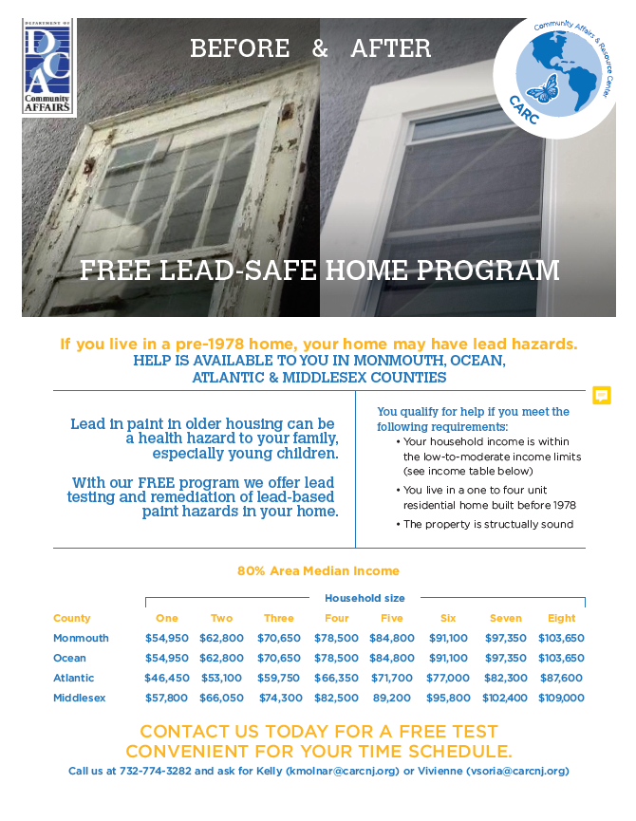
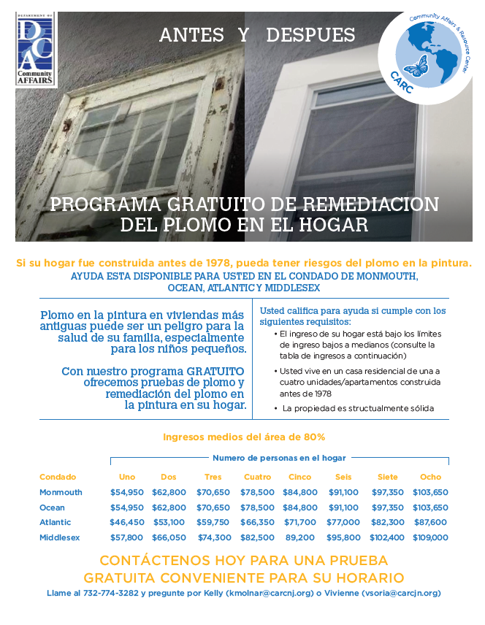

Middlesex CCYC/PCA-NJ

- Click for Babies Campaign – actively collecting hand-knitted purple caps now through November 2021. Spread the word!
  - Facebook page: https://www.facebook.com/clickforbabiesnj; Contact Raul Castillo, rcastillo@preventchildabusenj.org, for more info.

Grow NJ Kids
- Grow NJ Kids County Collaborative Meeting - September 29th, 10am (save the date)
  - For more info, please contact Leanna Felipe, lfelipe@preventchildabusenj.org

Central Jersey Family Health Consortium
- Plenty of programs and services offered for infant and maternal health and early childhood development. Visit https://cjfhc.org/ or contact Isabel Colon, icolon@cjfhc.org, for more info.
  - Upcoming events - https://cjfhc.org/events/

- Middlesex/Somerset Community Advisory Board (CAB) Meeting – September 28th, time TBA, (save the date)
  - Please reach out to Isabel Colon, icolon@cjfhc.org, to further network and to ensure that you are added to the mailing list to receive updates and formal invitations to future meetings.

Ages and Stages Questionnaires –

- ASQ-3 English
- https://www.asqonline.com/family/253fd3

- ASQ-3 Spanish
- https://www.asqonline.com/family/fb3b6a

YMCA of MEWSA
- Please contact Cindy Shields, Cindy.Shields@ymcaofmewsa.org, for information on school registrations for the upcoming 2021-2022 school year and for employment opportunities to share with your networks.

Family Success Centers

*Upcoming event flyers can be found on each FSC’s Facebook page.
Greenway Family Success Center (Facebook page) - https://www.facebook.com/GreenwayFamilySC/ Please visit Facebook page for registration and more information
Greenway FSC Baby Supply Drive on September 21st.
Our plan is to distribute baby items (clothes, diapers, wipes, pull-ups, and food) to families that register. When they come to collect the supplies, we’ll tell them individually about the ASQ and Pete’s Place and answer their questions. We’ll also offer safety information about COVID19.
- Mobile Family Success Center (Facebook page) -
https://www.facebook.com/MFSCMiddlesex
  - Bike Rodeos (raffling off bikes) coming soon!

- Harmony Family Success Center (Facebook page)-
https://www.facebook.com/FSCHarmony/ - New Partner! Please reach out to Johanna Crespo, jcrespo@prab.org for further networking.
  - Ask a Pediatrician event coming soon!

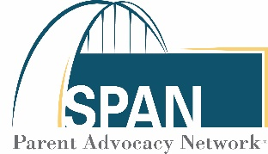

SPAN Parent Advocacy Network

- Empowering families as advocates and partners; particular focus on early intervention and special education. Please reach out to Stefani Babits, sbabits@spanadvocacy.org, for further networking.
- Visit Facebook page for info on upcoming events: https://www.facebook.com/parentadvocacynetwork

New Brunswick Free Public Library
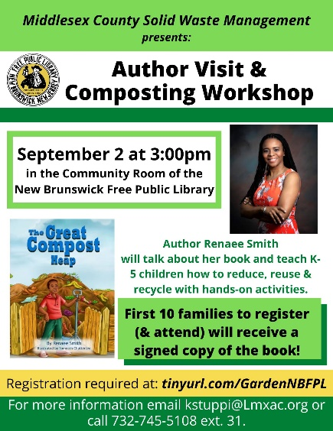
- Author Renaee Smith is coming to the library next Thursday, September 2, to talk about her book The Great Compost Heap! She will teach children in grades K-5 how to reduce, reuse, & recycle with hands-on composting activities. The first ten families to register (& attend) will receive a signed copy of her book! Registration is required at tinyurl.com/GardenNBFPL; contact Karen Stuppi at kstuppi@Lmxac.org or at 732-745-5108 x31 with any questions.

FREE Training
- To inquire about a FREE Connections Matter training for staff and/or parents please email Patty Mojta, pmojta@preventchildabusenj.org.

