SOMERSET COUNTY RESOURCE LIST-COVID 19- 03/01/2021
We are updating resources on a bi-weekly basis, please refer to the date above to ensure information is up to date or visit our website at www.cjfhc.org and click on ‘County Resource Updates during COVID-19’.

COVID TESTING AND RELATED INFORMATION SPECIFIC TO THE COUNTY
Enter your zip code to find a free Coronavirus testing center free screening and treatment
https://findahealthcenter.hrsa.gov/
COVID‐19 Public Hotline 1‐800‐222‐2222
Residents can call 908-231-7111 for a daily-automated reading of the current coronavirus (COVID-19) case count in Somerset County, New Jersey.

The State's toll-free vaccination hotline (1-855-568-0545) is available to assist callers with identifying if they are currently eligible for a vaccination, pre-register for the vaccine, and to help them identify locations nearest to them where they can get vaccinated. The hotline is open from 8:00 a.m. to 8:00 p.m. every day.

· COVID testing or vaccination questions can call the Somerset COVID Hotline at (908) 231-7155 weekdays from 8:30 a.m. to 8:00 p.m. and Saturdays from 10:00 a.m. to 4:00 p.m.

· New list created for public transportation access to statewide COVID vaccine sites, organized by County will continuously be updated, as new sites are known http://vtc.rutgers.edu/transit-to-vaccine-sites/

· The Somerset County Call Center highlighted on Bound Brook’s Facebook page:

· English: https://www.facebook.com/1boundbrooknj.org/photos/a.1708753372726412/2850183231916748/

· In Spanish: https://www.facebook.com/1boundbrooknj.org/photos/a.1708753372726412/2850182635250141/

Manville ‐ https://www.manvillenj.org/639/Coronavirus‐Disease‐2019‐COVID‐19

Zufall Health - is now offering (by appointment) free COVID-19 testing at its Somerville location (71 Fourth Street) and is continuing to use its mobile van to provide testing at identified communities with greatest barriers.

Official Somerset County COVID-19 webpage : https://www.co.somerset.nj.us/residents/covid-19-status

FOOD INSECURITY
Zarepath Christian Church: My Neighbor’s Food Pantry
https://www.zarephath.org/outreach/mnm/
595 Weston Canal Rd, Somerset
732‐560‐4001
Food pantry is open on Thursdays and Saturdays.
If unable to pick up, they may be able to deliver.

FRANKLIN TWP. FOOD BANK INC.
Food Pantry
224 Churchill Avenue
Somerset, NJ
(732) 246-0009ext 120
SHIP: Samaritan Homeless Interim Program.
87 E. High Street, Somerville
908‐725‐3260
(Hot meals, Lunches and Dinners may be offered to the poor or homeless.)

Food Bank Network of Somerset County
9 Easy Street, Bound Brook
Telephone: 732‐560‐1813

Interfaith Hospitality Network of Somerset County
98 West End Avenue
P.O. Box 575
Somerville, NJ 08876
(908) 704‐1920

Jewish Family Services ‐ Hunterdon, Somerset & Warren
150‐A W High St
Somerville, NJ, 08876 Call (908) 725 – 7799

Salvation Army, South Jersey
Food pantry location ‐ 108 Hamilton St.
Bound Brook, NJ, 08805
Phone number ‐ (732) 748 ‐ 1146
Covers all of the area, including Somerset. In addition to distributing free or low cost food, the center will offer other items like clothing, school supplies

Somerset Foodbank ‐ http://somersetfoodbank.org/need‐help/
Food Bank -https://www.co.somerset.nj.us/government/human-services/somerset-county-food-pantries

HOUSING
https://affordablehousingonline.com/housing‐search/New‐Jersey/Somerset‐County
https://www.lowincomehousing.us/cty/nj‐somerset

MENTAL HEALTH SERVICES
West Orange African Heritage Organization

Leading By Mission LLC
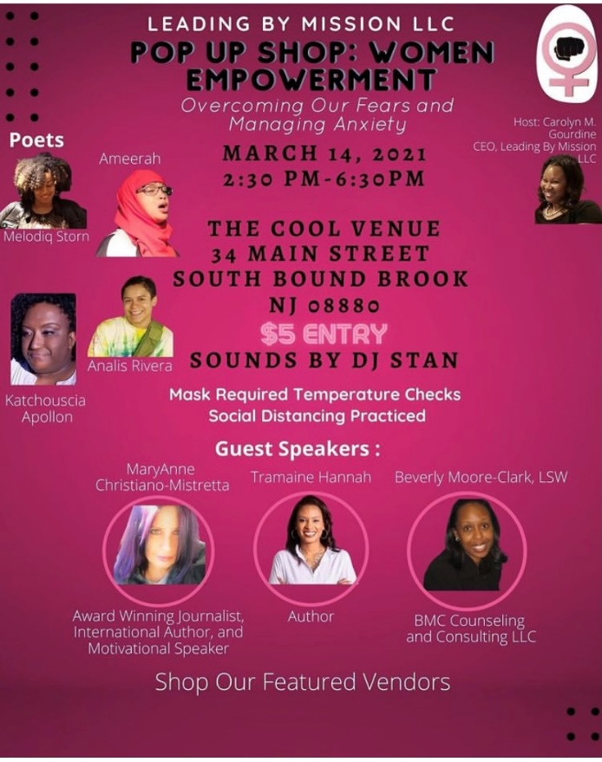

Delta Sigma Theta Sorority Inc.; Central Jersey Alumnae Chapter
A Virtual Conversation on Anxiety and Depression- March 6, 2021 – 10am-12pm
Registration Required- www.cjadeltas.org

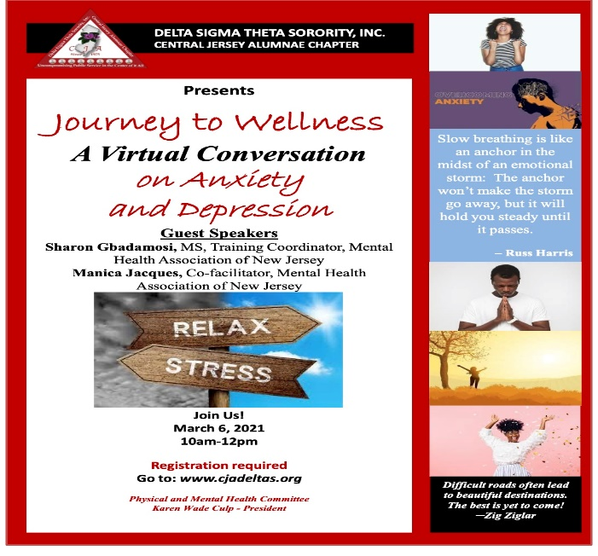

Richard Hall County Health & Wellness Center
NJ Mental Health Cares, free, confidential help from trained specialists. Call 1-866-202-HELP (4357) 8 am - 8 pm, daily.
Somerset County mental health professionals, telehealth support, call 908-975-9401 or (Spanish) 862-308-0430
Bridgeway's Psychiatric Emergency Screening Services (PESS)
No fee for crisis intervention and court involvement.
In Case of a Psychiatric Emergency
Please contact Bridgeway's Psychiatric Emergency Screening Services (PESS) at 908-526-4100.
This service can be accessed 24 hours a day, 7 days a week.

Somerset County Psychiatric Mobile 24/7: 908‐5264100
NJ Mental Health Care: 1‐866‐202‐HELP (Crisis ‐ 732‐235‐5700) or dial 9‐1‐1
Bound brook Counseling Services: - 732-356-1082
NJ Hotline Self‐Help Page: ‐ https://nj.gov/humanservices/dmhas/home/hotlines/#1

GENERAL SERVICES
- Alcohol/Substance Addiction Services

- If you or a loved one is in need of substance abuse treatment or just looking for info and referral, please contact the IME Addictions Access Center 1-844-276-2777.

- A Simple Way Narcotics Anonymous Virtual
Every Monday- Somerville NJ
7:30-9:00PM
https://us04web.zoom.us/j/79446996876
Meeting ID 794 4699 6876, Dial In 646-558-8656, Password 136136
Open Meeting (anyone welcome), Speaker, Discussion, Step

A Worldwide Connection by Phone: Multiple Meetings

http://nabyphone.org/

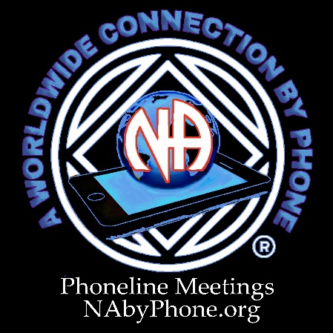

- Diaper Bank Information
- Central Jersey Diaper Bank
222 Livingston Avenue
New Brunswick, NJ 08901
T: 732-296-9922
F: 732-296-9933

- Child Abuse and Neglect Support Services

Department of Children and Families
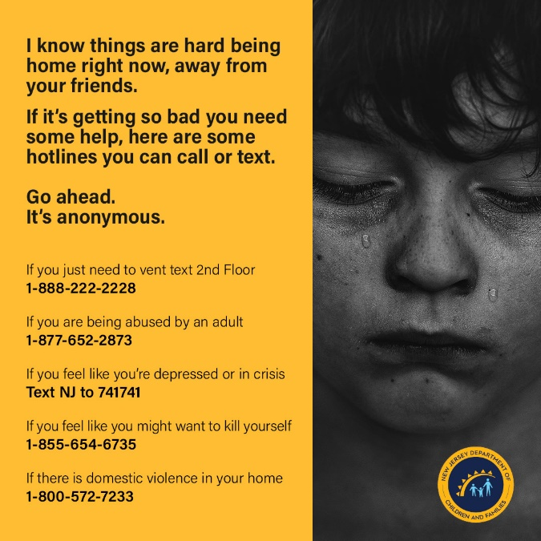

- Domestic Violence and Intimate Partner Violence Support Services

Zufall Health – Sexual Assault Support Services Hotline
908-526-2335 x130

National Domestic Violence hotline numbers:
800‐799‐7233
800‐878‐3224 TTY
855‐812‐1001 video chat

24 Hour Domestic Violence Hotline
908‐355‐Help (4357)

- Safe + Sound Somerset: Coalition members can and should share their hotline as much as possible. Those who do not feel safe in their homes can call or text 866‐685‐1122. Providers can also call or text the hotline with questions about how to work with clients who they suspect might be in a domestic violence situation. They are committed to releasing trauma informed and COVID‐19 resources with a focus on safety. Next week they will have dates and topics for webinars related to COVID‐19 and Domestic Abuse.
Call 24hr Hotline-866-685-1122
Text 24hr Hotline-866-685-1122

- Job Skills Training
One Stop - Provides quality, accessible, and comprehensive employment and supportive services responsive to the needs of job seekers, employers, and the community. Services for residents of Somerset and Hunterdon counties include career and vocational counseling, access to training grants, basic computer and literacy instruction, and employment based case management in conjunction with the Somerset and Hunterdon Boards of Social Services.

Monica Mulligan, One Stop Operator

Phone: 908-541-5780

Email: OneStop@co.somerset.nj.us

Location: 2nd Floor, 27 Warren Street, Somerville, NJ 08876

The Greater Raritan Workforce Development Board- https://www.thegrwdb.org/

- Utility Assistance Programs
Somerset County Residents Rental Assistance - Services are available to prevent the loss of permanent housing and/or resolve homeless situations. The services include limited payments toward rent and utility arrearages, security deposits and temporary shelter.
https://www.co.somerset.nj.us/government/human-services/community-development/cdbg-cv-emergency-rental-relief-err-program

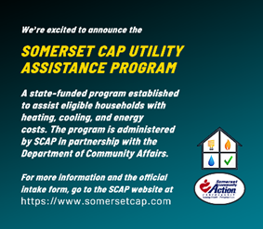

Maternal Health & Support Groups/Community Activities

- Central Jersey Family Health Consortium
Pregnant and new moms with babies under one year-
Virtual Groups:
English: Tuesdays & Thursdays- 1:00 pm
Spanish Wednesdays- 1:00 pm
For registration in English email pvena@cjfhc.org
Para registrarse en Español envie un email a mflores@cjfhc.org

- Melinated Mom
Monthly Support Groups - Every 2nd Saturday of the Month from 1:30pm - 3:30pm
Register at: http://mmmommytalks.Eventbrite.com
English Speaking
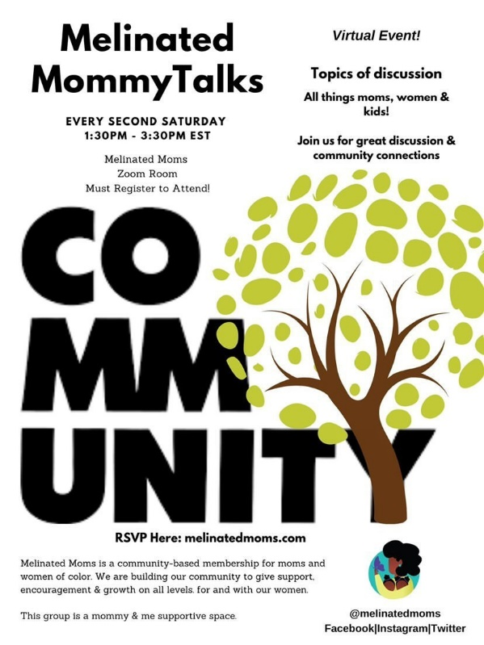

- The Tea with Doulas
Somerset County Families are encouraged to Attend
Register at www.rockcollege.com
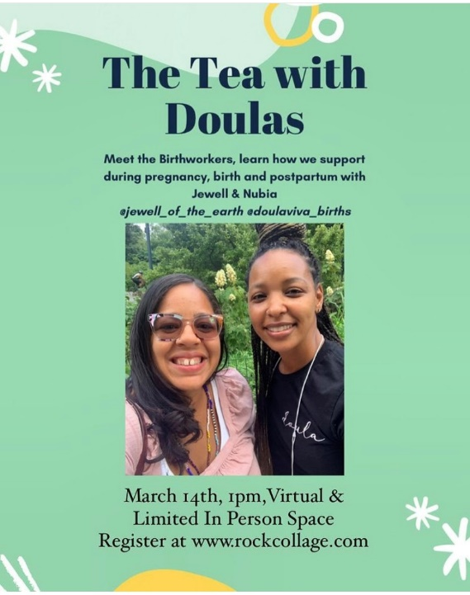

- Zeta Phi Beta Sorority, Incorporated - Beta Alpha Rho Zeta Chapter
Please click here for the Scholarship application & instructions.
https://docs.google.com/.../1dmMyhJm3zB0eXh5sD2ir.../edit...

Community Information

Internet Assistance
There is a program offered by Comcast, which may help by providing free internet access for two months. There are certain limitations with the plan ‐ to apply click the link https://www.internetessentials.com/covid19

