MERCER COUNTY RESOURCE LIST-COVID 19- 8/31/2021
We are updating resources on a monthly, please refer to the date above to ensure information is up to date or visit our website at www.cjfhc.org and click on ‘County Resource Updates during COVID-19’.

Resources Directory
- COVID-19 Resources
- Testing
- Vaccines
- Funeral Expenses

- Food Resources
- Food Banks/meals
- WIC
- NJSNAP(Food Stamps)

- Utility Assistance
- Housing Resources

- Health Care Services
- Clinics
- Health Care Coverage Enrollment
- Prescription services
- Mental Health & Addiction Services
- Transportation
- Women & Maternal Health
- Pregnancy Testing
- Prenatal Support: Doula, Prenatal Education Groups
- Mom Support Groups
- Breastfeeding Support
- Transportation
- Early Childhood Services (0-5 years of age)
- Developmental Milestones Tracking
- School Readiness
- Childcare

- Children/Youth Activities
- Children/Youth Wellbeing

- Family & Community Events
- Legal Services
- Domestic Violence
- Job Skills & Education
- General

COVID-19 RESOURCES

Is your Covid-19 Vaccination card damaged or lost? NJ Docket App can help. For Frequently asked questions visit: https://www.nj.gov/health/cd/topics/ConsumerAccessFAQ_20210712.pdf
To request a copy click here

COVID TESTING AND RELATED INFORMATION SPECIFIC TO THE COUNTY:
https://www.mercercounty.org/departments/division-of-public-health/coronavirus-disease-2019-covid-19/covid-19-vaccination
Get FREE SCHOOL & COVID VACCINES: For full list around Trenton Area visit TRENTONNJ.ORG/COVID
NJ COVID VACCINE Scheduling system:
Link - https://covidvaccine.nj.gov/covid-19%20vaccine/
COVID-19 tests are available at a number of locations in Mercer County (see below). Visit the location’s website or call for information on how to get tested.
Free at-home testing for COVID-19: https://www.mercercares.org/
Henry J. Austin Health Center in Trenton is offering COVID-19 saliva tests to the community by appointment, at no cost for patients without health insurance.
Tests are available for HJAHC’s adult and pediatric patients at 321 N. Warren St. and their mobile health unit throughout Trenton. To make an appointment, call 609-278-5900.
- To get a COVID-19 test, you must be a current patient, have been seen by a Henry J. Austin Health Center provider within the past year or set up a telemedicine appointment. HJAHC Telehealth information. En Español
- All patient information is kept confidential; HJAHC does not share information.
- Patients do not need identification or health insurance for a COVID-19 test.
- Help is available for patients who are uninsured, self-pay or need transportation.

Facility | City | County | Minimum Age | Phone for appointment and questions | Facility Website
Capital Health System - Hopewell | 1 Capital Way Pennington | Mercer | 18 years | (609) 537-7468 | Pre-register at covidvaccine.nj.gov/
CVS Pharmacy | Ewing | Mercer | 18 years | (800) 746-7287 | cvs.com/immunizations/covid-19-vaccine
CVS Pharmacy | Lawrenceville | Mercer | 18 years | (800) 746-7287 | cvs.com/immunizations/covid-19-vaccine
CVS Pharmacy | Princeton | Mercer | 18 years | (800) 746-7287 | cvs.com/immunizations/covid-19-vaccine
Henry J Austin Health Center | 112 Ewing Street  Trenton | Mercer | 18 years | (609) 278-5900 | henryjaustin.org
Henry J Austin Health Center | 321 North Warren Street  Trenton | Mercer | 18 years | (609) 278-5900 | henryjaustin.org
Hunterdon Family & Sports Medicine at Hopewell Valley | 84 Route 31 North, Suite 103 Pennington | Mercer | 18 years | (609) 730-1771 | hunterdonhealthcare.org
Infocus Urgent Care | 100 Campus Town Circle, Suite 100 Ewing Township | Mercer | 18 years |  | infocusurgentcare.org
Mercer County | Mercer County Community College 1200 Old Trenton Road  West Windsor | Mercer | 18 years |  | Pre-register at covidvaccine.nj.gov/
Mercer County/Capital Health | Cure Arena 81 Hamilton Avenue  Trenton | Mercer | 18 years |  | Pre-register at covidvaccine.nj.gov/
Rite Aid Store 01326 | 1801 Kuser Road Trenton | Mercer | 18 years |  | riteaid.com/pharmacy/covid-qualifier
Rite Aid Store 10505 | Robbinsville | Mercer | 18 years |  | riteaid.com/pharmacy/covid-qualifier
Riverside Urgent Care of Ewing | 1680 N Olden Avenue Ewing Township | Mercer | 18 years | (609) 896-0485 | riversidemedgroup.com/riverside-urgent-care/
RWJ Hamilton | 1 Hamilton Health Place Hamilton | Mercer | 18 years |  | rwjbh.org/covid19vaccine
ShopRite Pharmacy #500 | Lawrenceville | Mercer | 18 years |  | vaccines.shoprite.com
ShopRite Pharmacy #506 | Hightstown | Mercer | 18 years |  | vaccines.shoprite.com
ShopRite Pharmacy #514 | Trenton | Mercer | 18 years |  | vaccines.shoprite.com
ShopRite Of Hamilton #521 | 130 Marketplace Boulevard  Hamilton | Mercer | 18 years |  | vaccines.shoprite.com
ShopRite Pharmacy #533 | 2555 Pennington Road  Pennington | Mercer | 18 years |  | vaccines.shoprite.com
ShopRite Pharmacy #566 | Hamilton Square | Mercer | 18 years |  | vaccines.shoprite.com
Stop and Shop Pharmacy #0850 | Pennington | Mercer | 18 years |  | stopandshopsched.rxtouch.com/rbssched/program/covid19/Patient/Advisory
Wegmans Pharmacy #93 | Princeton | Mercer | 18 years |  | https://www.wegmans.com/pharmacy/

FEMA’s IA Program supports funeral expenses due to Covid-19. Application process had already started.
- FEMA will be accepting applications starting Monday, April 12th. To apply individuals must call 844-684-6333. TTY: 800-462-7585. Hours of operation are Monday-Friday, 8 a.m. to 8 p.m. Central Time
- The FEMA website has been updated to include this information, plus the policy and FAQ docs: https://www.fema.gov/…/coronavi…/economic/funeral-assistance
- Supporting documentation will be sent in via fax, mail or uploaded via https://www.disasterassistance.gov/

Back to Top
FOOD INSECURITY
For updated food pantry information please visit- https://trentonhealthteam.github.io/food/

- Summer Meals at Trenton Public Library Mondays- Fridays 12 – 2 PM 120 Academy Street

- Arm In Arm
Food Distribution by appointment
Locations:
123 E. Hanover Street, Trenton, NJ
48 Hudson Street, Trenton, NJ
61 Nassau Street, Princeton, NJ
PLEASE CALL AND LEAVE A VOICE MESSAGE

609-396-9355. For more information please to visit Arm In Arm's website - https://arminarm.org/2020/03/10/coronavirus-service-changes/
Pantries are not open for walk-in service. If you would like to be added to a mobile delivery list, please call 609-396-9355 ext. 11. Please speak very slowly and clearly. Leave a message with your full name, full address and best phone number to reach you - a representative will be in touch with you. Estimated week or more until Arm in Arm will reach your neighborhood for delivery. You will be notified 24 hours in advance of future delivery to your address. Must be a resident of Mercer county

- United Progress, Inc (UPI) Community Food Distribution
  - United Progress, Inc (UPI) will be hosting a community food distribution event on Wednesday, September 23rd from 12pm-3:00pm at the CURE Insurance Arena, 81 Hamilton Avenue, Trenton, NJ 08611. They are currently seeking volunteers. To register to be a volunteer please contact Iris Coriano at 787-678-8908. Volunteers should arrive at 10:30AM and wear masks at all times.
- Capital Health provides food bags to patients that have appointments on Thursdays. 433 Bellevue Ave, Trenton, NJ 08618 (609) 815-2671
- Community Food Pantry Available In Princeton / West Windsor for All Mercer Residents
- JFCS (Jewish Family & Children’s Service) is operating a prepared bag model where community members can set up a time for no-contact pick up of a pre-packed bag of groceries which includes non-perishable items, as well as fresh fruit and vegetables, cheese and chicken.
- Where to find the JFCS Pantry?
  - Our pantry is located at 707 Alexander Road, Suite 204 Princeton, NJ 08540. The office is located just off of Route 1 and accessible via NJ Transit Bus Route #600/Carnegie Center stop.
- How to set up a pick up time?
  - Call our offices at 609-987-8100 Ext 237 to set up a pick up time. Staff is available Monday – Thursday 9 AM – 5PM and Fridays 9 AM – 4 PM.
- For additional details please visit:
- Website: www.jfcsonline.org
- Facebook: www.facebook.com/JFCSMercer
- Twitter: www.twitter.com/JFCSMercer
- YouTube: www.youtube.com/JFCSMercer
- LinkedIn: www.linkedin.com/company/JFCSMercer

MEAL ON WHEELS OF MERCER COUNTY 320 HOLLOWBROOK DR. EWING TOWNSHIP (609) 695 8483 Only Prepared food for people who are 65 years
- Abundant Life Christian Fellowship 1901 N. Olden Avenue, Suite 25, Ewing (609) 902-5547: Every 4th Saturday from 10:00am-4:00pm.
- RISE Food Pantry
The Rise Pantry is open Monday, Tuesday, and Wednesday mornings in addition to two Wednesday evenings each month. It is located at 133 Broad Street in Hightstown and is convenient for the families that we serve.
The WIC Program
How to contact WIC during COVID?
- Participant may contact the WIC office at (609) 498-7755 or Faxing information to (609) 571-9540 or (609)-571-3624.
- Participants have the option of uploading their documents to the Participant Portal see link below Access the WIC Participants Portal at: https://wic.nj.gov/participantportal/
- Participants portal is a secured link created by the State of New Jersey WIC program to provide easy access for participants to contact the local WIC agencies and upload their documents. Participants may choose to create their own WIC Portal this will give them access to: Review next appointments Date/ Time and what will be need for the WIC appointment. Participants may also view account information, update information, add information e.g. their newborn baby or add information for a temporary Proxy. Uploading All required documents before appointment will assist in determining eligibility and expedite the intake process.
- Email: wicnutritionist@chsofnj.org For immediate service (609) 947-7011
- For immediate breastfeeding service contact PC at (609) 477-9565 (English/Polish) or (609) 414-3322(English/Spanish) Wicbreastfeeding@chsofnj.org : For general information (609)731-0489 or (609)610-0338 (English/Spanish) or (609)731-9096 (English only)
- What’s needed for Certification/Recertification: Proof of Income, proof of address/residency, proof of identification, and proof of pregnancy (if applicable?) and Recent Height and Weight on each participant.
NJSNAP (Food Stamps) New Jersey’s Supplemental Nutrition Assistance Program, NJ SNAP, provides food assistance to families with low incomes to help them buy groceries through a benefits card accepted in most food retail stores and some farmers markets. Eligibility is set by several factors, such as income and resources. You can use SNAP benefits to stretch your food budget and buy nutritious foods that can keep you and your family healthy. To apply: https://oneapp.dhs.state.nj.us/default.aspx
EBT
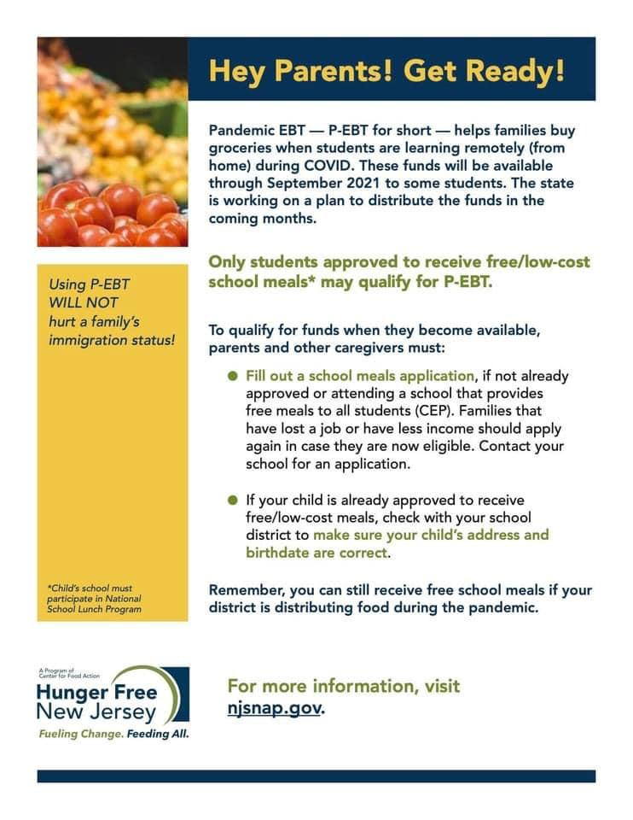

Back to Top
HOUSING

Recently, the federal government issued a limited eviction moratorium beginning August 3rd through October 3rd for renters living in communities experiencing a surge in COVID-19 cases. In addition, Governor Murphy signed legislation that expands COVID-19 Emergency Rental Assistance and Utility Assistance Programs. For more information, or to apply for rental assistance or utility assistance, please use the links below

First, know your rights: https://legalfaq.org/

Renters MUST self-certify to qualify for assistance: https://covid19.nj.gov/pages/renter

State Rental Assistance Application: https://njdca.onlinepha.com

A Video Tutorial on completing the application: https://njdca.onlinepha.com/en-US/Pages/View/152/how-tenants-can-apply-for-cverap

Frequently asked Questions and Answers: https://njdca.onlinepha.com/en-US/Pages/View/145/program-frequently-asked-questions

Comprehensive Statewide Housing Resources: https://www.housinghelpnj.org/

Renters may also access assistance at both the County and City level using the federal database of rental assistance programs: www.consumerfinance.gov/renthelp

Federal Relief Resources for Renters and Landlords

The Centers for Disease Control and Prevention (CDC) recently announced a one-month extension of the CDC Eviction Moratorium expiring on July 31, 2021. USDA recognizes the COVID-19 pandemic has triggered an almost unprecedented housing affordability crisis in the United States. The American Rescue Plan (ARP) provided billions of dollars to support distressed tenants and landlords and USDA continues to collaborate with federal partners to ensure Rural America receives ample relief. Provided below is information on several federal resources designed to help those facing rental hardship or eviction.
U.S. Treasury
Even as the American economy continues its recovery from the devastating impact of the pandemic, millions of Americans face deep rental debt and fear evictions and the loss of basic housing security. To meet this need, the U.S. Treasury’s Emergency Rental Assistance (ERA) program makes funding available to assist households that are unable to pay rent or utilities. The funds are provided directly to grantees such as states, U.S. territories, local governments, and (in the case of the first round of funding) Indian tribes. Grantees use the funds to provide assistance to eligible households through existing or newly created rental assistance programs. To learn more about how to apply for emergency rental assistance in your state, please visit this link. Information in Spanish for renters can be found here, and information in Spanish for landlords can be found here.
U.S. Department of Housing and Urban Development (HUD)
The Emergency Housing Voucher (EHV) program will provide 70,000 housing choice vouchers to local Public Housing Agencies (PHAs) in order to assist individuals who are homeless, at risk of homelessness, fleeing domestic violence, or were recently homeless or have a high risk of housing instability. For more information on eligibility and how to apply, please visit this link. HUD and USDA have also partnered on developing a Frequently Asked Questions (FAQs) fact sheet, which can be found here. Information in Spanish can be found here.
Consumer Financial Protection Bureau (CFPB)
CFPB provides additional resources to inform renters of potential options to help them stay in their homes. Please visit CFPB’s Renter Protections resource webpage for more information. Information in Spanish can be found here

DCA COVID-19 Emergency Rental Assistance Program
Do you need help paying your rent or arrears due to the pandemic? Online applications for Phase II of the #COVID19 Emergency Rental Assistance Program for New Jersey residents is now open
Link - https://njdca.onlinepha.com/en-US/Pages/View/148/cverap2-pre-application
People can contact our Client Call Center at 609-490-4550 or by email to COVID.NJDCA@nanmckay.com
For More information - https://njdca.onlinepha.com/Content/Uploads/DCA_NJ_ERAP_Flyer_2021_03_10.pdf

CATHOLIC CHARITIES
Homelessness Prevention
Our Homelessness Prevention Program emphasizes both immediate and longer-term strategies for reducing homelessness and strengthening self-sufficiency. While housing units are not offered at all locations, we help individuals and families remain housed through rent/mortgage and utilities assistance.
Mercer County: 132 N Warren Street, Trenton NJ 08608 – 609-394-8847

Rapid Re-Housing
Rapid Rehousing uses a combination of federal (HUD) and county funds to help homeless individuals and families in Burlington and Mercer locate affordable permanent housing and offers 3-6 months of financial assistance. The program focuses on four areas: intensive case management, financial assistance, housing location and multiple types of community support and resources. In Burlington and Mercer counties, Rapid-Re-Housing is one of several programs offered to help individuals and families obtain housing and develop the skills necessary for meeting monthly housing and other living costs. Assistance is available for the following: money management, credit repair, saving skills, employment support, job referral services, resume review, and job retention.
Mercer County: 132 N Warren Street, Trenton NJ 08608 – 609-394-8847

HOMEFRONT
HomeFront can work with you if you have lost your home, need one-time help in a crisis or need help to find a safe place you can afford. We can also help with back rent or security deposits.
https://www.homefrontnj.org/clientservice-housing/

PIAZZA & ASSOCIATES:
Affordable housing https://www.piazzanj.com/
VILLAGE RESOURCES - 200 Mott St., Trenton NJ 08611
http://www.villageresourcesnj.org/
HOUSING INITIATIVES OF PRINCETON
To apply for assistance: https://housinginitiativesofprinceton.org/what-we-do
Can also contact by phone:
Emergency Rental Assistance: 609-921-2328
Transitional housing: 609-4974535 or by e-mail: info@housinginitiatives.org

ARM in ARM
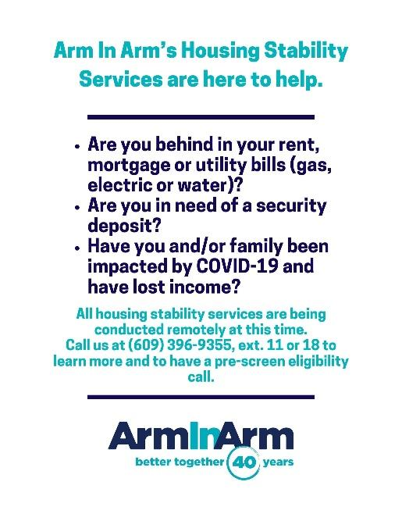
- https://arminarm.org/preventing-homelessness/
- Arm In Arm staff will be available to intake clients remotely via phone Mondays through Thursdays from 9 am – 3:30 pm. Please call 609-396-9355 x11 You might be prompted to leave a message. Please provide your full name, complete address (including city), and best number for us to return your call. Staff will contact you for an eligibility pre-screening.
- Hamilton Township Residents
  - Arm In Arm staff will be available to intake clients remotely via phone Mondays through Thursdays from 9 am – 3:30 pm. Please call Lisa at (609) 396-9366, ext. 16 or 609-577-9054. You might be prompted to leave a message. Please provide your full name, complete address (including city), and best number for us to return your call. Staff will contact you for an eligibility pre-screening.
Back to Top
UTILITY ASSISTANCE PROGRAMS

According to PSE&G: "Qualified customers can make a Deferred Payment Arrangement (DPA) with no money down and extended time to pay off their balance. A customer can select a DPA to pay their balance over a 12-, 18- or 24-month period. To make a Deferred Payment Arrangement, log in to My Account or call 800-357-2262."
Low Income Assistance Programs
- Low Income Home Energy Assistance Program (LIHEAP) or 800-510-3102
- Universal Service Fund (USF) or 800-510-3102
This program helps low income households pay for their electric and natural gas costs.
For more information, call the Mercer County Housing an Community Development Office at 609-989-6858 or 609-989-6959
Moderate Income Assistance Programs
- Payment Assistance Gas and Electric (PAGE) or 855-465-8783
- NJ SHARES (NJS) or 866-NJSHARES (657-4273)
Senior/Disabled Adult Assistance Programs
New Jersey Lifeline or 800-792-9745
ARM in ARM – Utility Assistance

Please call 609-396-9355 ext. 11 for pre-screening.

What you need to provide:
- Identification for each household member and the person named on the utility bill
- Current utility shut-off notice
- Proof of all household income, such as your most recent pay or benefits stub, for the last 30 days
- For SSI, TANF, and GA recipients, Mercer County Board of Social Services emergency assistance approval or denial letter and grant letter from the last 30 days
Heritage North Family Success CenterIf you or someone you know has been affected by COVID-19 and needs help with rent, mortgage, utilities, food, etc…. please call HNFSC at 609-393-2980
Back to Top

GENERAL SERVICES

LEAD ASSESMENT

Isles- https://isles.org/our-approach/live-green-and-healthy/lead-and-healthy-homes/

BABY PANTRY

- Diaper Bank Information

Makers Place- Trenton based diaper pantry
- Call or text : (609) 751-9128
- Online Diaper Application- https://www.makersplace.org/diapers
- Email them at- hello@makersplace.org
- Facebook Link - http://www.facebook.com/makersplacetrenton

Home Front
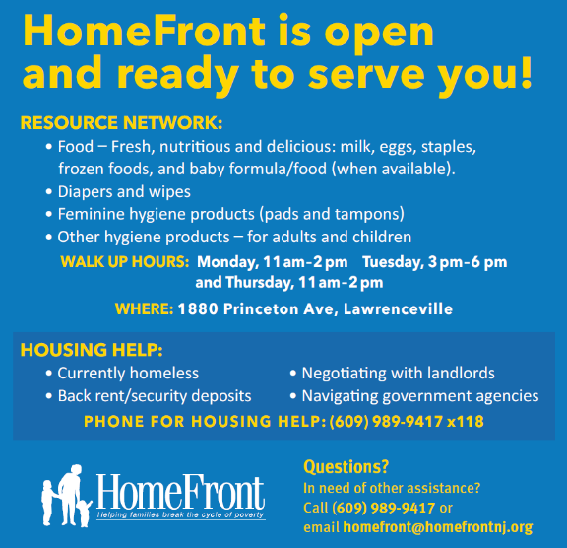

Storks Closet
Provides mommy baby essentials. Call 609-542-477
Hrs of operation: Fridays 10-3 PM, Saturdays 10-2
By appointment only

- Child Abuse and Neglect Support Services
DHS: Commission On Abused, Neglected, And Missing Children
Offers programs and services that enhance the physical, emotional, and social well-being of the children in Mercer County
Contact person: Yolanda León, Program Development Specialist
Phone: 609-989-6966
Fax: 609-989-6032
Mail: 640 S. Broad Street
P.O. Box 8068
Trenton, NJ 08650-0068
Email: yleon@mercercounty.org

Anchor House
The agency works with homeless, runaway, and abused children and youth, from 12 to 21 years of age, to enable them to utilize their strengths and the support of their families and communities to help ensure a stable and successful home.
Address: 482 Centre Street
Trenton, NJ 08611
Mercer County
Phone: (609) 396-8329
Anchor House Shelter
482 Centre St
Trenton, NJ 08611
Mercer County
(609) 396-8329
Anchor Link Street Outreach Program
899 S Broad St
Trenton, NJ 08611
(609) 218-5630

Teen Pregnancy Resources
Project TEACH (Teen Education and Child Health) is an alternative, year-round education program for pregnant or parenting teens. The program meets the unique needs of students who benefit from a small academic setting. The healing-centered approach addresses students' social and emotional needs while they pursue their academic studies.
1600 STUYVESANT AVE , Ewing Township NJ 08618
(609) 588-3157
Back to Top
HEALTHCARE
CLINICS
- Henry J Austin Health Centers. For appointment contact: 609-278-5900
delivers person-centered, high quality health care.
Centering Parenting Available (NEW): CenteringParenting model combines one-on-one child health assessment, interactive learning and community building in a postnatal group setting. HJA Centering Families will bring a group of 5 to 6 mom and baby pairs for care during their first two years of life. Based on the well-child visits schedule, in the 9 group sessions, the providers will provide well child care and also attend to health and safety issues of mothers. Each group session will be for 2 hours.
- New Hope Health Center Free Clinic218 N. Broad Street, Trenton NJ 08608. Hours of operation Tuesdays 10 am – 3 pm, second Saturday of the month 9 am – 12 noon
- Health Start Prenatal Clinic - Capital Health 433 Bellevue Ave, Trenton NJ 08618. Contact: 609-815-7296 for appointment.
- Pregnancy Testing. See Maternal & Women’s Health Section
- NJ Cancer Education and Early Detection In collaboration with the New Jersey Department of Health, Trenton Health Team (THT) provides comprehensive screening services for breast, cervical, prostate, and colorectal cancer as part of the New Jersey Cancer Education and Early Detection (NJCEED) program. Call 609-888-6189 for appointment or by completing form here: https://trentonhealthteam.org/people/shelby-guzman/

Back to Top

Healthcare Coverage (Health Insurance)
- Public Benefits & Healthcare Services
Children’s Home Society:
Medicare Enrollment Assistance Services.
- The State Health Insurance Assistance Programs (SHIPs) provide free, local, in-depth, and objective insurance counseling and assistance to Medicare-eligible individuals, their families, and caregivers – in Mercer County SHIP is a program of the Children’s Home Society of New Jersey.
- Children’s Home Society certified SHIP counselors are providing service by telephone and video communication during the Coronavirus (COVID-19) pandemic.
- Contact Cathy Forbes on 609-273-0588 or email cforbes@chsofnj.org to set up your virtual appointment today.

- Children’s Futures Insurance Enrollment Assistance :
Children’s Futures is a designated Certified Application Counselor organization. Our certified application counselors can help you navigate the Healthcare Marketplace.
Please call- (609) 695-1977
Hours- 9:00 AM - 4:00 PM
Or contact them via Facebook Messenger as well- https://www.facebook.com/pg/ChildrensFutures/services
- New Jersey Hospital Association (NJAH) for personal assistance navigating all healthcare coverage including market place, Medicaid, Medicare and charity care, contact NJHA Navigator Tahirih Gomez-Smith. 609-608-2337. Tgomez-smith@njha.com
- Family Resource Network is offering free services for health insurance open enrollment in English and Spanish. For more information, contact Yamilet Zegarra, Navigator/ Resource Coordinator, Family Resource Network, yzegarra@familyresourcenetwork.org, (609)276-9595.

Prescription services
Quality Institute Prescription Assistance Guide provides an updated list of prescription assistance programs and companies offering prescription delivery during COVID-19.
Link : https://www.njhcqi.org/wp-content/uploads/2020/05/Quality-Institute-Prescription-Assistance-Guide-Updated-5-14-20.pdf.

Back to Top
MENTAL HEALTH SERVICES

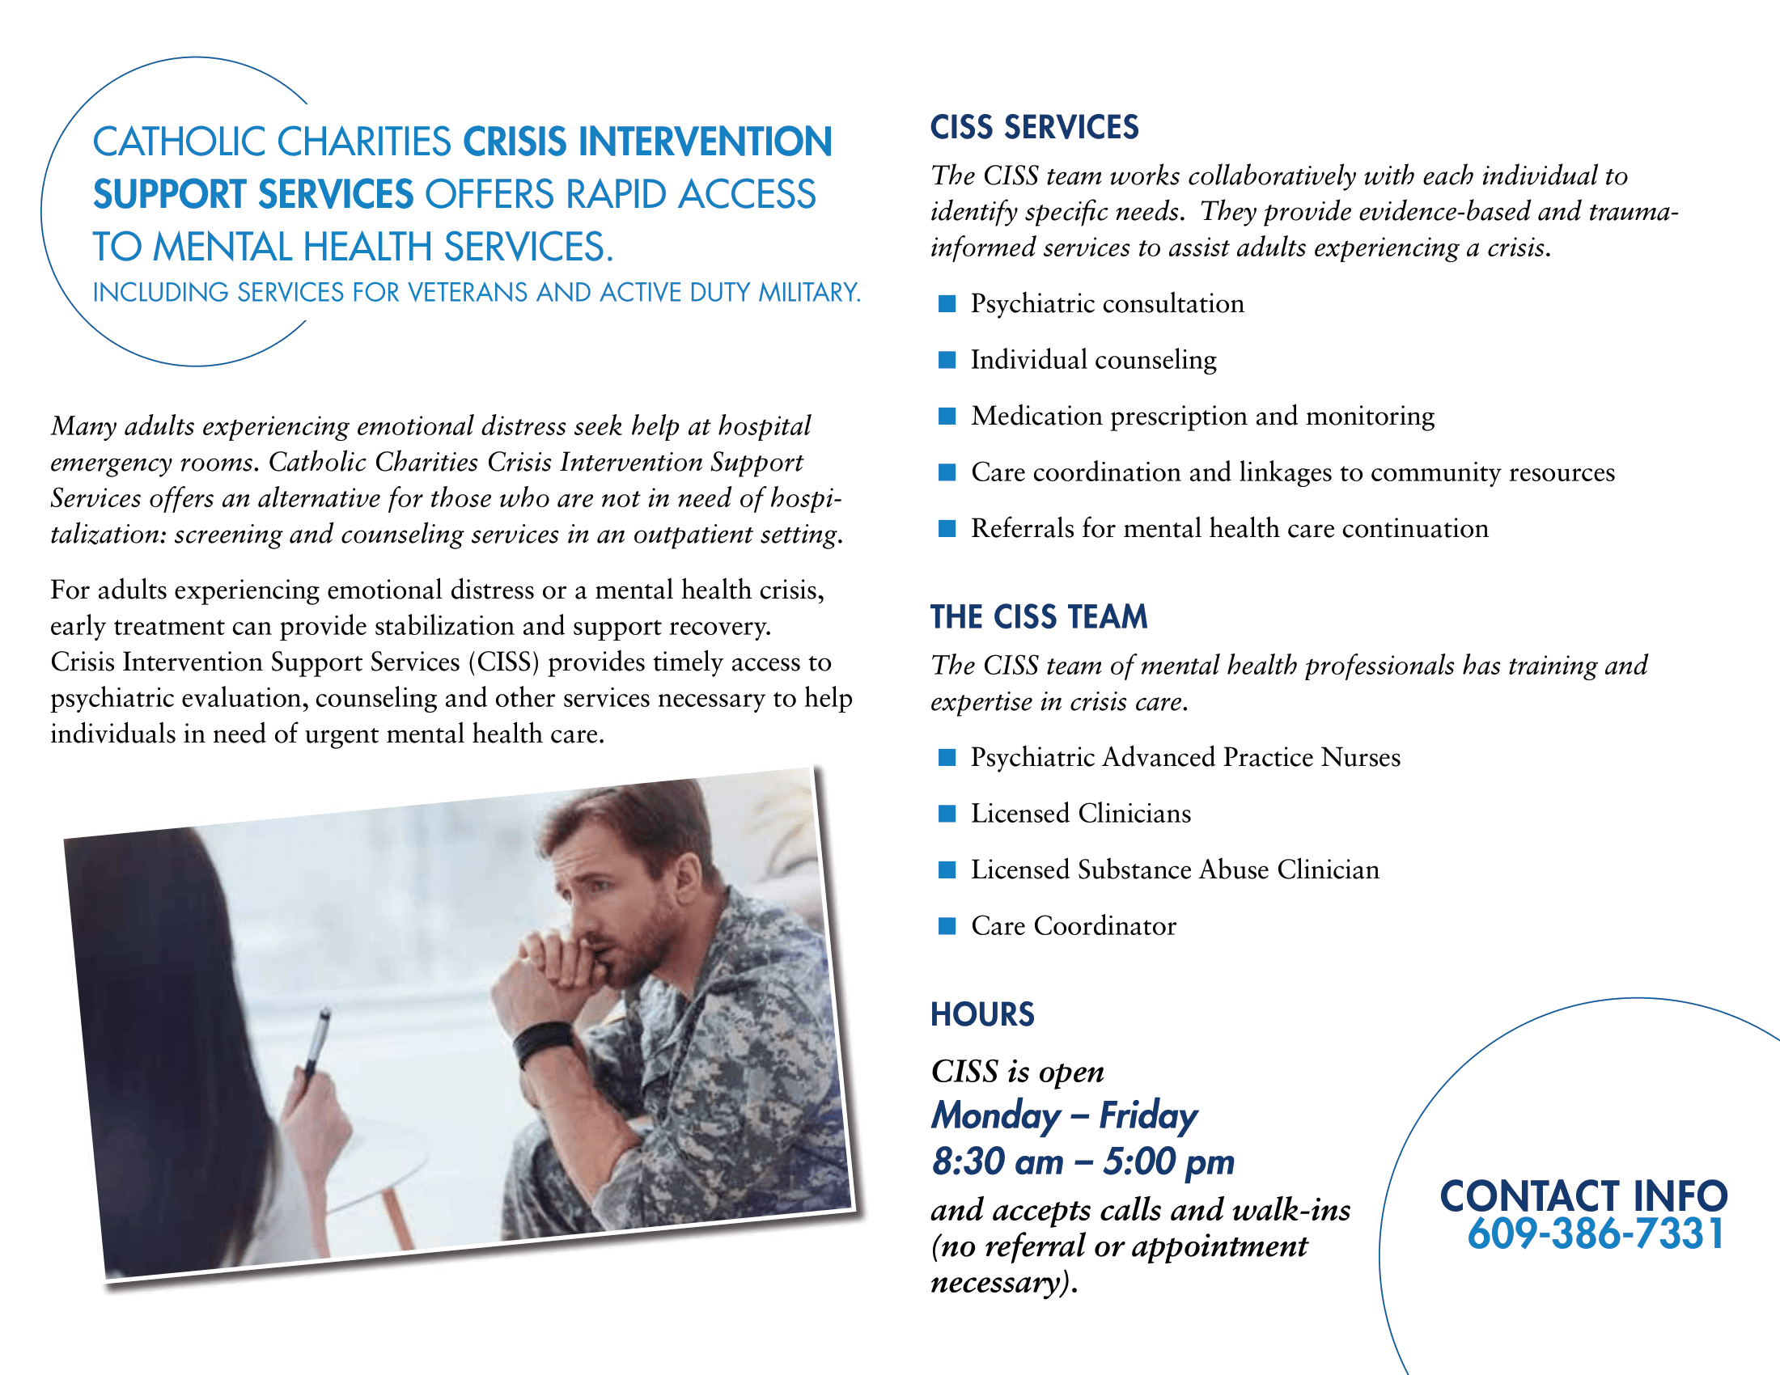

Salvation Army - Officers, retired officers, employees, and volunteers across the United States have joined forces to form The Salvation Army’s Spiritual and Emotional Care Hotline (or HOPEline), which is available from 9 a.m. to 1 a.m. ET at 1-844-458-HOPE. The hotline’s theme is “We’re Here to Listen

Barbara and Herb Goodfriend Counseling Center - 609-394-2532. Counselors are doing screening and providing counseling and support by phone until the office reopens.

COPING WITH STRESS
New Jersey's Mental Health Hotline at 877-294-HELP (4357) or visit njmentalhealthcares.org for emotional support, guidance, and mental health referrals as needed. You also may call the SAMHSA Disaster Distress
Helpline at 1-800-985-5990 or text TalkWithUs to 66746 (TTY 1-800-846-8517).
Kwenyan & Associates
Provides mental health treatment and services. https://www.kwenyanandassociates.com/
860 Lower Ferry Rd Suite 1, Ewing NJ 08628 (609) 403-8740
2000 Spruce Street, Ewing NJ 08638 (609) 583-4777/79
NJ Children’s System of Care
24 hrs/7days a week: 1-877-652-7624
Provides assistance with: Behavioral Health, Intellectual/Developmental Disability Services, Substance Use Treatment: https://www.performcarenj.org/index.aspx
Catholic Charities
https://www.catholiccharitiestrenton.org/services/mental-health/
Telehealth and Telemental health services – 609-394-9398
Mom Support Groups
- Central Jersey Family Health Consortium
Pregnant and new moms with babies under one year-
Virtual Groups:
English: Tuesdays & Thursdays- 1:00 pm
Spanish Wednesdays- 1:00 pm
For registration in English email pvena@cjfhc.org
Para registrarse en Español envie un email a mflores@cjfhc.org

The Father Center of New Jersey
The Father Center’s anger management classes offer a small group format that provides opportunities for personalized learning.
- Participants learn to identify the primary ways anger activates and escalates within their mind and body.
- They develop a personal plan that will be most effective in helping them stay cool, calm and in control during stressful situations.
- For more information and to enroll in the classes - (609) 695-3663| info@thefathercenter.org

- Alcohol/Substance Addiction Services
Catholic Charities
Address:39 North Clinton Avenue, Trenton, NJ 8609
Website: http://www.cctrenton.org
Intake Phone Number: 800-360-7711
Alternate Intake Phone Number: 609-278-3202

NJQuit- Smoking Cessation Support Services
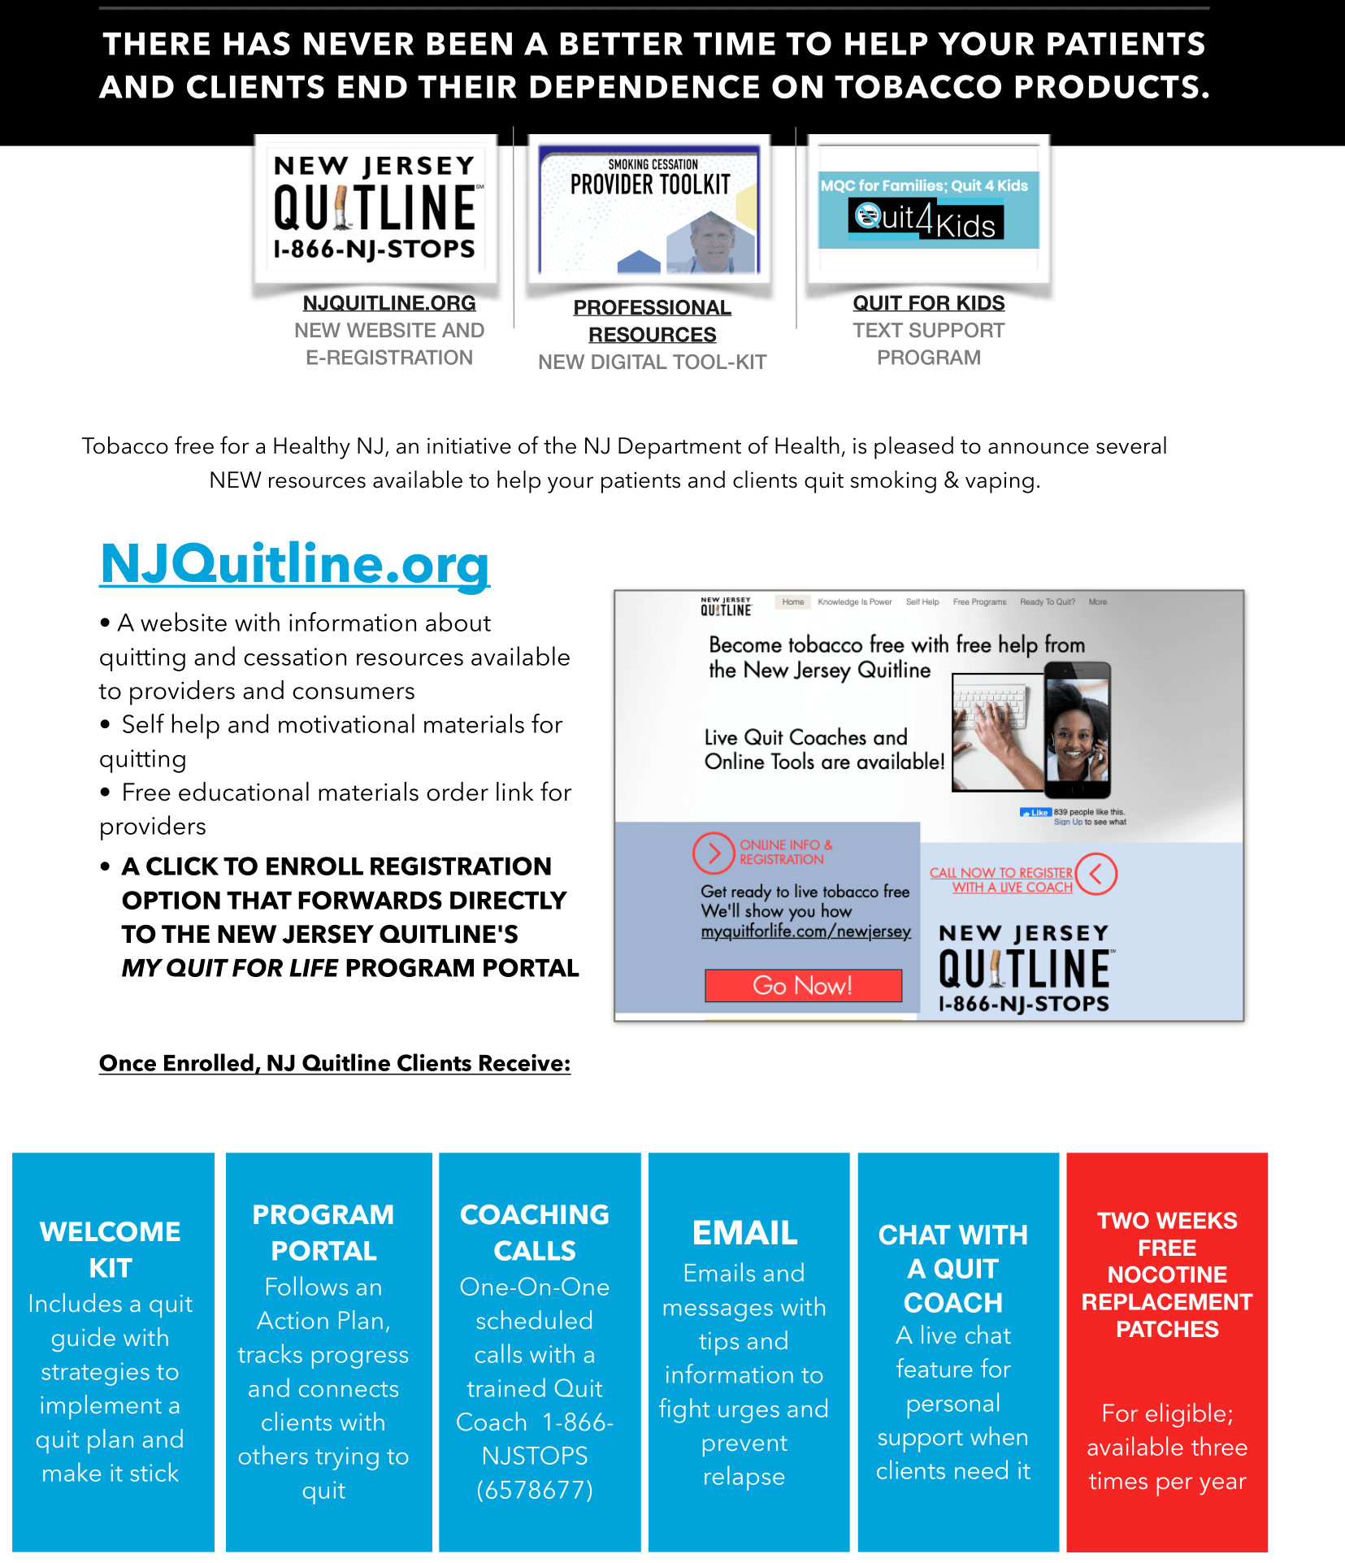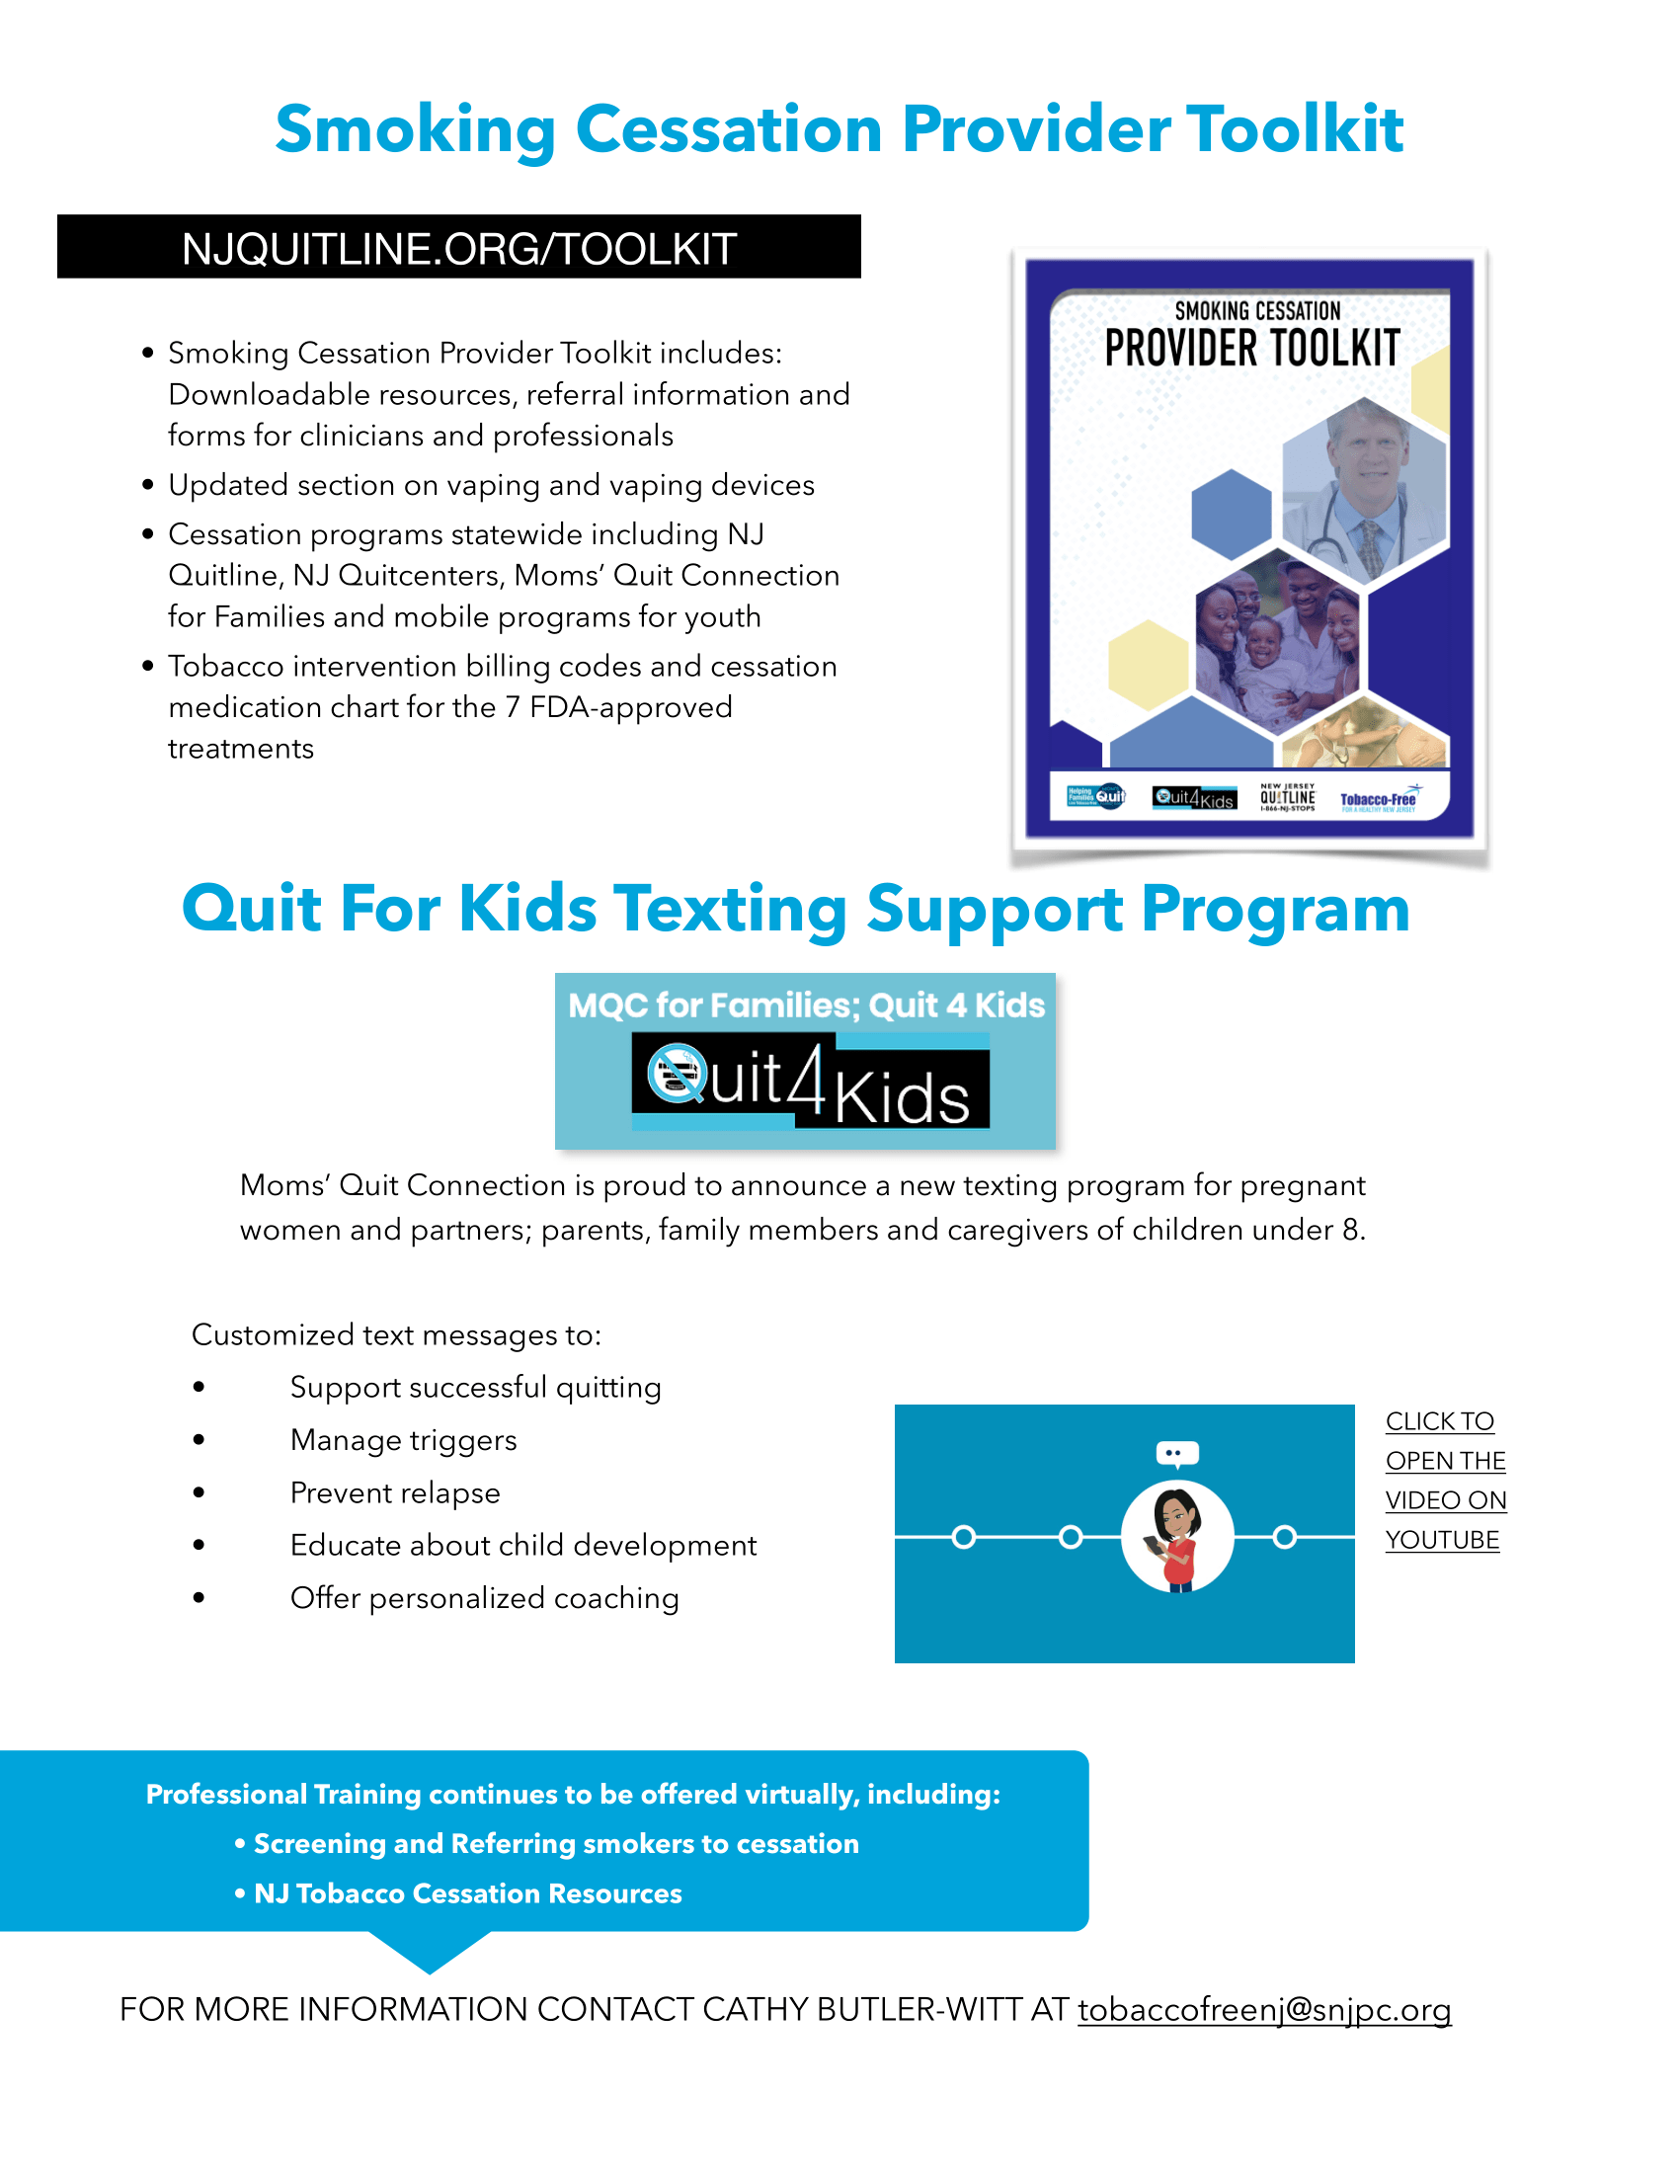

For My Baby And Me
If you or a loved one are pregnant or a new mother and using drugs like heroin or prescription painkillers, we are here to help.
You and your baby’s well-being are our top priority. That’s why our program is more than drug treatment - it’s a chance to create a better future for yourself and your baby. Women in this free program receive:
- Transportation from wherever you are
- Medicine to treat withdrawal (learn more here)
- Safe housing, food and clothing
- Healthcare and childcare
- Legal assistance and more

TRANSPORTATION

Logisticare – https://www.logisticare.com/members-families for Medical Travels only. Must be pre-approved. Call Medicaid to determine eligibility and request service.
NJ Transit’s ADA: Access Link – Provides public transportation to people with disabilities who are unable to use the local bus service according to the American with Disabilities Act (ADA) https://www.njtransit.com/accessibility/access-link-ada-paratransit
This service can used during pregnancy for medical appointments. To apply for temporary eligibility during pregnancy: https://www.praspect.org/documentation/ADA_PARATRANSIT_TEMPORARY_ELIGIBILITY_REQUEST_MIH.pdf

Back to Top
Maternal & Women’s Health
Pregnancy Testing, Prenatal Support, Preparing for Birth, Support for New Moms

Pregnancy Testing
Children’s Futures
Free Pregnancy Testing is available
Monday & Fridays by appointment ONLY
Available Tuesday-Thursday
From 10:30 am. – 4:30 pm. NO appointment needed!
For more information or to schedule an appointment,
Call 609-695-1977

PRENATAL SUPPORT

Children’s Futures Doulas
- What is a Doula?
A SKILLED and CERTIFIED person supporting expectant moms of color with emotional, physical and informational support they deserve during pregnancy, delivery and even after birth
Expecting moms can receive help with:
- A Birthing Plan
- Breastfeeding
- Postpartum Care-Adjusting to your newborn, feelings and body
- Connecting to a Community Health Worker who will assist with additional resources
- Fatherhood Resources Available
For more information Please Call
Ashley Neblett, Trenton Community Doula Supervisor Office Phone: 609 695-1977 x 102
Mobile Phone: 609 575-6438 EMAIL: aneblett@childrensfutures.org

AMAR Community Doula Program
A Community Doula is a person from your community trained to offer emotional, physical and informational support to a pregnant woman and her family during pregnancy, childbirth and postpartum period. The Program provides services to the Hispanic Community of Mercer County.
Call Teresita Carrasquillo: 609-960-5034 or email: tcarrasquillo@chsofnj.org

https://www.chsofnj.org/amar-doula/#.YN3I_tZFzIU
PREPARING FOR BIRTH – CHILDBIRTH EDUCATION GROUPS
- Children Home Society:
- Vilma Aguirre 609.807.1925 (Spanish groups- CUNA program
https://www.chsofnj.org/wp-content/uploads/2016/03/CUNA_span2015-without-COA.pdf

- Shahera Hutchinson 609.474.0732 (English) – Body & Soul Program
https://www.chsofnj.org/body-and-soul/#.YN3IX9ZFzIU

- Breastfeeding classes - Gladis Martinez 609.301.0912
- Infant massage for infants 0-6 mos - Shahera Hutchinson 609.474.0732

Need Help Understanding NJ Worker’s Rights to Paid Leave? Click here

Early Head Start Home Base Program for Pregnant moms
This program helps you: ♥ Prepare for the successful birth of your baby ♥ Enrich your child’s development through early learning ♥ Learn how to provide your child with a healthy and safe learning environment ♥ Reach family goals for success and independence ♥ Build confidence while learning more about yourself and your community.
For more information please contact Shaila Montero (Central Intake Specialist) at (609) 336-5035 for a direct referral, Or Johanna Quiñones EHS Manager (609) 695-6274 ext. 107 jquinones@chsofnj.org Monday - Friday 9am - 5pm.
For more information check- https://www.chsofnj.org/wp-content/uploads/2020/06/EHSHBP-Brochure-2.28.19.pdf
Mom Support Groups
- Central Jersey Family Health Consortium
Pregnant and new moms with babies under one year-
Virtual Groups:
English: Tuesdays & Thursdays- 1:00 pm
Spanish Wednesdays- 1:00 pm
For registration in English email pvena@cjfhc.org
Para registrarse en Español envie un email a mflores@cjfhc.org

Teen Pregnancy Resources
Project TEACH (Teen Education and Child Health) is an alternative, year-round education program for pregnant or parenting teens. The program meets the unique needs of students who benefit from a small academic setting. The healing-centered approach addresses students' social and emotional needs while they pursue their academic studies.
1600 STUYVESANT AVE , Ewing Township NJ 08618
(609) 588-3157

Back to Top
Breastfeeding Support
CJFHC Virtual Support For Breastfeeding Families
- Do you have questions about feeding your baby? Need support during this challenging time? We can help! Email breastfeedingsupport@cjfhc.org to register for an individual session or support group.
- Appointment-based, 1-on-1 individualized (or tailored) breastfeeding sessions with an IBCLC Lactation Consultant
- Virtual Support Groups: Tuesday 10am • Thursday 1pm
- Facilitated by Yosefa Lebeau, MD, IBCLC

Children’s Futures
All parents are welcome to join our Virtual Breastfeeding Group. 1st and 3rd Thursdays 6:00 PM – 7:30 PM via Zoom. For Zoom Link info, contact: June Matthews-Gray 609-695-1977 Ext. 110 jgray@childrensfutures.org

Transportation to Prenatal Appointments: See Transportation
Back to Top

EARLY CHILDHOOD SERVICES (0-5)
Developmental Milestones Tracking
Ages & Stages Questionnaire (ASQ-3) www.asqmercer.org free online screening tool to help you keep track of and learn about your child's development. For children 2 months – 5 years of age. Within a few days after we receive your completed ASQ-3, we will contact you to share the results and offer follow-up activities and resources
Early Intervention (0-3 years) If you suspect that an infant or toddler may be experiencing developmental delays, contact Early Intervention System at 888-653-4463. The call is toll-free for New Jersey residents
School Readiness (EHS, HS) Our Head Start/Early Head Start program promotes School Readiness for children in low-income families by providing comprehensive educational, health, nutritional, and social services. Serves pregnant women and families with children ages 0-5. Option for Home or Center based instruction. For more information please contact Shaila Montero (Central Intake Specialist) at (609) 336-5035 for a direct referral, Or Johanna Quiñones EHS Manager (609) 695-6274 ext. 107 jquinones@chsofnj.org Monday - Friday 9am - 5pm. https://www.chsofnj.org/wp-content/uploads/2016/05/HS-EHS-Brochure-02-29-16.pdf
Trenton Public Schools Pre-K Registration
For registration packet, please visit: Registration (trentonk12.org)
Back to Page
Child Care
Child Care Connections
Helps families identify and find quality childcare resources and services for their children.
- Child Care Referrals: http://childcareconnection-nj.org/res_referral.cfm

- Financial Assistance: http://childcareconnection-nj.org/tuition_assistance.cfm

- Parent Education: http://childcareconnection-nj.org/parent-education.cfm

- Emergency Preparedness: http://childcareconnection-nj.org/emergency-preparedness.cfm

HEAD START
https://www.chsofnj.org/wp-content/uploads/2016/05/HS-EHS-Brochure-02-29-16.pdf
For more information please contact Martha Marqez (Central Intake Specialist) at (609) 336-5035 for a direct referral, Or Johanna Quiñones EHS Manager (609) 695-6274 ext. 107 jquinones@chsofnj.org Monday - Friday 9am - 5pm.

Back to Top Page

CHILDREN ACTIVITIES

MERCER COUNTY LIBRARY SYSTEM- For additional activities Visit www.mcl.org
Indoor Story Time (Lawrence Branch)
Outdoor Baby Time (Hollowbrook, Ewing branch)
Outdoor Music & Movement (Ewing Branch)
Outdoor Preschool Time (Ewing Branch)
Outdoor Movers & Shakers (Lawrence Branch)
Indoor Songs & Stories (Hightstown Branch)

Trenton Free Public Library Children’s Activities
Young Scientist Club For TWEENS in grades 3 to 8 -Whether you’re interested in science and engineering, or just want to make cool stuff, join our Young Scientist Club! No meetings to attend - just pick up a bag of supplies at the library and make the projects at home! Supply bags will be available starting February 8. Videos with instructions will be posted on our website at that time. Call the library for more information or to reserve your bag!
TRENTON PUBLIC LIBRARY
Young Artist Club For TWEENS in grades 3 to 8 Unleash your creativity with our art club kits designed especially for Tweens. New art projects to make at home will be available every week. All materials are supplied. Call to reserve your bag! This month we will be Shadow Tracing Art, Himmeli Sculptures, Foil Monoprinting & an Emotional Clock
Virtual Storytime For KIDS ages 1 to 5 Every Wednesday at 10:00 AM On FACEBOOK Join Ms. D every Wednesday morning on Facebook for a Facebook LIVE Storytime featuring stories, rhymes and songs. Videos will be available for viewing after the live event. Visit the Trenton Free Public Library Facebook page @TrentonPubLib.
Bilingual Storytime - Thursdays, September 16th and 30th, 3:30 - 4:30 PM. Enjoy stories, songs, rhymes, and more!
Take Home Craft Bags For Kids ages 3 to 8 Everything you need for a fun craft activity at home! Available for pickup at the library. New crafts every week!
Visit the Virtual Programming page on our website to view read aloud recordings and free activity and project ideas. https://trentonlib.org/virtual-programming/
For Library information and updates on events and other happenings, visit our website at www.trentonlib.org or follow us on Twitter: @TrentonPubLib Facebook: @TrentonPubLib Instagram: TrentonPubLib
After School Programs: https://www.bgcmercer.org/after-school-programs

YOUTH ACTIVITIES

Activities for Teen Boys -The Father Center of New Jersey
Healthy Relationships, Healthy Choices is a curriculum designed for a classroom of 15-20 9th grade boys. The program gives boys the chance to learn these life skills early on and helps prepare them for healthy relationships throughout their lives. The program is implemented throughout the school year, with 28 weekly, two-hour sessions that focus on:
· Leadership & life skills development
· Healthy & productive relationships
· A focused community service project
· Career development
· Educational field trips
Recruitment and selection of students for the program takes place in August.
Contact: Calvin Thomas, cbtjr1@aol.com
Activities for Teens
Back to Top

FAMILY & COMMUNITY EVENTS

Trenton Public Pools Hours of Operation 11-1 and 2-5 PM
Cooper Pool – 396 Union Street
Father Rocco Pool – 1501 New Willow Street
Hetzel Pool – 190 North Olden Avenue
MLK Pool – 347 Brunswick Avenue
Roberto Clemente Pool – 342 Academy Street
Mercer County Park Commission: Offers various programming for all ages: Kayak Nature Tours, Bike Nature Tours, Family Field Trips, Mercer County Stables and many more. For all activities visit: https://mercercountyparks.org/#!/calendar/
Family Success Centers in Trenton
Children’s Home Society
- Family Success Center Trenton Heritage North Calendar – The Family Success Center-South Ward is a community-based, family-centered neighborhood-gathering place where any community resident can go for family support, information and services. All services are Free and Confidential.
Facebook Link- : https://www.facebook.com/HNFSC/

- Family Success Center Heritage South
Calendar in English:
Heritage South Family Success Center - Home | Facebook
Sign up today!
Spanish Facebook Link-
Heritage South Family Success Center - Home | Facebook

Link to CHS Facebook- https://www.facebook.com/CHSofNJ/

Families First Discovery Pass
The New Jersey State Council on the Arts and the New Jersey Historical Commission have partnered with the NJ Departments of Human Services (DHS) and Health (DOH) to launch New Jersey’s Families First Discovery Pass program. This program provides families and individuals enrolled in state assistance programs with free or highly discounted admission to arts and history organizations, venues, and programs – both in-person and virtual. The Families First Discovery Pass Program offers broad access to cultural experiences for New Jersey residents and helps cultural organizations engage new audiences with the goal of building long-lasting relationships. Residents who receive benefits through SNAP, WFNJ, Child Care Subsidy and/or WIC are eligible for free or steeply discounted cultural programs throughout the State.
view participating organizations

Back to Top

LEGAL SERVICES
- Legal Services of New Jersey
Provides advice, information and referrals to low-income people in civil matters. Apply online or call our Toll free statewide Legal Hotline 1-888-LSNJ-LAW

Immigration Assistance
- Catholic Charities: 327 South Broad Street, Trenton NJ 08608 609-394-2056
- Legal Services of New Jersey. Apply online or call our Toll free statewide Legal Hotline 1-888-LSNJ-LAW
- LALDEF (Latin American Legal Defense And Education Fund) 714-716 S Clinton Avenue, Trenton, NJ 08611 609-688-0881 legal@laldef.org
Domestic Violence and Intimate Partner Violence Support Services

The Womanspace
- They continue to provide services to victims and survivors of domestic violence and sexual assault: Mercer County 24-Hour bilingual hotline - 609-394-9000; statewide domestic violence hotline - 800-572-SAFE (7233); statewide sexual assault hotline - 1-800-601-7200; administrative office, crisis intervention teams, education, outreach & training - 609-394-0136;
- The Womanspace Safe House provides safe, short-term emergency housing for victims of domestic violence, sexual assault, and human trafficking in a confidential location. Call the Hotline for more information: 609-394-9000 or visit the website: www.womanspace.org.

NJ Coalition to End Domestic Violence
Address: 1670 Whitehorse-Hamilton Square Road Trenton, NJ 08690
Phone: (609) 584-8107 (statewide) www.njcedv.org

Back to Top

EMPLOYMENT & CAREER ADVACEMENT

- Mercer County One-Stop Office of Training and Employment Services
Vocational Classes or workshops and college courses
    - Accepted participants may train in one approved credit or noncredit certificate program for one year (up to $4,000 in cost) in order to prepare for a demand occupation. Participants also undergo employment skills training.
    - Contact number is (609) 989-6523
- Employment Assistance Services
  - Mercer County One-Stop Career Center-
    - They provide On -the -Job Training (OJT) as well as training for someone's existing job.
    - They help candidates post for job openings for free
    - At the One-Stop or employer site, they assist in the recruiting and initial screening of candidates for available jobs.
    - Contact information- 26 Yard Avenue Trenton, NJ 08650, Phone: 609-989-6523 Hours: Monday-Friday: 8:30 a.m. - 4:30 p.m.
- Job Skills Training
Mercer Street Friends
- Adult Education Program is designed to help adults earn their diploma at no cost to them. They are currently 100% remote so right now all classes are via Zoom. Depending on the day, classes usually begin at 10am and run throughout the day until 4-5pm. Tuesdays we offering tutoring up until 8pm.
- Individuals can call Michele Obermeier to 347-234-3784 or send an email to mobermeier@mercerstreetfriends.org.
- Mercer Street Friends offers many other services as well. Please visit - https://mercerstreetfriends.org/#

Department of Labor and Workforce Development
- Career Services Visit- https://nj.gov/labor/career-services/
- State of New Jersey COVID-19 Jobs and Hiring Portal: https://jobs.covid19.nj.gov/?_ga=2.250481158.1660520678.1611934691-414612309.1591816842&Facets.filterbox.filter0=%5B%5D&Facets.filterbox.filter1=%5B%5D
SkillUp Mercer
helps people access training resources to develop new job skills in their current career or to prepare themselves for a new journey. This is free online program. To register mercer.skillupamerica.org/?utm_medium=email&utm_source=govdelivery Questions? Email mcotestraining@mercercounty.org
The Father Center of New Jersey
The Father Center offers fathers the emotional, social, and economic resources to improve their lives and those of their children. From stress management training and anger management programs to adult computer classes, we support fathers in gaining the life skills to be there for their families.
Address: 1 West State Street 5th Floor
Trenton, New Jersey 08608
Phone:(609) 695-3663| Email: info@thefathercenter.org

The Father Center of New Jersey Services related to employment and career advancement
- Bridges to Success is here to help dads. Our small group classes support men who are looking to find a job, better support their family, and gain the tools to build stronger families. Contact: Marsalis Taylor, mtaylor@uih.org
- Computer literacy course covers all the basics to help you get informed and comfortable with technology. Some of the main topics of the classes include:
· Essential computer terms
· Introduction to word processing, spreadsheets, and databases
· Introduction to important mobile apps
· Introduction to typing
· How to build a resume and prepare for a job
Enrollment is free, and you can register in person at our office or at the link below.
For any questions or concerns, please email Jamil Butler at jbutler@uih.org

- The Dress2Impress Program provides suits to program participants for interviews and business attire for the newly employed. By equipping our clients with the professional attire to confidently begin their new roles, we prepare them for success in the workplace. Contact: Cynthia Wade, cwade@uih.org.
- The Father Center provides on-site interviews for men and fathers who are unemployed, looking for a job, or have a record or a disability. This program gives our clients the opportunity to practice their interview skills and re-enter the workforce with renewed knowledge and confidence. We ask that participants arrive for interviews in professional business attire.
- Contact: Jamir Butler, jbutler@uih.org
Professional Head Shots- For more information or to schedule an appointment,
please contact Client Services Specialist Marsalis Taylor at 609-695-3663 or mtaylor@uih.org.
T.A.S.K ONLINE CLASSES call - (609) 695-5456
Education
- Literacy attainment
  - LALDEF
    - High School Equivalency Exam Prep in Spanish (HSE)
    - adult.education@laldef.org or contact the LALDEF office at (609) 688-0881. ESL classes
- English for Speakers of Other Languages (ESOL)
  - LALDEF
    - ESOL Tutoring
    - English for Speakers of Other Languages (ESOL)
    - adult.education@laldef.org or contact the LALDEF office at (609) 688-0881
- Catholic Charities – ESL Classes
In Collaboration with St. Francis Community Center, we offer classes to help non-English speaking families with English language skills. 327 South Broad Street, Trenton NJ 08608 609-394-2056

Trenton Public Library: For Current events visit: https://trentonlib.org/

Back to Top

GENERAL ASSISTANCE PROGRAMS & OTHER RESOURCES
Child Tax Credit –Who gets it and when? https://www.youtube.com/watch?v=KMe3q9N5UHY
Emergency Broadband Assistance
The Emergency Broadband Benefit will provide a discount of up to $50 per month towards broadband service for eligible households and up to $75 per month for households on qualifying Tribal lands. Eligible households can also receive a one-time discount of up to $100 to purchase a laptop, desktop computer, or tablet from participating providers if they contribute more than $10 and less than $50 toward the purchase price. To apply visit: Emergency Broadband Benefit | Federal Communications Commission (fcc.gov)
Need help understanding NJ Worker’s Rights to Paid Leave?
visit https://www.njtimetocare.com/ for assistance
Back To Top

