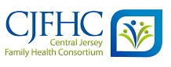
HUNTERDON COUNTY RESOURCE UPDATES DUE TO COVID-19

September 1, 2021

We are updating resources on a monthly basis, please refer to the date above to ensure information is up to date or visit our website at www.cjfhc.org and click on ‘County Resource Updates during COVID-19’.

- COVID-19 Related Resources
- Testing
- Vaccines
- Funeral Expenses
- Food Resources
- Food Banks/meals
- WIC
- NJSNAP (Food Stamps)
- Utility Assistance
- Housing/Shelter
- Health Care Services
- Health Care Coverage Enrollment
- Charity Care
- Mental Health & Addiction Services
- Health Services

- Women & Maternal Health
- Prenatal Support
- Mom Support Groups
- Breastfeeding Support
- Doula Services
- Breast & Cancer Screenings
- Early Childhood Services (0-5 years of age)
- Child Development
- School Readiness
- Childcare
- Free Diapers
- Children/Youth Activities
- Family Community Events
- Legal Services
- Domestic Violence
- Job Skills & Education
- Information & Assistance
- General

COVID TESTING AND RELATED INFORMATION SPECIFIC TO THE COUNTY
COVID-19 Testing - How do I get tested?
If you are exhibiting symptoms of COVID-19 these are your options for testing:
- Call your primary care provider for an assessment or advice.
- If you do not have a primary care provider, please call Hunterdon Healthcare’s Physician Referral Service at 1-800-511-4462.
https://covid19.nj.gov/pages/testing#test-sites

Joint Hunterdon County – Hunterdon Medical Group (HMG) Assessment and Testing Site. Call 908-237-4230 to make an appointent: https://co.hunterdon.nj.us/Coronavirus/testingsite.html

Facility | City | County | Minimum Age | Phone for appointment and questions | Facility Website
CVS Pharmacy | Flemington | Hunterdon | 18 years old | (800) 746-7287 | cvs.com/immunizations/covid-19-vaccine
Hunterdon County Health Department | Hunterdon County HazMat Building 314 State Route 12 County Complex Flemington | Hunterdon | 18 years |  | co.hunterdon.nj.us/Coronavirus/clinics.html
Hunterdon Family Medicine at Cornerstone | 9100 Wescott Drive, Suite 103  Flemington | Hunterdon | 18 years | (908) 237-4238
Hunterdon Family Medicine at Highlands | 61 Frontage Road Hampton | Hunterdon | 18 years | (908) 237-4238 | hunterdonhealthcare.org
Hunterdon Family Medicine at Delaware Valley | 200 Frenchtown Road Milford | Hunterdon | 18 years | (908) 237-4238 | hunterdonhealthcare.org
Hunterdon Family Medicine at Hickory Run | 384 County Road 513 Califon | Hunterdon | 18 years | (908) 832-2125 | hunterdonhealthcare.org
Hunterdon Family Practice and OB | 1100 Wescott Drive  Flemington | Hunterdon | 18 years | (908) 237-4238
Hunterdon Family Medicine at Phillips Barber | 72 Alexander Avenue  Lambertville | Hunterdon | 18 years | (908) 237-4238
Hunterdon Family Medicine at Riverfield - Clinton | 1738 Route 31 North, Suite 203  Clinton | Hunterdon | 18 years | (908) 237-4238
Hunterdon Healthcare POD | 2100 Wescott Drive Flemington | Hunterdon | 18 years | (908) 237-4238 | hunterdonhealthcare.org
ShopRite Pharmacy #457 | 272 Highway 202 & Route 31N  Flemington | Hunterdon | 18 years |  | vaccines.shoprite.com
ShopRite Pharmacy #497 | 50 Walmart Plaza  Clinton | Hunterdon | 18 years |  | vaccines.shoprite.com

Information about COVID-19 in New Jersey and COVID-19 Information Hub
(800) 962-1253; https://covid19.nj.gov/

Hunterdon Healthcare’s COVID-19 Community Hotline
908-788-6440
Helps triage and navigate patients to their primary care provider or a designated Respiratory Illness office for further assessment and testing.

Hunterdon Healthcare Urgent Care – Flemington Urgent Care Clinic
63 Church St., Flemington, NJ 08822. (908) 237-4036. Open: 8AM-8PM
We strongly recommend you to call the clinic ahead of the time to schedule and verify that they still do COVID-19 testing. Supplies may be limited. https://carbonhealth.com/coronavirus/covid-19-testing-centers/New-Jersey

Hunterdon Urgent Care – Raritan Urgent Care Clinic
45 Route 206, Raritan, NJ 08869 (908) 237-4122
We strongly recommend you to call the clinic ahead of the time to schedule and verify that they still do COVID-19 testing. Supplies may be limited. https://carbonhealth.com/coronavirus/covid-19-testing-centers/New-Jersey

Walmart Drive-thru testing site
152 NJ-31 N, Flemington, NJ 08822. Questions about testing and appointments, call Quest's COVID-19 line at 866-448-7719 open Monday, Wednesday and Friday from 7 to 9 a.m.
All locations are open weather-permitting; there will be no testing inside Walmart stores.
Testing for adults who meet CDC and state/local guidelines on who should be tested, including first responders, health care providers, and others with symptoms of COVID-19, and those in high-risk groups without symptoms. Appointment required. Appointments can be made online at www.MyQuestCOVIDTest.com. At the time of the appointment, residents will wait in their vehicle and wear a mask.
https://whyy.org/articles/quest-diagnostics-and-walmart-offer-drive-thru-covid-19-testing-in-n-j/

County Vaccination Program Public Health Nurses
Contact Francia Reyes at 908-806-4548

https://findahealthcenter.hrsa.gov/
Enter your zip code to find a free Coronavirus testing center. Go there for free screening and treatment
If you test positive, you will be isolated for 14 days.

Where to get vaccinated?
For COVID-19 Vaccination centers, please visit https://co.hunterdon.nj.us/Coronavirus/clinics.html

FEMA’s IA Program supports funeral expenses due to Covid-19. Application process had already started.
- FEMA will be accepting applications starting Monday, April 12th. To apply individuals must call 844-684-6333. TTY: 800-462-7585. Hours of operation are Monday-Friday, 8 a.m. to 8 p.m. Central Time
- The FEMA website has been updated to include this information, plus the policy and FAQ docs: https://www.fema.gov/…/coronavi…/economic/funeral-assistance
- Supporting documentation will be sent in via fax, mail or uploaded via https://www.disasterassistance.gov/

Back to Top
FOOD PANTRIES/ SUMMER MEALS/NUTRITION EDUCATION

Free Summer Meals for Kids
https://www.frsd.k12.nj.us/cms/lib/NJ01001104/Centricity/Domain/64/Summer%20Meals.pdf
Flemington Area Food Pantry
- Delivery from food pantry -Until further notice … The Flemington Area Food Pantry has instituted a drive-thru service - with optional ONLINE ordering during our normal business hours.
- Online Ordering link - https://flemingtonfoodpantry.org/order (Available also in Spanish)
- A volunteer will greet you at your car to take your order. You will receive the same amount of food and you will select your meat, produce, personal items, eggs and yogurt.
- Clients will NOT need to enter the pantry.
- Open Monday-Thursday 9-11:30, every other Wednesday night from 5:30-8:00 on- Sep/16
- And every other Saturday morning from 9:30-11:30 on- Sep/19

Address: 154 Route 31 North Flemington, NJ Located across the parking lot from the front of the Flemington WalMart.
Telephone-(908) 788-5568
Link- http://flemingtonfoodpantry.org/
ALSO PROVIDES DIAPERS

The Pantry is open from 5:30pm – 8:00pm on the following WEDNESDAY
Note: The Pantry is now open the third Tuesday of each month FOR SENIORS ONLY. 12pm - 3:30pm.
YMCA Food Distribution
- On Saturdays 10:30 am; At the Flemington Baptist Church, 170 Main St., Flemington. Held In the parking lot or basement.
- Every other Monday at 10:00 am at the Evangel Chapel, 55 Leigh Street, Clinton.
- Every other Monday at 10:00 am at the Rockaway Reformed Church, 115 Main St., Whitehouse Station.
For more information contact Gabriela Bonnavent, 908-892-7369.

Fisherman’s Mark Food Pantry
37 South Main Street. Hibernia Firehouse, Lambertville, NJ 08530. (609) 397-0194
Mon/Wed/Fri: 10-12 noon; Tues & Thurs: 3-5pm. Closed the last Wednesday of every month. No proof of income required during these times – For All Hunterdon County Residents.Case management appointments by phone only (help with utilities, housing and resources).

Salvation Army Flemington - The Father's Table Community Meal and Soup Kitchen
40 E Main St, FLEMINGTON, NJ. (908) 237-9008
Friday community meal is served as a delivery on a limited basis, families can sign up https://www.facebook.com/183924187196/posts/10157002539727197/?d=n.
Important: Sign up needs to be done before Fridays.
You can also contact Adam Boynton, Lieutenant at adam.boynton@use.salvationarmy.org

The Salvation Army. Summer Meals for Kids
40 E Main St, FLEMINGTON, NJ. (908) 237-9008
Start Date: 7/7/2020. End Date: 8/27/2020. Days of Operation: Tuesday, Wednesday, Thursday.
Lunch Time: 1:00 p.m.-2:00 p.m.
Open Cupboard Food Pantry
37 Old Highway 22, Clinton, NJ 08809 between I-78 and Rte 31, Rite-Aid Shopping Center next to the A&P.
(908) 730-7320
The Pantry is open to give and receive food, 9:00 am- 12:00 pm Tuesday through Saturday and Thursday and Friday evenings from 4:30-7pm

Delaware Valley Food Pantry
1 Cherry Street #1, Lambertville NJ 08530. 609-638-7888
Remains open on Wednesdays from 2pm to 4 pm and Saturdays from 10 am to noon.
SPANISH - Sigue abierto los Miércoles de 2pm a 4pm y Sábados de 10am a 12pm medio día

Frenchtown Presbyterian Church
22 4th Street, Frenchtown, NJ 08825. 908.996. 2227
Mondays 10-10:30am.

Readington Area Starfish
390 Main Street Route 523, Whitehouse Station, NJ 08889. 908-534-0974
Provides food for local Readington Township residents. If interested in referring anyone in the area, email name and contact information to Christine Dey @ ss@readingtontwp-nj.org. Proof of residency is required.

The Village Pantry at Presbyterian Church of Milford
70 Bridge Street, Milford, NJ. 908-507-3943
Remains open, individuals can come in, one person at a time. Pantry is open for everyone.
Can also call Jody Leffler ahead to order and she’ll put it together for pick up
Hours of Operation: Sundays: 11:30am to 1:30pm; Tuesdays: 6pm to 8pm; Thursdays: 6pm to 8pm

WIC Program (Women, Infant, Children): The New Jersey Supplemental Nutrition Program for Women Infants and Children is commonly known as WIC. WIC is a successful public health nutrition program that provides wholesome food, nutrition education and community support for income eligible women who are pregnant and post-partum, infants and children up to five years old. Call for appointment 908-454-1210 or click here

Supplemental Nutritional Assistance Program (NJSNAP)
Hunterdon County Department of Human Services. Community Services Building. 6 Gauntt Place - PO Box 2900, Flemington, New Jersey 08822
908-788-1300;
County residents who wish to apply for SNAP food assistance, or cash assistance under the Work First New Jersey program can do so online at NJHelps.org. Social Services can conduct interviews by phone

NJ SNAP Food Assistance flyer
https://nj.gov/humanservices/library/slides/SNAP-CVgeneric_v4.pdf

Jewish Family Services can provide emergency food assistance. Please call 908-725-7799

Hunterdon County Department of Human Services. Community Services Building. 6 Gauntt Place - PO Box 2900, Flemington, New Jersey 08822
908-788-1300;
County residents who wish to apply for SNAP food assistance, or cash assistance under the Work First New Jersey program can do so online at NJHelps.org. Social Services can conduct interviews by phone

NJ SNAP Food Assistance flyer

NUTRITION EDUCATION PROGRAMS

ShopRite Dietitian Program- Providing complimentary nutrition services to customers and the community.

ShopRite Dietitians
ShopRite’s complimentary dietitian service, now in its 11th year, offers one-on-one nutritional counseling for customers looking to find ways to eat better, discover new recipes, or manage a specific diet due to a health concern
Shoprite Flemington
272 Rt 202 & 31, Flemington NJ,08822
(908) 782 – 2553
Dietitian: S. LangSaponara
Susan.LangSaponara@wakefern.com

Back to Top

UTILITY ASSISTANCE
The moratorium on utility shutoffs is expected to end on June 30th

According to PSE&G: "Qualified customers can make a Deferred Payment Arrangement (DPA) with no money down and extended time to pay off their balance. A customer can select a DPA to pay their balance over a 12-, 18- or 24-month period. To make a Deferred Payment Arrangement, log in to My Account or call 800-357-2262."
Low Income Assistance Programs
- Low Income Home Energy Assistance Program (LIHEAP) or 800-510-3102
- Universal Service Fund (USF) or 800-510-3102
Moderate Income Assistance Programs
- Payment Assistance Gas and Electric (PAGE) or 855-465-8783
- NJ SHARES (NJS) or 866-NJSHARES (657-4273)
Senior/Disabled Adult Assistance Programs
- New Jersey Lifeline or 800-792-9745
For assistance with the application, contact Norwescap at 908-782-0612

Board of Social Services Emergency Assistance
rovides emergency assistance to prevent homelessness for recipients of WFNJ/TANF/GA and SSI.
Benefits include, but are not limited to:
- Shelter and household furnishings
- Temporary rental assistance or housing costs
- Utility payments (such as heat, water, and electric)
- Moving expenses (security or first month rent)
- Rapid rehousing for TANF recipients
6 Gauntt Pl, Flemington NJ
6 Gauntt Pl Bldg 2
Flemington, NJ 08822

HOUSING

Board of Social Services. 6 Gauntt Pl Bldg. 2, Flemington NJ 08822

Central Jersey Housing Resource Center Central Jersey Housing Resource Center Corp. (CJHRC) is known helping clients achieve their housing and financial goals by providing information, resources and referral services.
Affordable housing Guide click here

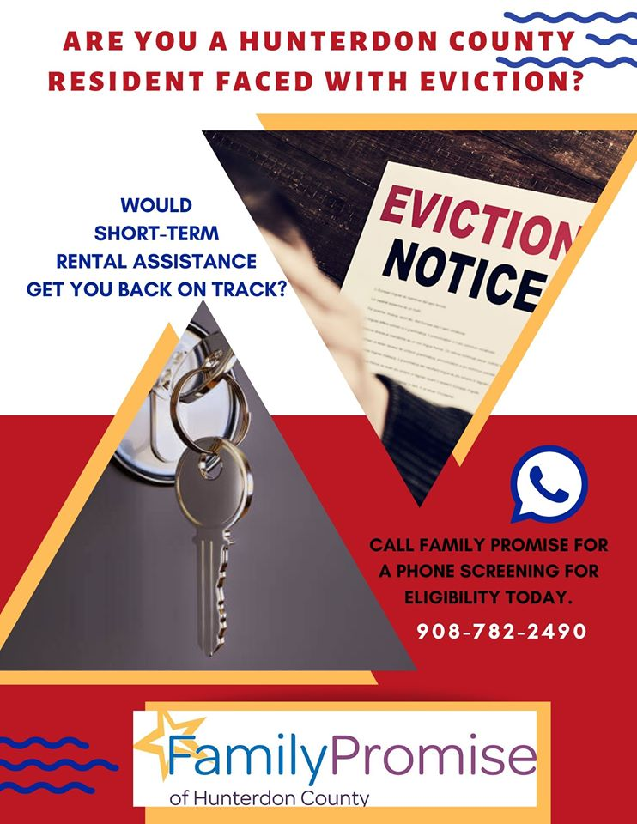
Emergency Housing- 211

NORWESCAP Homeless Prevention Program
908-454-7000 x 118 housing@norwescap.org
Provides rental and housing temporary short-term assistance to household who face imminent loss of housing by eviction.

Family Promise of Hunterdon County Inc. Our Homeless Prevention Program is dependent upon available funding and fairly strict criteria, per HUD guidelines. This program is designed to help residents maintain their existing housing when they are facing eviction due to an unexpected emergency expense. Eligible clients are less than 3 months in arrears with their rent, proven to be due to a large unavoidable expense. Clients are screened for eligibility and then we work directly with landlords to bring them current on their rent. This is intended to be a one-time program for county residents who can sustain their current rent and designed to prevent them from ever becoming homeless. Funding for this program is limited and clients must meet eligibility criteria. If you are interested in finding out more, please contact our office at 908-782-2490.
SHELTERS
Emergency Shelters https://www.nj211.org/resource-search/taxonomy/BH-1800/hunterdon/1
For a list of shelters in and around Hunterdon County

Family Promise of Hunterdon County Inc. Our shelter is made up of an inter-denominational network of 15 host and 31 support congregations and over 1,000 community volunteers who provide: shelter, meals, security, companionship and respect for homeless families and individuals. This is not a religious organization; rather it is a program that takes advantage of under-utilized space at houses of worship. Our professional staff helps families resolve their homelessness, each weekday from 7 am–5 pm at the day shelter in Flemington. At the end of the weekday, and on weekends, our families go “home” via the Link public transportation to one of our host congregations. At the shelter sites, volunteers welcome the families with a home-cooked meal every night, served with love. It is, at its core, a highly successful program of neighbors helping neighbors. Above all, it is a program, not just shelter, in that guests work with a case manager to: develop a case plan, find opportunities for education/employment, and commit to long-term goals to help themselves work out of poverty and the conditions that led to their homelessness.
If you are in need of shelter services, please contact our office at (908) 782-2490
Back to Top

HEALTH CARE COVERAGE
- New Jersey Hospital Association (NJAH) for personal assistance navigating all healthcare coverage including market place, Medicaid, Medicare and charity care, contact NJHA Navigator Tahirih Gomez-Smith. 609-608-2337. Tgomez-smith@njha.com
Hospital Assistance (Charity Care)
Charity Care You may be able to get financial assistance if you do not have insurance, are underinsured, or if it would be a financial hardship to pay in full the expected out of pocket expenses for eligible services at Hunterdon Medical Center.
Hunterdon Medical Center. 2100 Wescott Dr, Flemington, NJ 08822. Please call 908-788-6194
MENTAL HEALTH

Family Promise of Hunterdon County Inc. The Mental Health Program provides innovative and comprehensive mental health support services to a growing client population, who are either homeless or in danger of becoming homeless. This program is intended to support our clients while they regain housing stability, integrate back into the community at large and enjoy a rich and loving family experience.
The program is a diverse system of mental health services- delivered directly to our clients in our shelter program and may continue once they have exited the shelter, to ensure housing permanency. It is through efforts like this that we are able to ensure that over 90% of our clients maintain their permanent housing status.

Jewish Family Service - Jewish Family Service is a NJ State licensed community mental health outpatient provider. Our experienced, compassionate professional staff in our Counseling Center provides individuals, couples, child, family and group therapy (Monday – Friday by appointment).
Our Counseling Center doors are open to the whole community. Services are provided on a sliding fee scale and payment arrangements can be made to accommodate all budgets. We also accept third party insurance. For more information or to schedule an appointment, please contact Jerry Starr at jstarr@jewishfamilysvc.org or 908-725-7799 x104.

Catholic Charities - Catholic Charities, Diocese of Metuchen provides short-term, outpatient counseling and treatment to individuals, families, and couples who may be impacted by depression, anxiety, the loss of a loved one, parenting difficulties, child behavior problems and other common life stressors. To be eligible, there must be diagnosis of a mental health and/or behavioral health disorder.
Flemington Service Center
6 Park Ave
Flemington
Phone: 908-782-7905
Fax: 908-782-5934
Kwenyan & Associates. We do have immediate openings for tele-therapy and tele-psychiatry services (video or phone sessions) and would be honored to support you during this time of national emergency. Call in today and speak with one of our compassionate and professional Staff! https://www.kwenyanandassociates.net/
200 Main Street
Flemington, NJ 08822

Phone: (908) 237-3826
(908) 237-3827
(908) 237-3828

NJ Hope and Healing Healing Crisis Counseling Program with MHANJ
The program offers free emotional support for anyone who lives in New Jersey. Given the major effect that COVID-19 can have on a person’s mental health, this is a program to offer to folks in New Jersey at no cost.
- 866-202-HELP (4357), multilingual; or text NJHOPE to 51684
- Facebook: https://www.facebook.com/gomohealth/posts/1317607411778062
- Twitter: https://twitter.com/gomohealth/status/1272884280331587585
- LinkedIn: https://www.linkedin.com/posts/gomo-health_announcing-the-new-jersey-hope-and-healing-activity-6678706691112095744-usOK
- Instagram: https://www.instagram.com/p/CBf2rArnFtn/

Family Support Organization- Family Support Organization of Hunterdon, Somerset and Warren (FSO) – ensures that families of children with special emotional, behavioral or mental health challenges are provided with a compassionate, community-based, culturally-competent system of care that will provide family-friendly support services, education and advocacy. Offers parenting classes and support groups. –
Visit - Hunterdon County, New Jersey - Department of Human Services

COPING WITH STRESS
· New Jersey's Mental Health Hotline at 877-294-HELP (4357) or visit njmentalhealthcares.org for emotional support, guidance, and mental health referrals as needed. You also may call the SAMHSA Disaster Distress
Helpline at 1-800-985-5990 or text TalkWithUs to 66746 (TTY 1-800-846-8517).
NJ Children’s System of Care
24 hrs/7days a week: 1-877-652-7624
Provides assistance with: Behavioral Health, Intellectual/Developmental Disability Services, Substance Use Treatment: https://www.performcarenj.org/index.aspx

- Alcohol/Substance Addiction Services
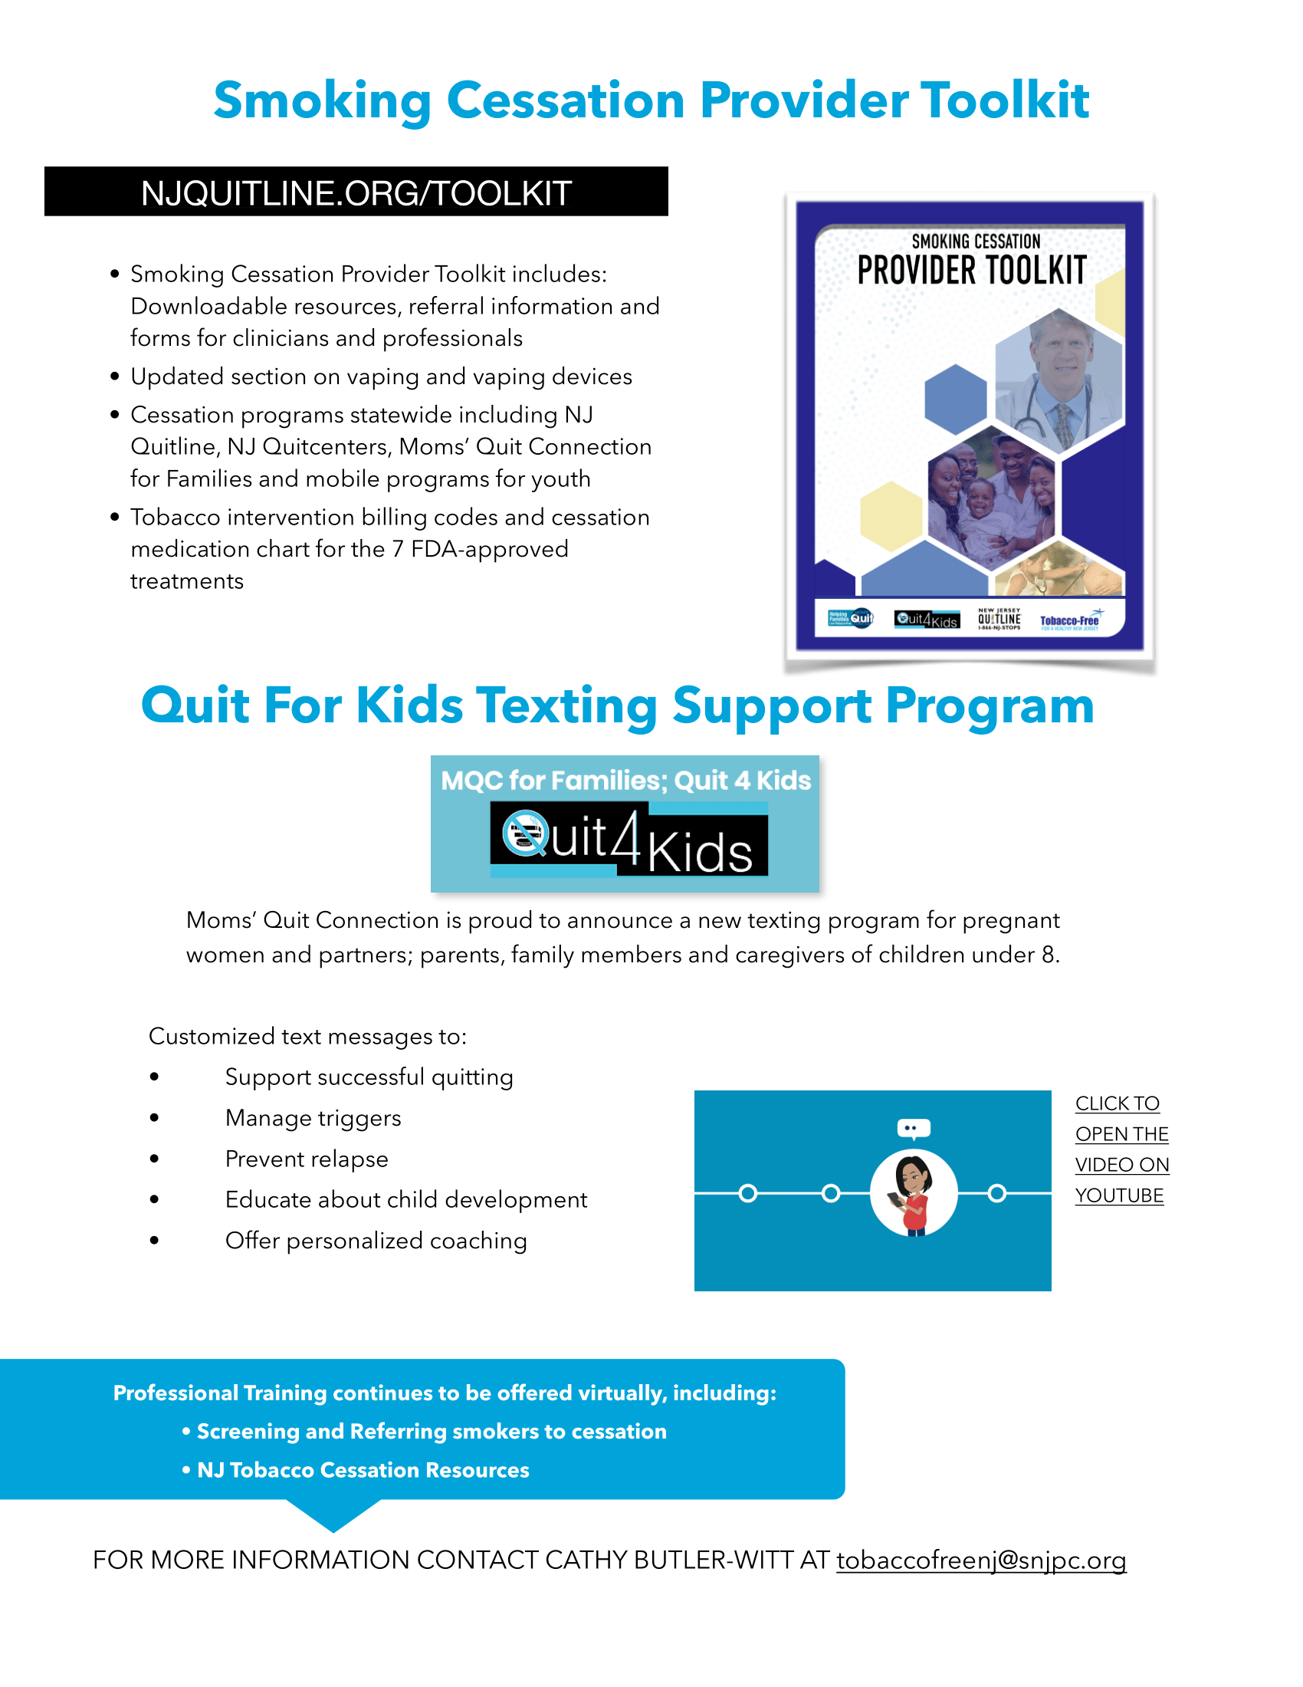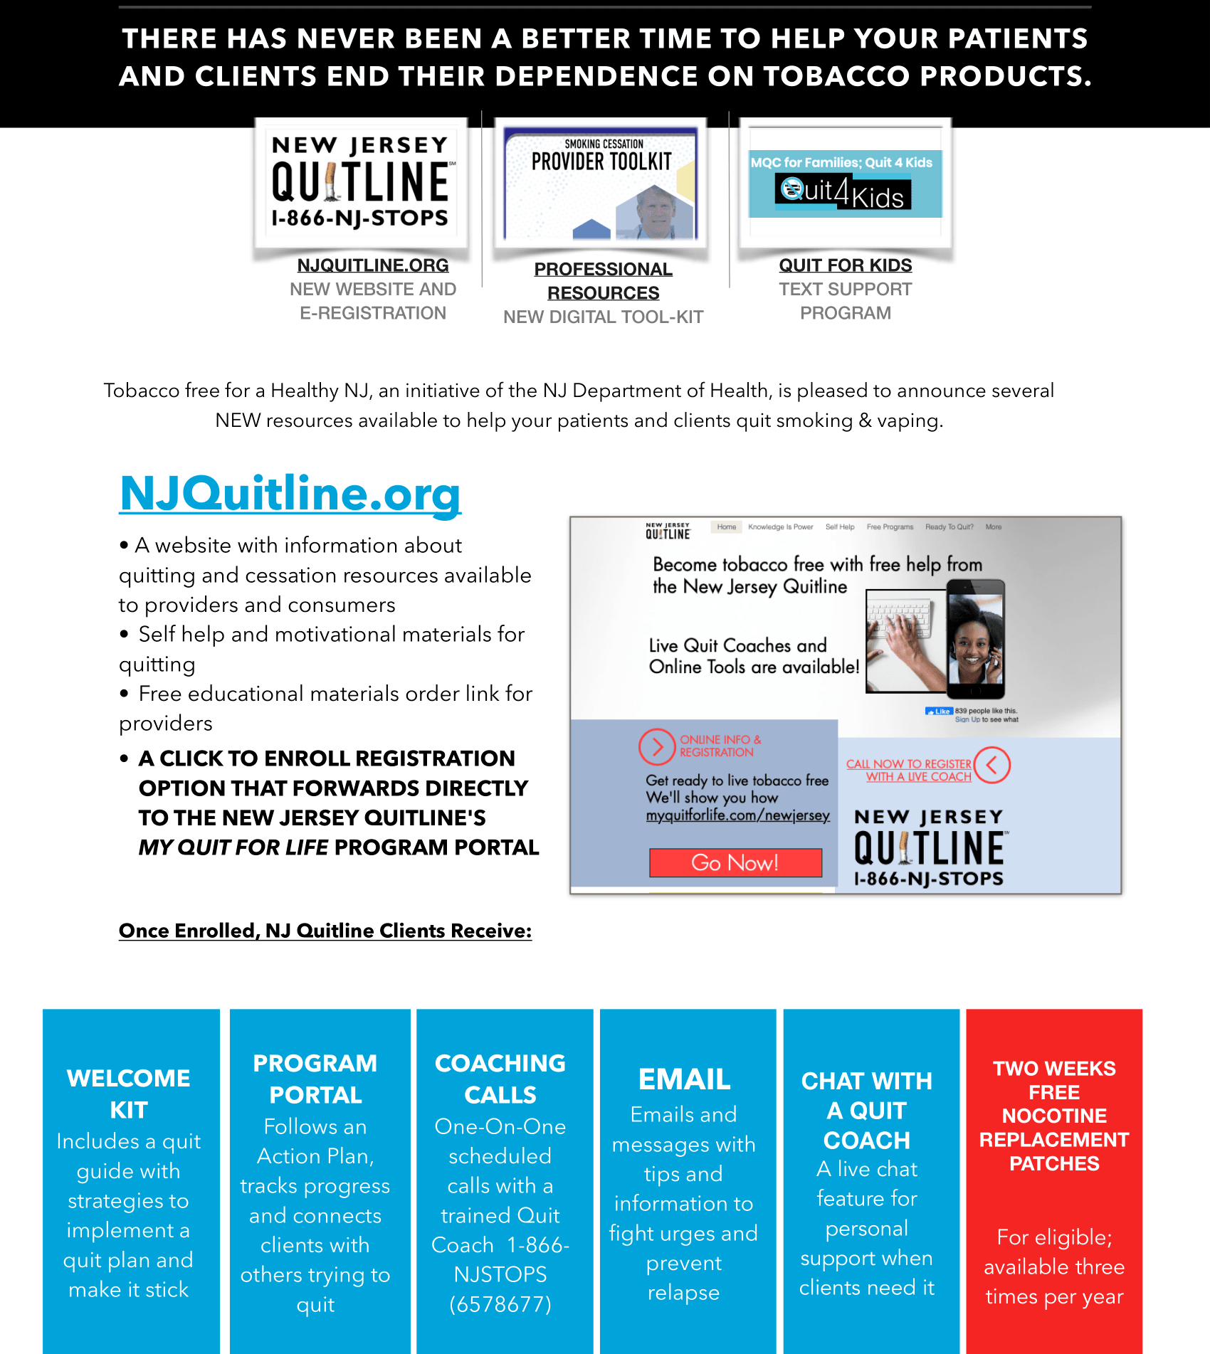

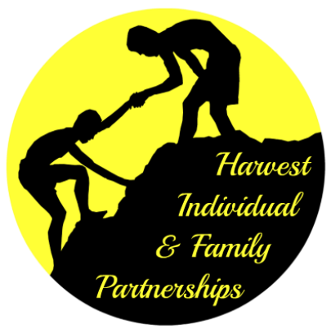

Families can schedule an appointment with one of our Family Partners to discuss personal matters in a safe, private, and confidential space. Partners serve as life coaches and advocates, guiding you through even the most difficult times. Topics with which they help include, but are not limited to:

- Family Health
- Employment Related
- Housing Related
- Financial Assistance
- Mental Health Services
- Legal Assistance
- Substance Abuse
- Child Care
- Food / Clothing
- Transportation
- Home Maintenance/ Repair
- Domestic Abuse
- Parenting Concerns
- Family Communication Issues
- Monday-Friday
- in Flemington during regular business hours

- Every Tuesday 9 a.m
at Frenchtown Presbyterian Church with Penni Trionfo

- With Carmel Gettings
At St. Ann's Catholic Church in Hampton. (Times/Dates TBD for Fall 2018)

Please Note:
• Partners dedicate 45 minutes solely to your case
• Appointments must be scheduled in advance with a family partner
• Sessions can be one time, or on-going on a weekly basis, indefinitely
• Please note, due to high demand of partnerships, if you arrive late, family partner reserves right to cancel meeting. Otherwise, time will be deducted from the 45-minute session

To reach a Family Partner Contact the office, or e-mail:
- Carmel Gettings – Director & Family Partner — cgettings@njprevent.com
- Claudia Roose – Bilingual Family Partner — croose@njprevent.com
- Nicholas Marcantuono – Family Partner — nmarcantuono@njprevent.com
- Penni Trionfo – Development, Volunteer & Resource Coordinator — ptrionfo@njprevent.com

HEALTH SERVICES
Cancer Education & Cancer Screening
Hunterdon County Cancer Education and Early Detection Program offers cancer screening to individuals who are uninsured, underinsured, who don’t have Medicaid or Medicare. Income and age restrictions may apply.
Breast Cancer
Cervical Cancer
Colorectal Cancer for both men and women
Prostate Cancer
For more information, or to see if you are eligible, please call 908-237-5409

Childhood Vaccine Program To support and encourage childhood immunizations, the Hunterdon County division of Public Health Nursing collaborates with Hunterdon Healthcare system to provide vaccinations to children of families who meet certain guidelines. Your child may be eligible for this county-funded program if:
- Your child is not qualified of currently enrolled in NJ Family Care or Medicaid; OR
- Your family is without health insurance; OR
- You have health insurance that does not cover childhood immunizations; AND
- You live in Hunterdon County and meet the income eligibility guidelines.
Access brochure information here. Contact Public Health Nursing: 908-806-4570

Dental Services
Zufall Healthy Smile Center provides preventive care dental for adults & children.
361 Route 31 Bldg. C Suite 701
Flemington, NJ 08822
Tel: 908-968-4440

Hunterdon County Department of Health – Lead Poisoning Screeenings
Prevent childhood lead poisoning by providing education and information on lead poisoning prevention methods to caregivers and medical providers.

Back to Top

WOMEN & MATERNAL HEALTH

Hunterdon County Department of Health Public Health Nursing: Improved Pregnancy Outcome Program
Provides referral, counseling and education to at risk women who reside in Hunterdon County. The primary goal is to help ensure a healthy outcome for mother and child, by coordinating the delivery of essential prenatal care.
Locating funds to pay for pregnancy
- Referral to prenatal care
- Nutrition Education
- Prenatal and postpartum education
- Newborn education
- Parenting education
- Education provided, plus referrals when needed for:
  - Healthy Living
  - Smoking Cessation
  - Community resources
Call 908-806-4548

Hunterdon County Nurse Family Partnership, a maternal and early childhood health program, fosters long-term success for first time moms and their children. a voluntary prevention program that provides nurse home visitation services to low-income pregnant women who are expecting their first child. Nurses begin home visits early in the mother's pregnancy and continue visitation until the child's second birthday. Nurses provide support, education and counseling on health, behavioral and self-sufficiency issues. Participants learn about pregnancy, nutrition, labor and delivery, healthy pregnancies and more. Nurses offer the support pregnant women need to have a healthy pregnancy, become knowledgeable and responsible parents, and provide their babies with the best possible start in life. The relationship between mother and nurse provides the foundation for strong families.
For more information about the Nurse-Family Partnership® Program at Project Self-Sufficiency of Sussex County, register online, or call 973-940-3500 or 844-807-3500. You can also call Central Intake for referral 1-888-551-6217

Early Head Start This program helps you: ♥ Prepare for the successful birth of your baby ♥ Enrich your child’s development through early learning ♥ Learn how to provide your child with a healthy and safe learning environment ♥ Reach family goals for success and independence ♥ Build confidence while learning more about yourself and your community.
For more information please contact Early Head Start directly at 908-824-2525

Healthy Families – TIP of Warren and Hunterdon Counties Provides early intervention and family support services, helping expectant and new mothers build strong, healthy relationships with their babies through in-home visits. Family Support Workers offer support and guide clients in getting community services like housing, education, childcare, and job training. Parents can receive voluntary and free help with learning about child developmental changes. Contact Central Intake for referral 1-888-551-6217

Parenting & Childbirth Education Classes Hunterdon Medical Center is offering a combination of virtual and in-person classes. A virtual tour of the Maternity and Newborn Care Center is available on this website for your convenience. For more information, please call Felice Lewaine at (908) 788-MOMS (6667).
Mom Support Groups
- Central Jersey Family Health Consortium
Pregnant and new moms with babies under one year-
Virtual Groups:
English: Tuesdays & Thursdays- 1:00 pm
Spanish Wednesdays- 1:00 pm
For registration in English email pvena@cjfhc.org
Para registrarse en Español envie un email a mflores@cjfhc.org

Breastfeeding Support
CJFHC Virtual Support For Breastfeeding Families
- Do you have questions about feeding your baby? Need support during this challenging time? We can help! Email breastfeedingsupport@cjfhc.org to register for an individual session or support group.
- Appointment-based, 1-on-1 individualized (or tailored) breastfeeding sessions with an IBCLC Lactation Consultant
- Virtual Support Groups: Tuesday 10am • Thursday 1pm
- Facilitated by Yosefa Lebeau, MD, IBCLC
Doula Services in Hunterdon
Hayley Weichler
Compassionate Beginnings Doula & Birth Services
www.doulanjpa.com
908-797-6268
doula@doulanjpa.com

I offer the following services:
Birth Doula Support
Childbirth Educator
Infant Massage Educator - will be training in let April
Hospitals that she supports:
- Hunterdon Medical Center
- Morristown Medical Center
- Capital Health - Hopewell, RWJ University Hospital
- Somerset, St. Peter’s University Hospital
- Summit Overlook
Back to Top
Cancer Screening Services for Women
Hunterdon County Cancer Education & Early Detection Program - offers cancer screening to individuals who are uninsured, underinsured, who don’t have Medicaid or Medicare. Income and age restrictions may apply.
Breast Cancer
Cervical Cancer
Colorectal Cancer for both men and women
For more information, or to see if you are eligible, please call 908-237-5409

EARLY CHILDHOOD SERVICES (0-5 YEARS OLD)

Developmental Milestones

Ages & Stages Questionnaire (ASQ-3) www.asqhunterdon.org free online screening tool to help you keep track of and learn about your child's development. For children 2 months – 5 years of age. Within a few days after we receive your completed ASQ-3, we will contact you to share the results and offer follow-up activities and resources.
Early Intervention (0-3 years) If you suspect that an infant or toddler may be experiencing developmental delays, contact Early Intervention System at 888-653-4463. The call is toll-free for New Jersey residents.

Hunterdon Healthcare Child Development Center Children and adolescents who have difficulties learning, developmental delays or other special needs are provided with skilled and comprehensive diagnostic testing and treatment designed to meet their individual needs.

190 Route 31, Suite 500
Flemington, NJ 08822
Phone: (908) 788-6396
Fax: (908) 788-6581
School Readiness

Early Head Start & Head Start Programs
Our Head Start/Early Head Start program promotes School Readiness for children in low-income families by providing comprehensive educational, health, nutritional, and social services. Serves pregnant women and families with children ages 0-5. Option for Home or Center based instruction. Contact Norwescap at 908-284-4757.

CHILDCARE

Hunterdon County YMCA Contact us now to learn more about the Child Learning Center and schedule a tour. Or call 908.236.0055 x 4605, email ksmith@hcymca.org.
Childcare Brochure can be accessed here
Child Care Resource and Referral

Norwescap Child and Family Resource Services (CFRS) empowers families and the community through enhancing the quality and accessibility of early education and by providing information and resources to community services
Childcare Subsidy
To expand access to high-quality childcare and early childhood education programs for low-income families, Norwescap CFRS administers Federal, State and private funds to subsidize childcare expenses for Hunterdon Sussex and Warren Counties. To access Childcare Subsidy application click here
- TANF (Temporary Assistance for Needy Families) Childcare Subsidy
  - Eligibility is determined by County Social Services
- NJCK (New Jersey Cares for Kids) Childcare Subsidy
  - Eligibility is based on state income guidelines and includes activity requirement:
    - Working 30 hours per week; or
    - Taking 12 college credits; or
    - Attending 20 hours per week training or technical school; or
    - Combination of the above to equal full-time participation
    - (Alternate requirements for families experiencing homelessness)
- Possible County and/or alternate funding

Back to Top

Diaper Bank Information
  - UNITED WAY Volunteer Center
CP: Amy Andersen
20 Fulper Rd
Flemington NJ 08822
908-237-1689 amy@uwhunterdon.org
Amy sends monthly email, CI picks diapers up
  - FRIENDSHIP FOR A NEW BEGINNING
- in St Flemington NJ 08822
908-806-4444

  - FLEMINTON FOOD PANTRY
CP. Jeaninne Gorman
154 Rte. 31, Flemington, NJ 08822
908-788-5568
jgorman@flemingtonfoodpantry.org
In addition to food, diapers are provided

  - HARVEST FAMILY SUCCESS CENTER
5 East Main Street, Flemington NJ 08822
908-237-0465

Back to Top

CHILDREN & YOUTH ACTIVITIES/RESOURCES
Harvest Family Success Center offers various programs for children and teens:
- Agnes Dewitt Girl Scout Camp
- Eagle, Silver, Gold Program
- First Lego League, Jr.
- Girl Scouts
- Girls Night IN
- Homework Club
- STEM Robotics
- Summer Day Camps
- Toddler time
Contact Family Success Center at 908-237-0465

Child Abuse and Neglect Support Services
  - DCP&P (Child Protection and Permanency)
CP: Christine Baxevane
84 Park Ave Flemington NJ 08822
877 NJABUSE 908-782-8784
Christine.Baxevane@dcf.nj.gov, (908) 782-8784 ext. 125

Back to Top
FAMILY & COMMUNITY EVENTS
.

Family Activities
Family Support Organization of Hunterdon, Somerset & Warren
FSO Link- https://www.facebook.com/FSOofHSW/
https://fso-hsw.org/
The Family Support Organization of Hunterdon, Somerset and Warren Counties’ mission is to ensure that children with special emotional and behavioral challenges and their families are provided with a community-based, compassionate and culturally competent support system that will provide them with ongoing family oriented support, information, education and advocacy. September is Hispanic Heritage Month.

For assistance with registering for a workshop, webinar or support group please contact INFO@fso-hsw.org OR Call:908-223-1191

https://fso-hsw.org/wp-content/uploads/2021/08/Outreach-Calendar4.jpg
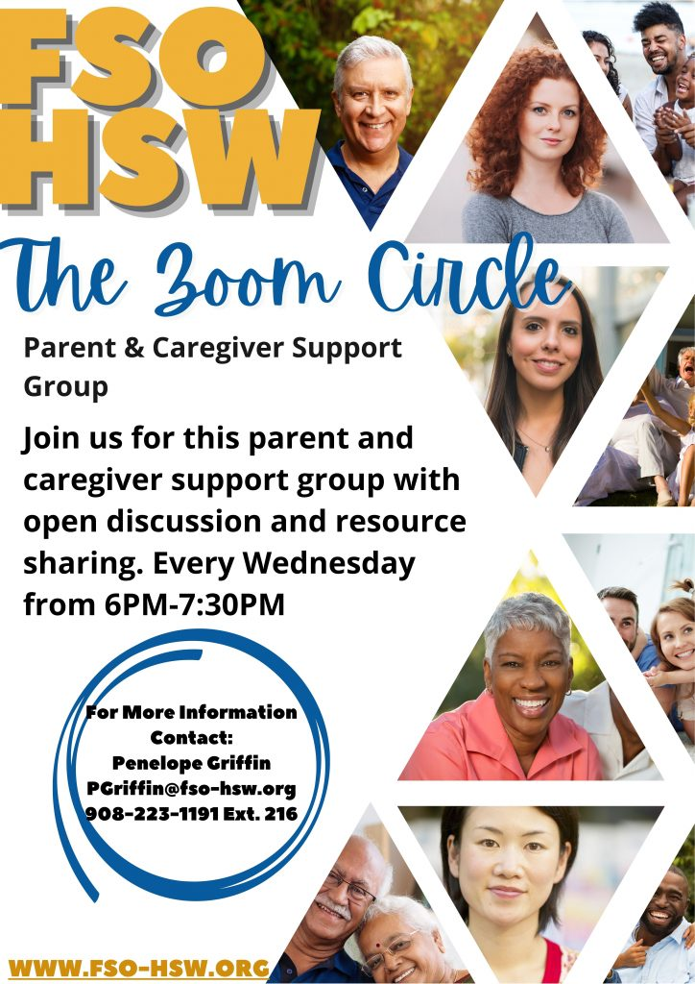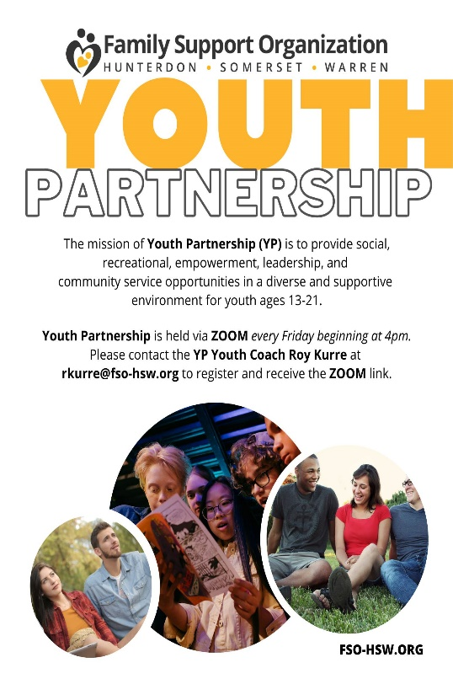

Watch from home
HUNTERDON COUNTY
PARKS & RECREATION JULY PROGRAMS. To access all programs click here
FREE DRIVE IN MOVIES - SEPTEMBER 4TH & 18TH

Back To Top
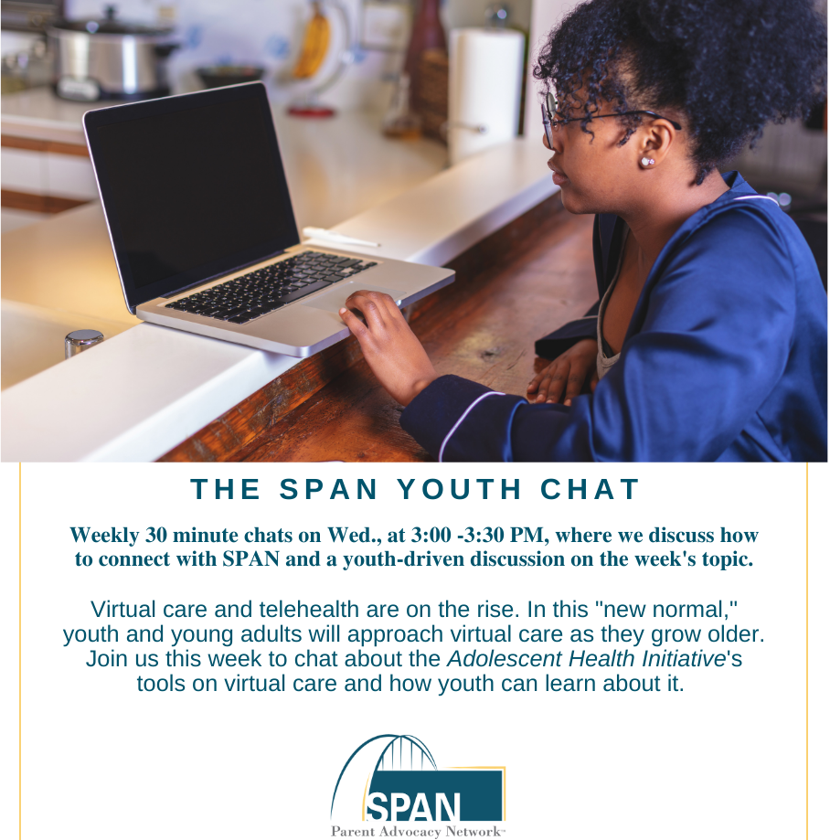

SPAN Parent Advocacy
SPAN Virtual Leadership Conference and Parent Advocacy 2021. There are a limited number of scholarships for leading parents available. As the conference is held virtually, scholars will be invited to register at no cost. Fill out the short scholarship application here. The date to submit the application is April 30, 2021. link to the app: https://app.smartsheet.com/b/form/40d639d16f6f448591f4f20a12ffe316

Back to Top

LEGAL SERVICES

Legal Services of New Jersey
Provides advice, information and referrals to low-income people in civil matters. Apply online or call our Toll free statewide Legal Hotline 1-888-LSNJ-LAW

Catholic Charities
The Immigration Services Program of Catholic Charities, Diocese of Metuchen provides low-cost, immigration legal services on common immigration matters. We have program offices in Perth Amboy, New Brunswick, and Phillipsburg, New Jersey. Please call to set up an appointment or visit our website for more information: (732) 214-8743

Harvest Family Success Center “ASK THE LAWYER”. A professional attorney provides free consultation to families in need. Please call 908-237-0465

Immigration Community Outreach is able to offer low cost legal consults. Please call 908-520-5001.

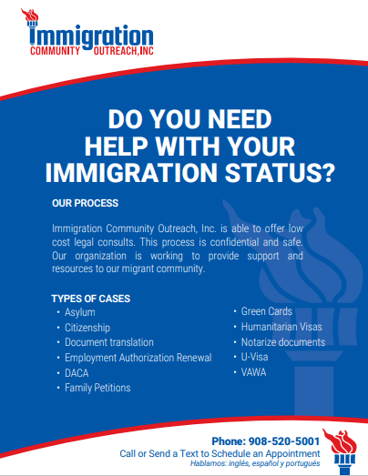

Back to Top
Domestic Violence and Intimate Partner Violence Support Services
  - SAFE in Hunterdon
49 E Main St
Flemington NJ 08822
908-788-7666 1-888-908-4033
Safe and transitional housing, legal advocacy, crisis intervention, individual on groups counseling, community education and children art therapy

Job Skills Training

Greater Raritan One-stop Career Center The Career Center is providing career services to the public. Staff has been in the office since mid-July on a rotating basis and fully staffed Oct 5th. The Business Representatives remain remote but are providing services to employers and job seekers. They and staff from the Workforce Development Board are sending out job leads to thousands of job seekers a week in a project that began back in March and continues today. For more information contact us at 908-541-5780 or text onestop to 56512 for weekly updates

Hunterdon County Polytech Career & Technical HCVSD offers students the opportunity to receive highly focused training in a career and technical field of their choice. Several of our career major programs afford students the option to earn stackable industry-based credentials and participate in structured learning experiences/internships directly related to their career major.

Unemployment Office
- For news and updates, visit https://myunemployment.nj.gov/ or call:
- North Jersey: (201) 601-4100; Central Jersey: (732) 761-2020; South Jersey: (856) 507-2340

ESL Classes

Harvest Family Success Center. Classes taught by an RVCC Professor of Spanish. Call 908-237-0465

ESL, GED Classes, Basic Computer Skills
Hunterdon County Educational Services Commission: 200 Main St. Flemington NJ. 908-237-500. Se habla español

Back to Top

Information & Assistance

Family Promise of Hunterdon’s Neighbors in Need Fund Neighbors in Need is an invaluable case management tool that allows us to assist Family Promise of Hunterdon clients who are in the shelter or recently exited from the shelter with expenses. This fund gives us the flexibility to respond to urgent needs for our clients that typically include: car repair, application fees, moving expenses, food, insurance, and miscellaneous emergency needs.
Phone: 908.782.2490
Fax: 908.782.4685
email: info@familypromisehc.org

New Jersey 211
www.211.org
call 2-1-1
877-652-1148
Hunterdon Helpline
800-272-4630
908-782-4357

Hunterdon County Department of Human Services –Division of Social Services
Community Services Building
6 Gauntt Place - PO Box 2900
Flemington, New Jersey 08822-2900
908-788-1300

Central Jersey Family Health Consortium – Central Intake Family Connections
888-551-6217

Back to Top

GENERAL ASSISTANCE PROGRAMS & OTHER RESOURCES

Emergency Broadband Assistance
The Emergency Broadband Benefit will provide a discount of up to $50 per month towards broadband service for eligible households and up to $75 per month for households on qualifying Tribal lands. Eligible households can also receive a one-time discount of up to $100 to purchase a laptop, desktop computer, or tablet from participating providers if they contribute more than $10 and less than $50 toward the purchase price. To apply visit: Emergency Broadband Benefit | Federal Communications Commission (fcc.gov)

Child Tax Credit –Who gets it and when? https://www.youtube.com/watch?v=KMe3q9N5UHY
Small Business Grants
REGISTER NOW: Pre-Registration Reopening for NJEDA Small Business Grants
The New Jersey Economic Development Authority (NJEDA) has reopened applications for grants for small businesses, including child care providers, impacted by the COVID-19 pandemic through Phase 4 of the Small Business Emergency Assistance Grant Program. This round of funding will provide grants up to $20,000 to small and medium sized businesses and non-profits that have been negatively impacted by COVID-19.
Click here to learn more about Phase 4 grants.
In order to apply for a grant, you must pre-register between Wednesday, May 26th at 9:00 a.m. and Wednesday, June 30th at 5:00 p.m. Interested business owners who did not SUBMIT a pre-registration in April need to pre-register at programs.njeda.com.
Business owners who submitted a pre-registration in April, but did not apply, do not need to pre-register again. Pre-registration IS NOT first come, first served, but businesses are encouraged to begin the process as early as possible. BUSINESSES THAT DO NOT PRE-REGISTER WILL NOT BE ELIGIBLE TO APPLY FOR PHASE 4 GRANTS.
Click here to pre-register.
Applications will become available in July, following the pre-registration period. Pre-registration and the application will be available in English and Spanish. The NJEDA is also offering interpretation services to support speakers of ten additional languages: Arabic, Chinese (Mandarin and Cantonese), Gujarati, Hindi, Italian, Korean, Polish, Portuguese, and Tagalog.
Questions? Please call 844-965-1125
Back to Top

