

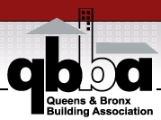

Join the

The Queens & Bronx Building Association

At our

Annual Holiday & Building Awards Gala
Honoring our
Associate of the Year
Chad Lerner of
Mike the Glazier
On

Saturday, December 11, 2021

6:00pm – 11:00pm

At
Marina del Rey
One Marina Drive
Throgs Neck, NY 10465
MUST SHOW PROOF OF COVID VACCINATION*



Annual Holiday & Building Awards Gala
Reservation Form

Saturday, December 11, 2021

Please reserve ____tickets at $250.00 per person (member)
Please reserve ____tickets at $275.00 per person (Non-member)

Please reserve____table(s) of ten at $2500.00 per table.
(Tables of ten automatically include QBBA Holiday and Building Awards Gala Sponsorship)
Please reserve____table(s) of ten at $2750.00 per table. (Non-Member)

Name: _____________________________________________
Company: _____________________________________
Phone:____________________Fax:____________________
Email Address: __________________________________________
Guest Name(s): __________________________________________
Company: ______________________________________________
Phone:_________________________Fax:____________________
Email Address: __________________________________________

RSVP NO LATER THAN Monday, December 8, 2021
Please make checks payable to:
Queens & Bronx Building Association
16-66 Bell Blvd, #745
Bayside, NY 11360
Phone: 718-428-3369
Fax: 718-428-3494
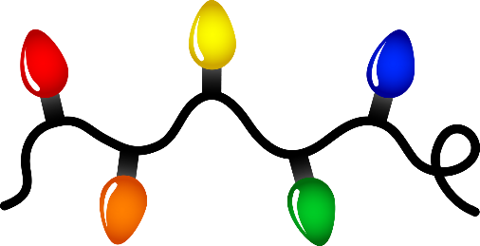
Reservations are necessary!
Annual Holiday & Building Awards Gala
Sponsorship Contract
THE QBBA NEEDS YOUR SUPPORT!

The undersigned agrees to participate as a “Sponsor” at the Queens & Bronx Building Association’s Annual Holiday & Building Awards Gala
**Please attach a check with your signed contract**
**Deadline for Sponsorship is December 8, 2021**
⁮ Yes, I would like to “Sponsor” the Holiday and Building Awards Gala. Enclosed is my check for $300.00
⁮ Yes, I would like a “Table Sponsor” enclosed is my check for $150.00. Email Logo to june@queensbronxba.com
Name: ________________________________________________
Company: ______________________________________________
Signature: ______________________________________________
Phone: _________________________Fax:____________________
Email Address: __________________________________________
All Sponsors will have their company names prominently displayed on the night of the event.

THANK YOU IN ADVANCE FOR YOUR KINDNESS & SUPPORT
Please make checks payable to:
Queens & Bronx Building Association
16-66 Bell Blvd., #745
Bayside, NY 11360
Phone: 718-428-3369
Fax: 718-428-3494
Payment Attached ⁭ Please Charge my ⁭Amex Visa ⁭ MasterCard
Name on Card _____________________ Card #_______________________
Expiration Date _______ V-Code # ______ Signature_________________ Date_______
Address of Card Holder-____________________________Zipcode- ________________

