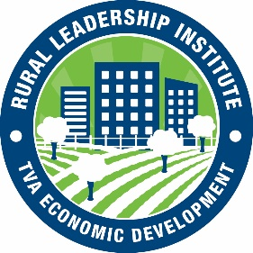
Local Economic Development Professional Graduate of
TVA’s Professional Rural Leadership Institute

UNION CITY, Tenn – Lauren Tanner, Membership Director of the Obion County Chamber of Commerce recently graduated from TVA’s Rural Leadership Institute. The Rural Leadership Institute, developed and sponsored by TVA Economic Development, provides professional leadership training to rural community economic development professionals in the TVA service area.
The institute is designed to help local participants more effectively lead volunteers, partner organizations, businesses, elected officials and citizens to ensure long-term success.
Four two-day sessions were conducted by leading area experts. The training included focused skills development in the following major areas:

- Foundations of Leadership
- Organizational and Individual Effectiveness
- Effectively Telling the Story of Your Community
- Outclassing the Competition

“Rural America’s ability to compete, gain jobs, and attract economic investments depends on local leaders being prepared, having product available, and using effective leadership and communication skills to differentiate their community’s unique strengths,” said TVA Senior Vice President of Economic Development John Bradley.

A total of 27 participants completed the course and received graduation certificates. Recent leadership graduate, Lauren Tanner, Membership Director of the Obion County Chamber of Commerce said, “It was an honor to be selected to participate in this year’s Rural Leadership Institute. Having been through institute, I feel better equipped to convey Obion County’s strengths and stories to individuals, small businesses, and manufacturers that are looking at making Obion County their permanent home.”

Based on the success and responses from this and previous classes, TVA Economic Development is planning future institutes. Rural community economic development professionals located in the TVA region will receive an application if interested in applying for future leadership classes.
The Tennessee Valley Authority (TVA) a corporation owned by the U.S. government provides electricity for business customers and distribution utilities that serve 9 million people in seven southeastern states. Economic development is a major part of TVA’s core mission. TVA’s Economic Development services are focused on attracting targeted new industries, retaining and growing existing businesses and partnering with communities to help foster economic growth. More information is available at TVA.com.
# # #

