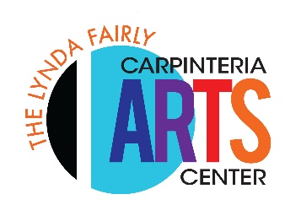
Application to Teach at the Carpinteria Arts Center

The Carpinteria Arts Center is pleased to offer a variety of arts education programs for children and adults. We work with professional artists and instructors to present one-day and multi-day workshops and ongoing weekly classes. We have multiple spaces, both indoor and outdoor, in which to teach. Our contracted teachers receive 65% of the class registration fees; the Carpinteria Arts Center receives 35% to cover our expenses, including insurance, site and facilities maintenance, utilities, taxes, staffing, marketing, publications, website, social media, and more. Our goal is to host programs that provide revenue for working artists while not causing undue financial burden to the Carpinteria Arts Center. With that in mind, we are most interested in working with artists and teachers who have a track record of successful teaching and who are willing and able to market their own programs to complement the promotional marketing done in house.

Instructor Name:
Address:
Phone: Email:
Website:
Proposed workshop or class title:
Proposal for One-time workshop Series of classes
Day/Dates/Time: (for example, 4 Mondays, April 13 – May 4, 3:30 – 5:00 PM)

Minimum and Maximum Number of students_______ to_______
Please note that Carpinteria Arts Center might require a higher minimum for your class to be financially viable.
Check all ages that you would like to include (teachers of children under 18 must get fingerprinted)

- Preschool
- Elementary
- Teens
- Adult
- All ages
- Parent/child

Cost per student (or parent/child pair): $_____________________ (The CAC will add 10% for non-members)
Program description:

Describe your experience and qualifications, including other venues or institutions where you have taught:

Do you maintain an active contact list of your past class or workshop participants? If so, how many people are on your contact list? Do you communicate with them on a regular basis? Do you have repeat or regular ongoing students?

Are there any special requirements for your class? Please explain.

How will promote your workshop to fill your class?

Additional Information:
- Teachers offering programs for students under the age of 18 will need to be fingerprinted and have a background check. Carpinteria Arts Center will pay for this.
- Instructor (or student) is responsible for all material costs.
- CAC will provide site, publicity, and insurance.
- Instructors are expected to promote their own classes via email, social media, traditional media, personal mailing lists, newsletters, and word of mouth.
- Please include a jpg of an example of your work with your proposal.
- Carpinteria Arts Center receives 35% of the tuition income from all programs.

Please submit your completed program proposal and/or any questions you may have to Janey Cohen, our volunteer program proposal coordinator, janeycohen@gmail.com.

