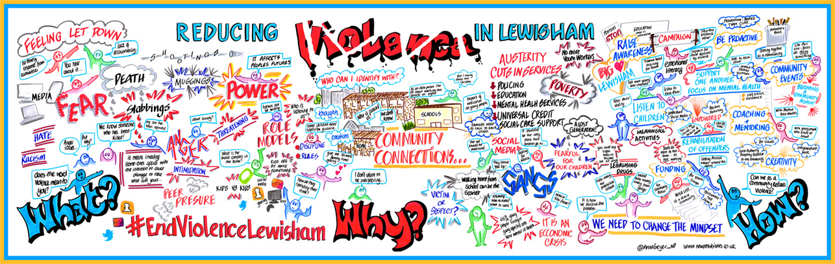  Take the first step towards strengthening the Hayes community!  - Would you like to have a say on how £15,000 of public budgets are spent?  - Build on your existing skills and develop new ones?  - Have fun and meet other people in your neighbourhood?  The last year has been really tough on all of us during the COVID19 pandemic. We have seen the value of community and how people have supported each other through the crisis. We’ve also seen how we need to work more closely together to build stronger communities as we come out of lockdown. So here is an opportunity for you to do something a bit different – go on give it a try…  Last year, the Hayes Together Stays Together planning group delivered a World Café event were the community were able to come along and have a collective conversation on community safety in Hayes! We are now ready to begin the next stage of the process, a Participatory Budgeting (PB) Programme.  PB is a decision-making tool, where you, the community can influence how public budgets are spent. Community groups and residents are able to bid into a pot of money, and the wider community are able to vote for their preferred projects.  It’s a democratic process that relies on members of the community making key decisions, shaping the programme, and playing a leading role in it’s delivery.  .  Come along and find out more, we will be holding an(online) briefing session about the project, and will be sharing information about how you can get involved.  You can get further information by emailing or ringing the contact details shown opposite. | We are looking for key individuals, organisations and partners who are committed to making a difference in Hayes  ────  Take the first step to being part of this exciting programme to find new solutions for the community, and improve the area!  ────  If interested, please contact us using the details below!  Contact us at:  antigua@mutualgain.org  020 3887 2859  www.mutualgain.org

This programme has been funded by the Metropolitan police, who are working with MutualGain. MutualGain are specialists in community involvement and supporting local people to develop their ideas into community led projects by working together.
We are looking for local people from Hayes who want to make change to do things differently, and have the willingness to make things happen!
What we can offer:
• Support to build new networks to develop your ideas for your community and to work alongside others.
• Learn about new ways of working with the local community and influence where community funding is spent.
• Enhance your skill set to make the change that you want to see in Knowle West.
The programme starts with an initial group of residents, and a few local workers, who will receive training by MutualGain about how to organise a different type of community meeting called a World Café. We will work alongside you to plan, organise, facilitate and deliver a World Café which leads into other activities in your community.
You can get involved by attending the briefing session on the 8th of December, or by contacting antigua@mutualgain.org .
You are invited to a Zoom meeting.
When: Dec 8, 2021 05:30 PM London
Register in advance for this meeting:
https://mutualgain.zoom.us/meeting/register/tJwld--hrzktGdXNgY5L_yjUQX9UkdAJS2bs
After registering, you will receive a confirmation email containing information about joining the meeting.

