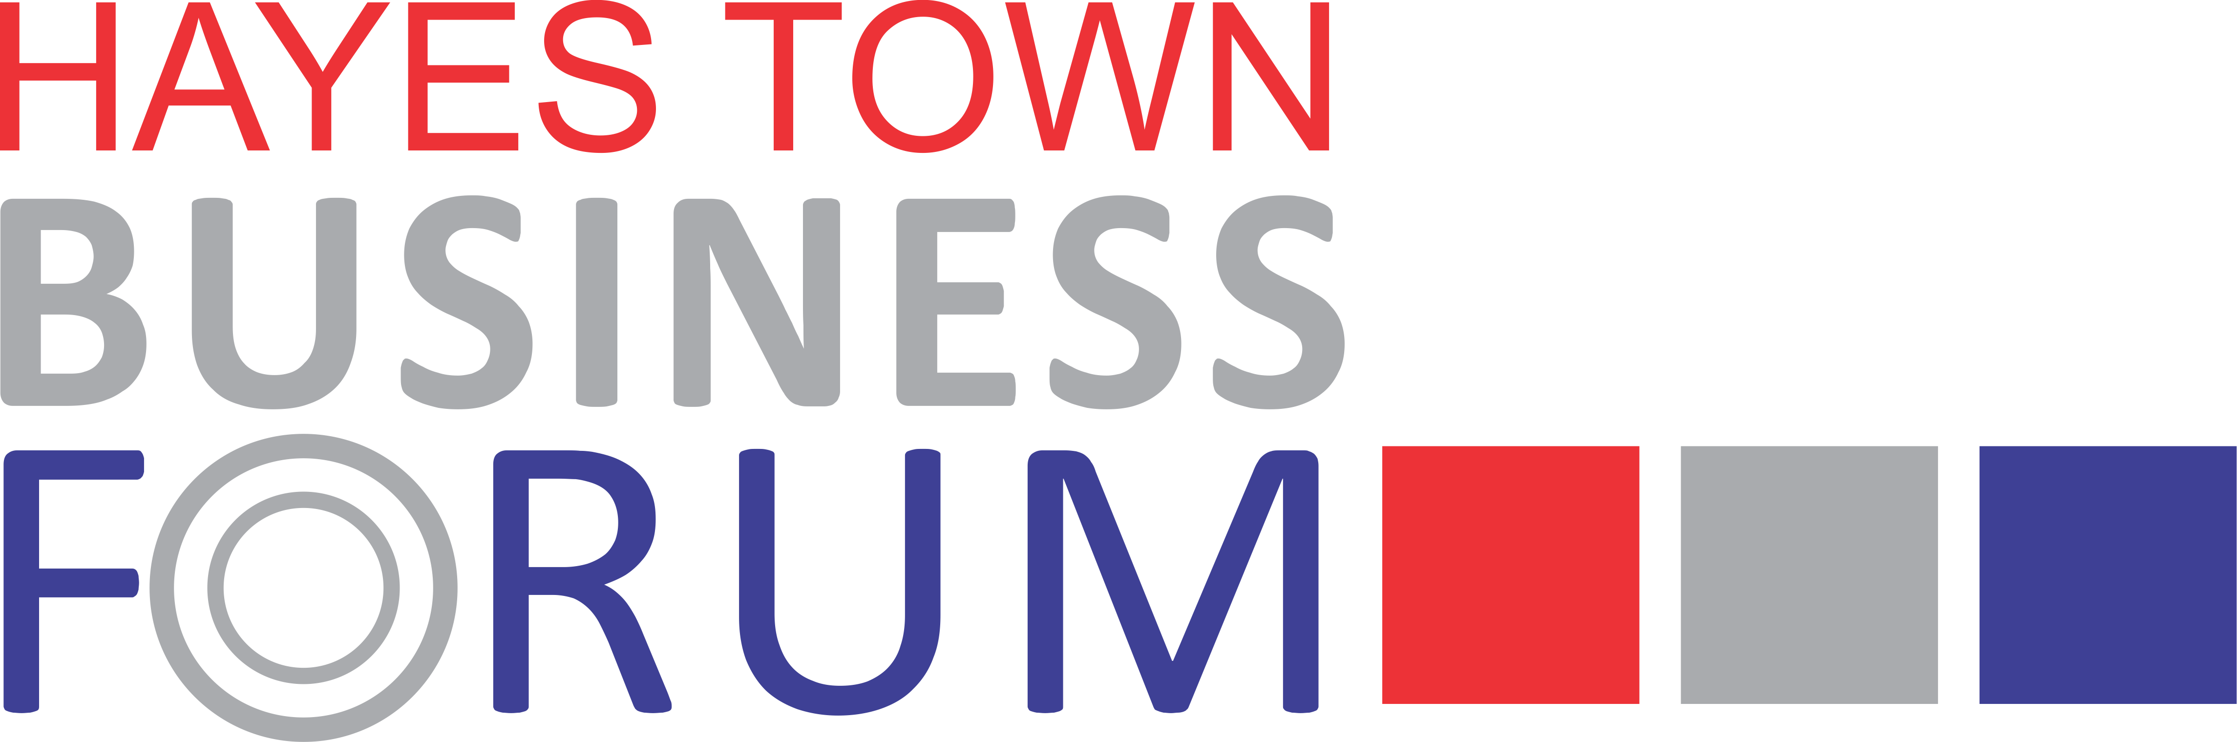

REOPENING YOUR PREMISES ON 12 APRIL

TOP TIPS ON WHAT YOU NEED TO DO

The Government has confirmed that non-essential shops, hairdressers, nail bars, cafés, restaurants and pubs can reopen from Monday 12 April.

REOPENING SAFELY

It is not just a question of opening the doors. You have a legal duty to make sure your premises are safe and there are things you have to do first. If you need advice please study the Government’s revised guidance which you can get from the internet as follows:

Close contact services (hairdressers, nail bars)

Close contact services - Working safely during coronavirus (COVID-19) - Guidance - GOV.UK (www.gov.uk)

Cafés, restaurants, pubs and takeaways

Restaurants, pubs, bars and takeaway services - Working safely during coronavirus (COVID-19) - Guidance - GOV.UK (www.gov.uk)

Shops

https://www.gov.uk/guidance/working-safely-during-coronavirus-covid-19/shops-and-branches

ENSURING SAFETY STANDARDS ARE MAINTAINED

Although the number of infections has fallen Hillingdon is still one of the Boroughs with the highest figures in London. To avoid the risk of yet another lockdown it is important to maintain strict standards on wearing of face-coverings, social distancing between customers and regular hand-washing by staff. Please do all you can to help.

COUNCIL INSPECTIONS

The Council will be sending Inspectors to make sure that all requirements are being met. If an Abatement Notice or Prohibition Notice is served on you and it is ignored the Courts can impose a fine of up to £20,000.

RE-START GRANTS

The Government is providing money for Councils to pay Restart Grants to businesses that will be reopening from 12 April. They will be a one-off grant for those that pay Business Rates and there will be two strands as follows:

Strand 1 Non-essential retail premises

- Rateable value up to £15000 – grant of £2667
- RV between £15000 and £51000 - £4000
- RV over £51000 - £6000.

Strand 2 – Hospitality, accommodation, leisure, personal care and gym businesses

- Rateable value up to £15000 – grant of £8000
- RV between £15000 and £51000 - £12000
- RV over £51000 - £18000

Not all businesses are eligible and the Government’s list needs to be studied to see if your business will benefit or if it is excluded.

Councils will be required to obtain more details on businesses than for previous grants and it is not yet clear whether fresh applications will be required.

This is a link to the Government guidance to local Councils https://assets.publishing.service.gov.uk/government/uploads/system/uploads/attachment_data/file/971363/restart-grant-la-guidance.pdf

The Government is also giving Councils more money to extend the Additional Restrictions Grants which include provision for businesses that do not pay direct Business Rates. The sums that will be given are not yet available.

HAYES TOWN BUSINESS FORUM

This leaflet has been produced by the Hayes Town Partnership and the Hayes Town Business Forum for the benefit of all businesses in the Town Centre.

Membership of the Business Forum is open to all businesses in Hayes Town and there are currently over 60 members. This gives them a voice with the Council.

Members receive regular updates on all matters relating to the coronavirus pandemic including grants and the Forum represents members in individual cases. There is an annual fee of £30 to meet running costs. To join the Forum send an email to the Chairman, Mr A S Puar, at puarpropertiesa@gmail.com

