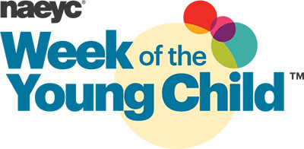
April 8- 15th
Help us celebrate the WEEK OF THE YOUNG CHILD by volunteering your talents!
MUSIC MONDAY: Do you play a musical instrument? Or love to sing?
Share some music with the classrooms!

TASTY TUESDAY: Love to cook? Have a great child friendly recipe?
Come cook with the kiddos!

WORK TOGETHER WEDNESDAY: Do you have any building blocks or materials that could be used for building to donate or let us borrow?
Please bring them in! We will be doing all kinds of building in the gym!

ARTSY THURSDAY: Do you have art supplies you are not using? Do you want to join the class while they paint and sculpt?
Visit our art displays outside each classroom!

FAMILY FRIDAY: Have a few minutes to read a book to the class? Want to join the class for breakfast or lunch?
Please send in family pictures for your child to share!

** If you are able to volunteer for any of the above days, please let us know at the front desk! 15 minutes or a couple of hours, we would love to have you!
Thank you in advance!!

