Getting Started

Your “golden ticket” to Teaching Strategies GOLD® online arrives in an e-mail invitation.

Here is how you can accept the invitation and set up your account:

You will receive an e-mail invitation. When you receive this email, click the Web site link in the body of the message, which will take you to the Accept this Invitation screen:
Please see the invitation email below:
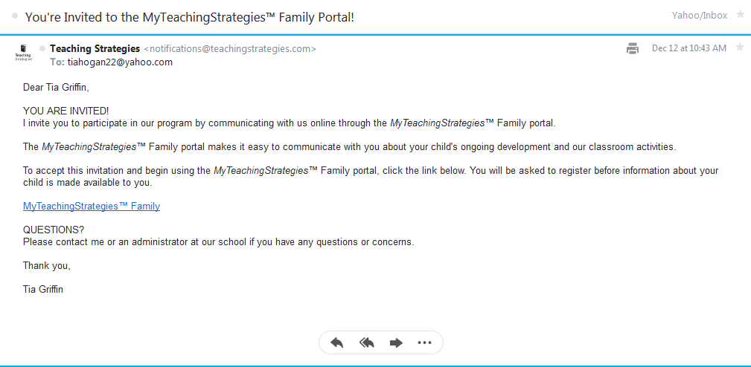

You will then see this screen appear next. Please click the link that reads "Sign Up" to register for a new account.

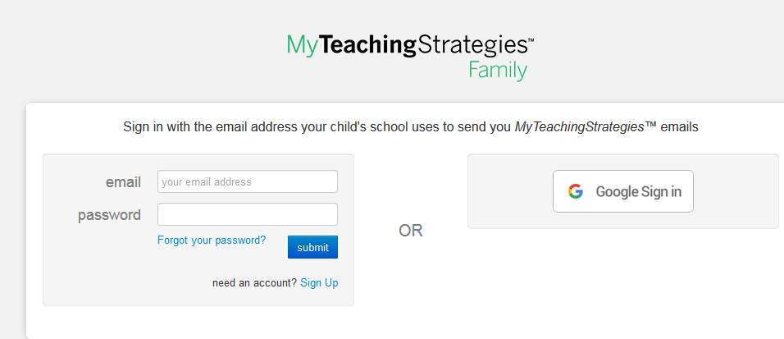

Please enter your e-mail in the next screen that appears as shown below.

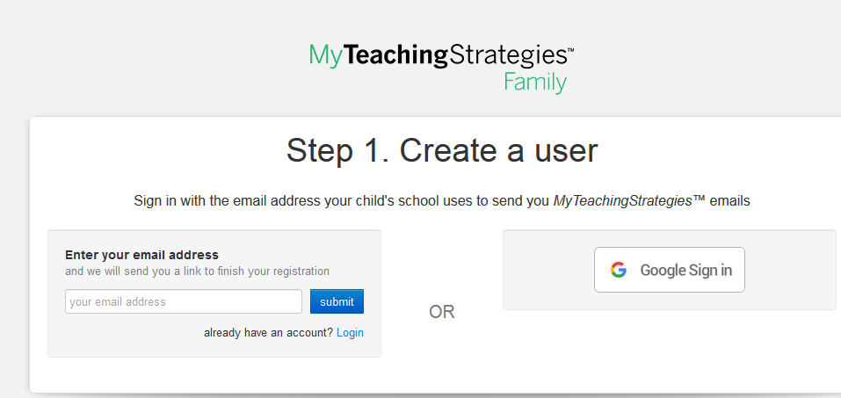

Next, please check your e-mail, as you will soon be sent a message such as the one below to complete the registration process.

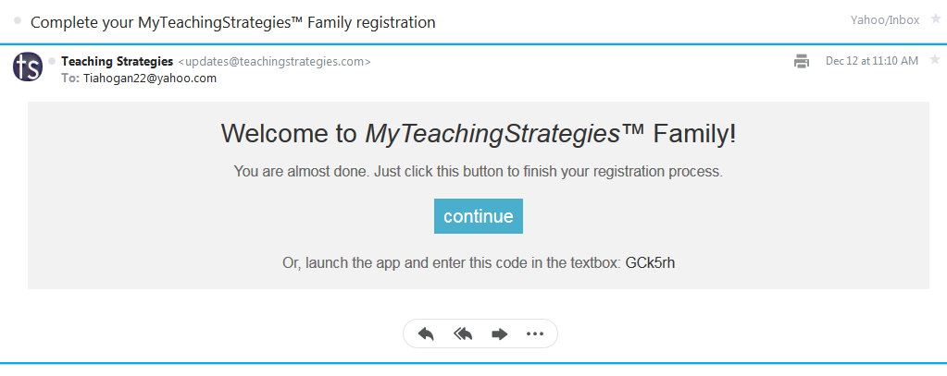

Please click "continue" and sign in with your newly created id and password. You will automatically be directed to your child's documentation home page.

This is what you should see!

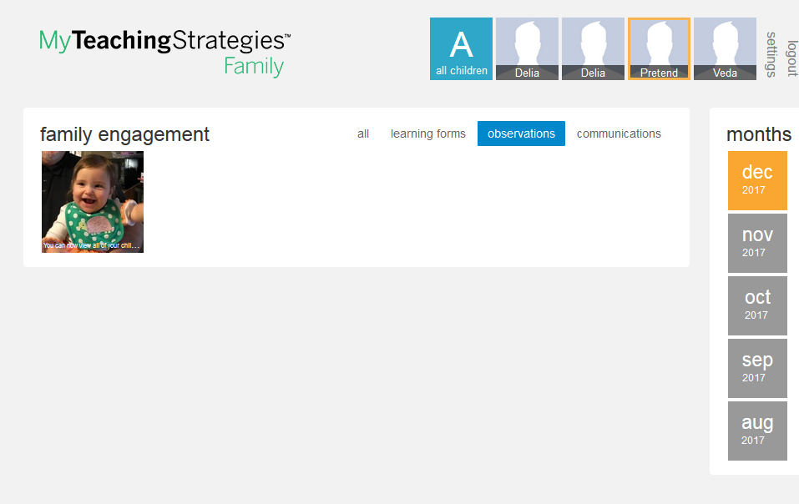

When you click on the documentation picture the captions and notes will display.

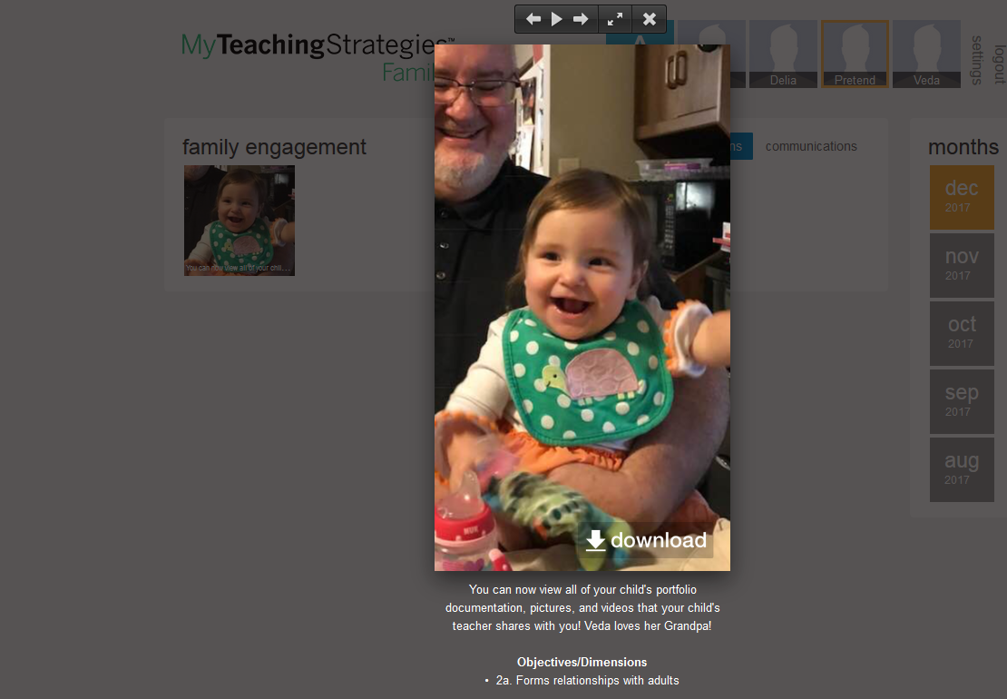

Thus far, we will only be using the "Observations" feature to share assessments, documentation, notes, pictures, and videos. As we learn to use more features of the program, we will introduce them to you as we go!

It is our hope that you are as excited about using Teaching Strategies Gold Online as much as we are!

If you should have any questions, please see a member of the KKLC Leadership team at the front desk.
Enjoy your upcoming connection with your child's classroom. We look forward to sharing many future experiences with you and your family!

Sincerely,

Katie's Kids Learning Center

