Inventory Order Form Instructions

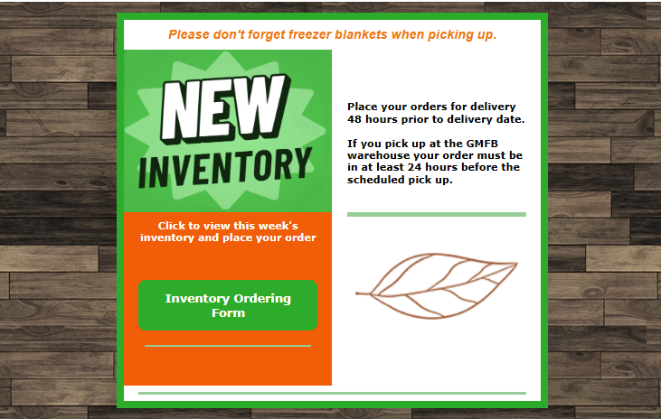
- You will receive an email on Friday morning at 8:00 a.m. through Constant Contact, which will look like the one above.

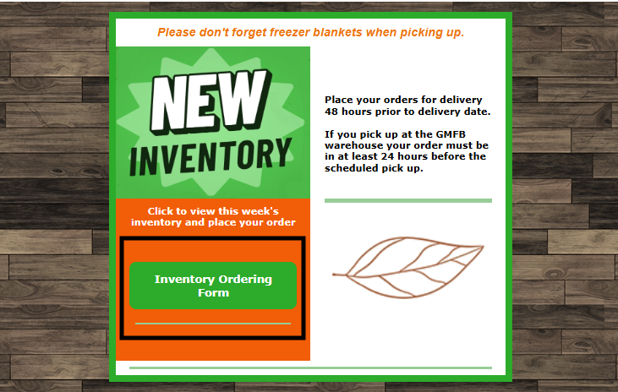
- You will click on the green “Inventory Ordering Form” Button to maneuver to the inventory ordering form. It is a JotForm.
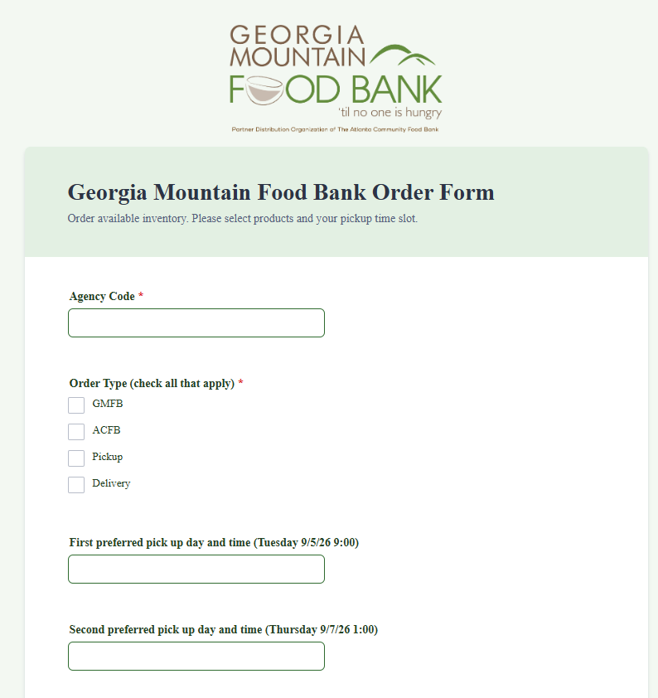

- When you get to the JotForm page, this is what you will see first.

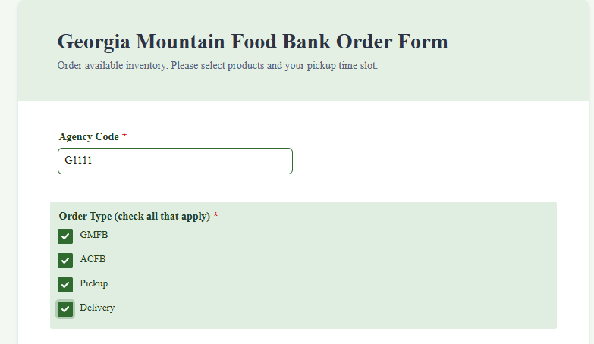
- You will be required to complete your Agency Code.
- You will be required to check at least one order type; HOWEVER you should choose at a minimum two choices, but can choose more. This is where you let us know if you are placing a GMFB order, expecting an ACFB order, and whether the order is pickup or delivery. Check all that apply.

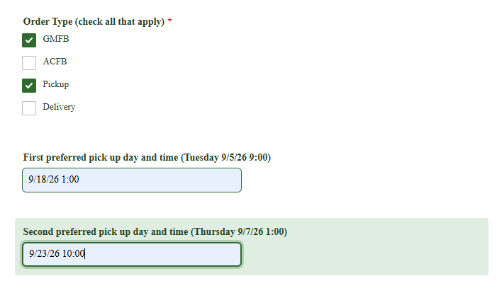
- If you have chosen pickup, you will need to provide two preferred times for pickup. Enter a date and time for each slot.

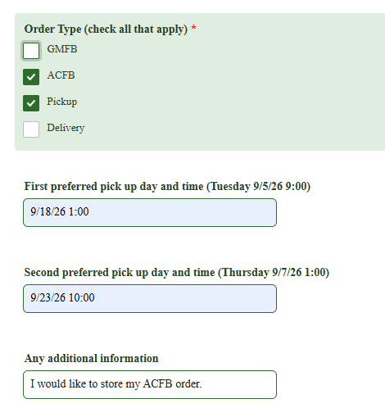
- If you have an ACFB order for pickup, you will need to provide two preferred times for pickup as well.
- There is a blank for any additional information. This is a free field to put what you want. For example, you could tell us if you would like us to store your ACFB or GMFB order for a time.
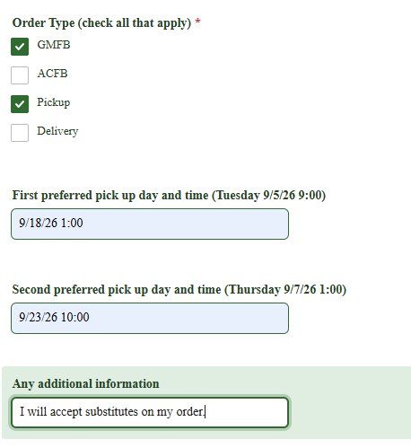
- You could also leave a comment, such as you will accept substitutions on your GMFB orders for items that are low.

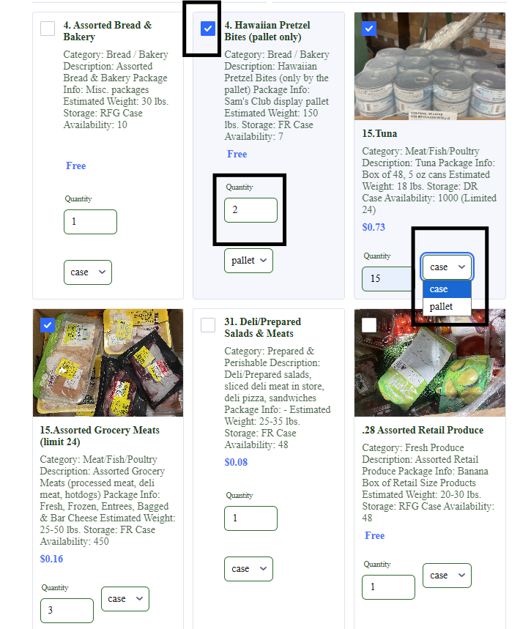
- Once the top portion is complete, you are ready to begin your order.
- You will notice that the descriptions, pictures when available, estimated weights, storage type, availability, limits, and cost share are all included for each item.
- When placing your order it is not necessary to check the white square at the top left of the item to select the item you want. Just enter the quantity you want for the item you wish, and the blue check will appear on the item.
- Although the quantity defaults to 1 you are not receiving 1 of everything. It only counts the item when the blue check appears on the item at the top left corner.
- Once you have entered the quantity you want of that item. You will need to use the dropdown to choose if you want it by the case or by the pallet, etc. It will default to the case unless it is only available by a particular method, such as by the tote.

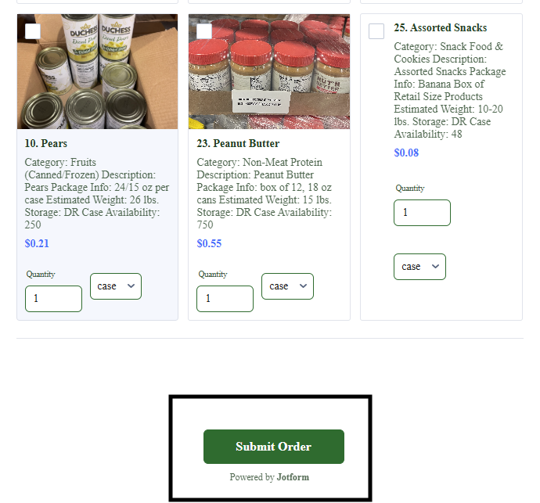
- Once you have selected all of your items for your order, click the “Submit Order” button.

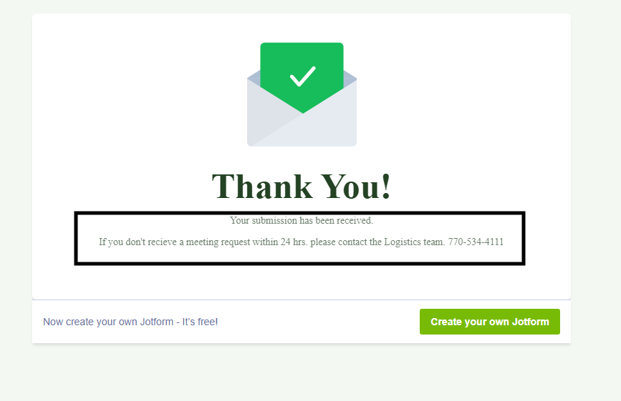
- Once submitted, you will receive this “Thank You” confirmation. Please note the information provided below the thank you. If you don’t receive a meeting request within 24 hours. Please contact the Logistics Team at 770-534-4111.

