RETAIL PARTNERS OF THE PERISHABLE RECOVERY PROGRAM

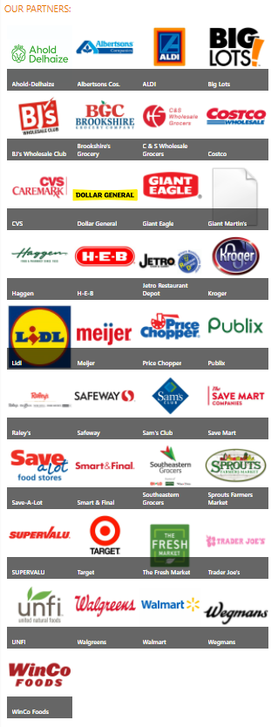
Ahold-Delhaize
Albertsons Cos.
ALDI
Big Lots
BJ's Wholesale Club
Brookshire's Grocery
C & S Wholesale Grocers
Costco
CVS
Dollar General
Giant Eagle
Giant Martin's
Haggen
H-E-B
Jetro Restaurant Depot
Kroger
Lidl
Meijer
Price Chopper
Publix
Raley's
Safeway
Sam's Club
Save Mart
Save-A-Lot
Smart & Final
Southeastern Grocers
Sprouts Farmers Market
SUPERVALU
Target
The Fresh Market
Trader Joe's
UNFI
Walgreens
Walmart
Wegmans
WinCo Foods

