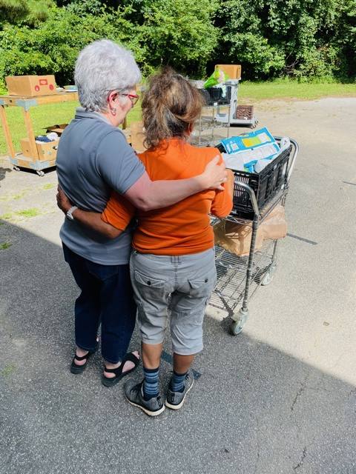
A STORY OF GRATITUDE

When I stopped working and got into retirement one thing that I noticed is that my income has lessened tremendously. Even though I get Social Security, it is barely enough for the necessities of everyday life! The income is a lot less, but my expenses are still the same, so I said to myself, “Something has got to give. I have to cut down on as many everyday expenses as possible.”

This is when I made a list of what I was spending, utilities, mortgage, groceries, clothing, car insurance, etc. These are all necessities which left me with the idea that the only area that I could budget was on my grocery spending by simply buying less groceries. While this is not an ideal solution, I knew I had to make changes to my spending.

Finally, something helpful came to my attention! I found a list of food banks local to our area. I started going to these places, which saved me a great amount of money!

Because of these resources I have been able to save money and use my Social Security income wisely. I am in a single income household, meaning that I only have one paycheck covering my household expenses. If it were not for these food banks, I would be starving to death, LITERALLY STARVING! These local food bank resources have saved my life, ensured my wellbeing, and have allowed my budget to provide the necessities of life.

“May God bless these volunteers who help and work tirelessly to provide for our community. I have to commend these volunteers in these food banks, they have good attitudes and are willing to help everyone. They serve diligently and with kindness in their hearts.

My gratitude and thankfulness are going out to each and every person who help to make these Food Bank Resources available.

