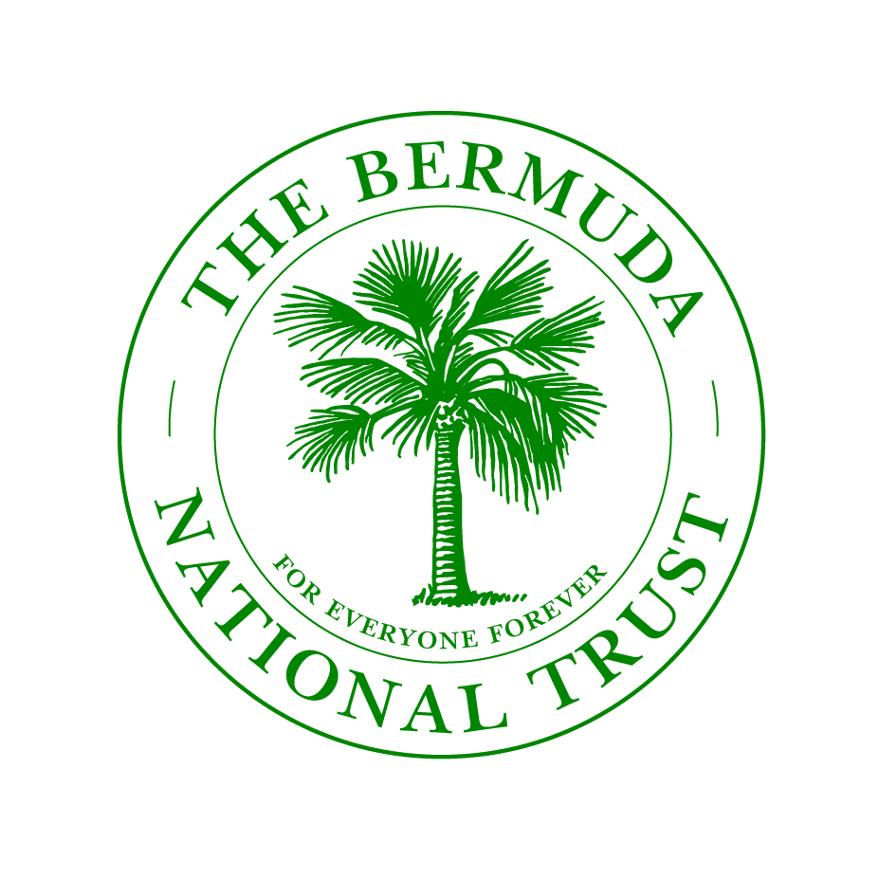
Arable Application

Instructions to bidders

Good day,
You are invited to submit a bid for the arable lease for : Lot J3 Jubilee Road, Devonshire Parish.

An aerial map is provided below with the holding in outlined in red and access in yellow.

The land comprises of 1.46 acres of arable land suitable for grazing cattle and horses.
Please return the completed form on the next page to the National Trust offices at Waterville, 2 Pomander Road, Paget, by February 19th 2021 marked for the attention of “Myles Darrell”

Before submitting a bid, you are expected to visit the site to satisfy yourself of the condition of the land and its surroundings - should further directions be required, please call Myles Darrell at 236 6483 x 224. (If necessary) Please access the properties ONLY during weekdays between 7 a.m. – 7p.m.

The Rent is a minimum of $730.00 per annum. You are free to make a higher submission. Your bid should also take into consideration any costs necessary to bring the property up to a cultivatable standard, if necessary.

The bidder is to provide all necessary tools & equipment necessary to maintain the property in a good workmanlike manner.

Please include two references.

Sincerely,
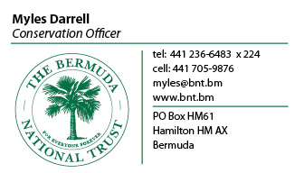

BID FORM - Please complete:

I, the undersigned, having carefully examined the application documents for the above property, and having visited the sites and ascertained all conditions pertaining to the condition of the grounds, hereby submit the following fixed prices for cultivating the listed Bermuda National Trust (BNT) property valid for two years for the following amount:

PROPERTY NAME | ADDRESS |  | TOTAL COST  (per annum)
[NAME] | [ADDRESS] |  | $
CONTACT INFORMATION:

Name:
Current address:
Tel number: (W) |  | E-mail:
(C)
ADDITIONAL INFORMATION:

I understand that if I am bidding on each property individually and that the Bermuda National Trust is not bound to accept the lowest tender they may receive.
Signed: Date:
(PRINT NAME): (TELEPHONE NO):
(ADDRESS):

To LEASE

1.46-acre Holding

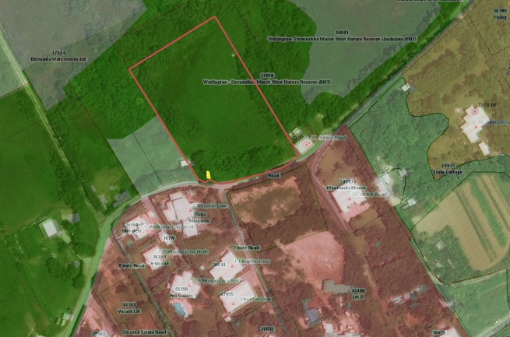
Lot J3 Jubilee Road, Devonshire Parish

If you are interested in leasing the above property please contact our conservation officer Myles Darrell. e-mail myles@bnt.bm or call 236-6483 x 224.

