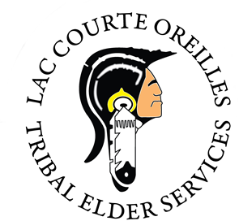
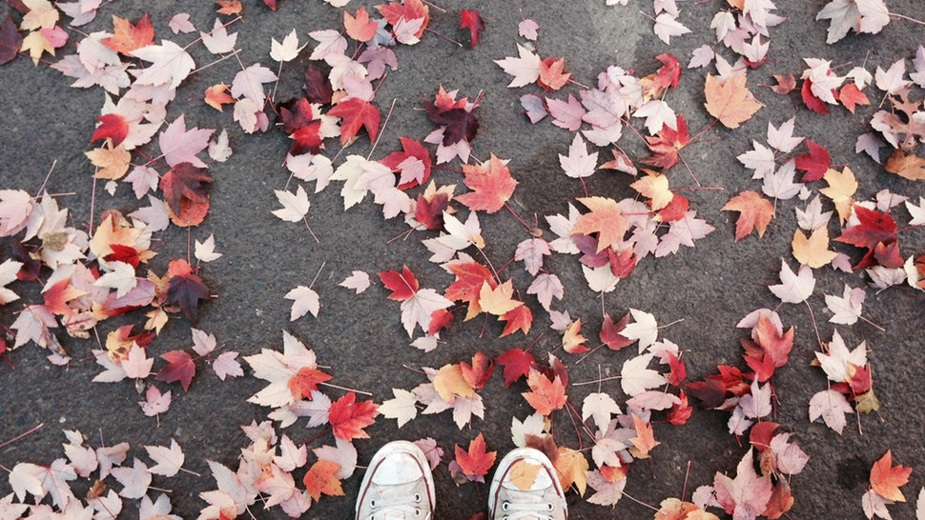

"You expected to be sad in the fall. Part of you died each year when the leaves fell from the trees and their branches were bare against the wind and the cold, wintry light. But you knew there would always be the spring, as you knew the river would flow again after it was frozen." — Ernest Hemingway

September 26, 2019
Boozhoo, I don’t want to take up too much time as there are other news articles and information attached to this, but just wanted to thank all those involved with our Annual Community Resource & Wellness event that took place on Monday Sept 9th, 2019 at the Seven Winds Conference Center, our staff was very diligent and took initiative to make it one of our best to date and I look forward to next years event, Thank you all who participated. We will be hosting another Medicare Outreach event next month at the LCO Tribal office – Peter Larson Room, Tuesday, October 15th from 10-1pm, our main focus will be to provide assistance and information in regards to the Medicare Open Enrollment period for 2020, the period will be available from November 1st to December 31st, a flyer will be distributed soon for your convenience.
GLNAEA meeting was held earlier this month in Red Cliff, WI at Legendary Waters casino, it was a great turnout by many of our WI tribes and their elders, the next Great Lakes Native American Elders Association meeting is scheduled to be held at the Bad River Casino, December 4th-5th, and yes reservations have been made.
Last but not least, our office phones here at the LCO Elder Center have been not working for over a month, I am very happy to announce that we are now up and running, Thank you to LCO IT Department and Charter Communications, I apologize for any inconvenience this has caused, Miigwech for taking the time in reading this.
Respectfully,
Terrance Manuelito
Tribal Aging Unit Director
Tribal Veteran Service Officer
Terrance.Manuelito@lco-nsn.gov
715 957-0077

Boozhoo,
I have been busy lately with upcoming events that are scheduled. On September 24th we will be taking the Elder and Disabled Tribal Members to a lunch and movie at the Riverstreet Family Restaurant and Hayward Cinema 4. The sign-up sheet filled up fast for this trip so I will be planning more of these trips in the near future. I have also scheduled an LCO Elder Indoor Fall Picnic that will be held at Kinnamon School on October 24th from 11:00 a.m. to 1:00 p.m. Come and join us for fun, food and conversation and bring your favorite photographs, and stories about your childhood, getting ready for winter and any other topics that peek your interest. Al Suubera will be hosting the lunch which includes; a fall appetizer board loaded with cured sausage, sweet/dill pickles, apples, dried cranberries, nuts and cheese and hot apple cider, spinach/cranberry salad, ham and bean soup and cranberry pie. Give me or the Elder Center a call at 715-865-3377 or 715-699-4403 so that I can sign you up for this event. Also if you have any ideas of upcoming trips you would like to attend, please give me a call or email me at Doreen.Wolfe@lco-nsn.gov
Miigwech

Jesse Taylor-Trepanier
  - Lac Courte Oreilles Tribal Aging and Disability Resource Specialist 715-957-0076/13878 W North Agency Road, Stone Lake, WI 54876

Aaniin! The Health & Wellness Fair turned out to be a great event with many vendors offering a lot of great information. The company was great, and the environment was pleasant. Sevenwinds Conference Center staff did a wonderful job setting up and meeting our space needs. I’d like to again thank our sponsors of the event and the many businesses that donated. If you missed this event you can still stop in and we can provide you with a list of program information and resources.
Another big event in September is the Commemoration of the 1854 Treaty on mooningwanekaaning or Madeline Island. This wonderful trip is to take place on Sunday September 29-30, 2019. For an itinerary or more information contact myself or Terrance.
We are holding a Technology Course every week on Tuesdays from 1:30-2:30 at the Reserve Elder Center. WOJB Engineer Mark Lundeen is available to answer any questions you may have. The first class was very well received with about 10 participants. If interested, you can jump in at any time, even if it’s the 3rd or 4th class. Just give me a call or stop in and we will get you on the list.
In collaboration with the LCO Health Center, WIHA, and the Senior Resource Center, there will be a Healthy Living with Diabetes Workshop September 25-October 30, 2019, from 4:00-6:30 in the lower level of the health center.
There is a new group you may be interested in, the Elders Monthly Book Club. The book club will meet once a month, and from time to time we may rent a DVD or attend a showing, if the book itself was made in to a movie at one time or another. The book will be chosen by the group every meeting or every other meeting depending on the participants. Audio books can be made available.
September Events: Health & Wellness Fair, 1854 Treaty Commemoration, Technology Course, Senior Resource Center Health Fair 9/25/2019 9:00-NOON
October Events: Technology Course, Elder Book Club, Healthy Living with Diabetes

