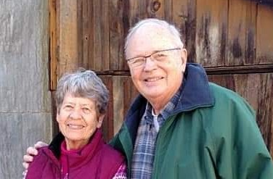

Gone from our sight,
but never our memories.
Gone from our touch,
but never our hearts.

A Service of Witness to the Resurrection
And A Celebration of the Life of
Helen Pederson
October 23, 2026 10:00 am

Prelude For Everything There Is a Season

Words of Gathering

* Hymn #664: Morning Has Broken

Prayer

Readings from Scripture:
Isaiah 40: 28-31

A Celebration of Helen’s Life

Reading from Scripture:
Matthew 1:18-25
Psalm 121

* Hymn #649: Amazing Grace

Meditation

Pastoral Prayer

* Hymn #676: Day Is Done

Blessing

Postlude

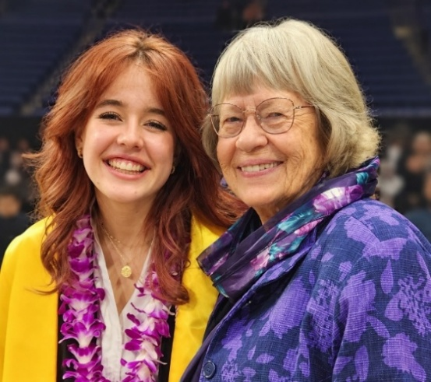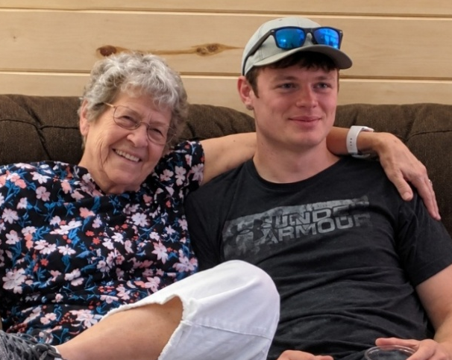
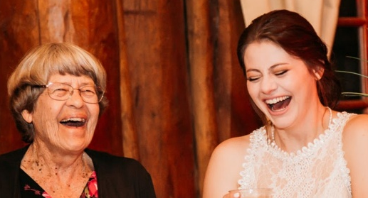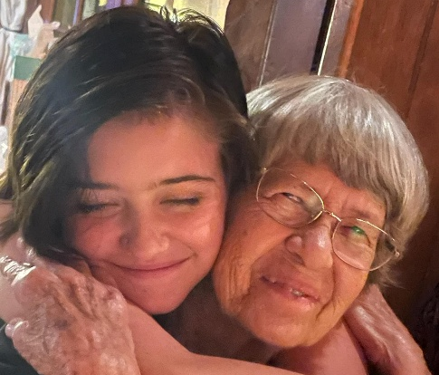

The Berg and Pederson families invite you to the Narthex for a reception
with the family.

In lieu of flowers, you are invited to make a memorial gift to Rio Rancho Presbyterian Church or Westside YMCA.

Leading Worship Today:
The Rev. Dr. Deborah Huggins, pastor
Nathan Secrest, Accompanist

Rio Rancho Presbyterian Church
1004 24th Street SE, Rio Rancho
info@rrpchurch.org | (505) 892.6664

*Please stand as you are comfortable Music: One License #A-736655

Celebrating of the Life of
Helen Pederson
March 25, 1938 – September 24, 2026

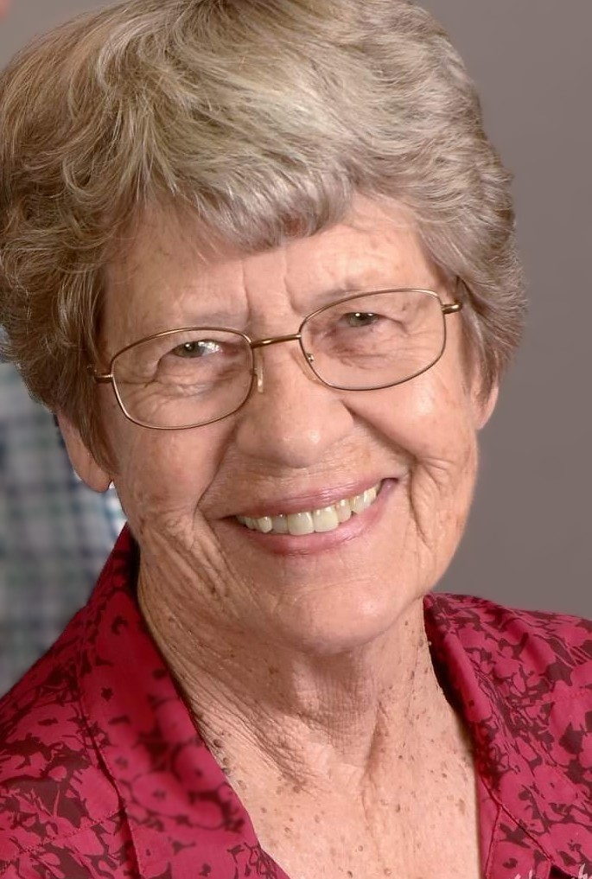

Helen Pederson
March 25, 1938 – September 24, 2026

Helen was born in Minneapolis, Minnesota on March 25, 1938, the first child of Lloyd and Alice (Goodhue) Berg. She grew up in Northfield with three sisters, Jeanette, Harriet, and Elaine. Helen was active in school, the Girl Scouts, and the YMCA. She was one of the first female counselors to lead a girls’ group on a multi-day canoe trip in the Boundary Waters Canoe Area with YMCA Camp Widjiwagan.

Helen attended the University of Minnesota, where she studied Home Economics and Physical Education. She met her husband, Dick, at the university, and they discovered that they shared a great love for the outdoors. They became leaders of the ski and canoeing clubs on campus and made wonderful friends as they traveled on many trips to ski and canoe.

Helen and Dick were married after they both graduated on June 25, 1961 in Northfield, MN. They had three children, June, Neal, and Cari. The family lived in many states across the country as Dick pursued his career with the Forest Service. Helen worked as a teacher of physical education and preschool, taught fitness classes, and served in many volunteer roles as well.

As their children grew up and each graduated from college, Helen and Dick retired to a beautiful home in Corrales, New Mexico. One of Helen’s favorite things to do was to lead and join hikes throughout New Mexico, exploring the beauty and history of the Land of Enchantment. Helen continued to volunteer at their church and at the YMCA for most of her life. She was also an enthusiastic member of the Smokey Bear Balloon chase crew from its inception.

Helen deeply enjoyed spending time with her grandchildren, Ben, Michelle, Bella, and Ash. They will always cherish the time they spent with her reading, hiking, and chasing the Smokey Bear Balloon.

She was preceded in death by her husband of 64 years, Richard Mathews Pederson and sister Jeanette (Berg) MacKenzie. She is survived by her children June Pederson, Neal (Kristin) Pederson, and Cari (Eric) Schnepp; grandchildren Ben Pederson, Michelle (Toby) Hogan, Bella Schnepp, and Ash Schnepp; sisters Harriet Berg, Elaine (Berg) Vance and half-brother John Flynn; Brothers-in-law Don (Darcey) Pederson, George (Alta) Pederson; and many nieces and nephews.

