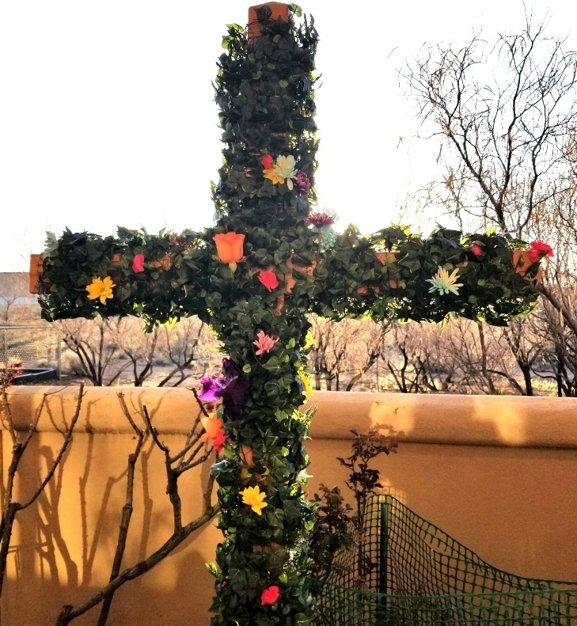

Leading Worship This Morning:
Rev. Frank Yates, Interim Pastor
Birgitta Gustafson, Liturgist
Nancy Leffler, Director of Music

Rio Rancho Presbyterian Church
1004 24th Street SE, Rio Rancho
info@rrpchurch.org
(505) 892.6664
Easter Sunrise Service
April 5, 2026, 7am

Gathering Music The Day of Resurrection - by Brad Nix

Prelude Rejoice, The Lord is King - by Jan Sanborn

Call to Worship:
Leader: The sun had just risen from behind the horizon…
the world was quiet, but for the chirping birds and buzzing insects…the three women walked slowly to the tomb. It was dawn. The sun was warming the earth.
People: The beauty of the day was lost on the grieving women.
Leader: It may as well have been midnight as they approached the tomb.
People: It was dawn. The earth was rejoicing. The breeze whispered alleluias across the land.
Leader: It made no sense. The stone had moved. The body was gone. Confusion and fear shoved grief to the side.
People: It was dawn. The trees swayed in the rhythm of songs from the heavens.
Leader: Dazzling clothes, strange voices, familiar words:
On the third day the Son of Man will rise again.
People: It was dawn. The women were running. The words were forming.
Leader: Christ is risen! Come and see! Christ is Risen!
People: He is risen indeed!

*Hymn #239 Good Christians, Rejoice and Sing

A Song of Victory: Psalm 118: 1-2, 14-24 Birgitta Gustafsen

The Day Dawns: John 20: 11-18 Rev. Frank Yates

Word Through Music Sunrise Resurrection Chancel Choir

Reflection Woman, Weeping in the Garden Rev. Frank Yates

Prayer of the Day
Leader: On this Easter morning we welcome you Jesus
into our lives.
People: We welcome your resurrection, for it is life-changing, life-giving and life-sustaining.
Leader: We welcome the hope it brings to our world.
People: We welcome the empty tomb for we know
that it means you are on the loose.

Leader: Lord, may your resurrection give life to those
who feel lifeless, those who are just going through the motions, and those who have had the death of a loved one.
People: Lord, may your resurrection give hope to those who are mired in despair, who feel hopeless, and who have given up all hope.
Leader: Lord, may your resurrection give joy to those who feel no joy, lost their joy or have had their joy snuffed out.
People: Lord, may you be on the loose in this world as the risen one. Amen.

Hymn #246 Christ Is Alive!

Postlude The Risen Lord - by Eugene Butler

