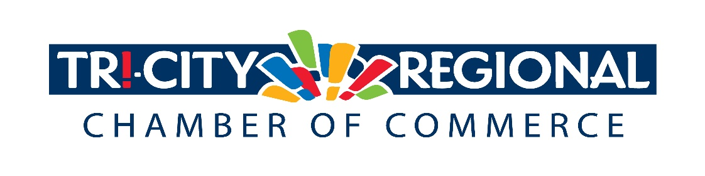
Senate Bill 5114
Under Senate Bill 5114, businesses that are currently closed under Phase 1 of the "Healthy Washington Roadmap to Recovery” would immediately move to "Phase 2" of the plan.
Activities | Phase 2
Social and At-Home Gathering Size - Indoor | Max of 5 people from outside your household, limit 2 households
Social and At-Home Gathering Size - Outdoor | Max of 15 people from outside your household, limit 2 households
Worship Services | Indoor maximum 25% capacity
Retail Stores (includes farmers' markets, grocery and convenience stores, pharmacies) | Maximum 25% of capacity, encourage curbside pick-up
Professional Services | Remote work strongly encouraged, 25% capacity otherwise.
Personal Services | Indoor maximum 25% capacity
Eating and Drinking Establishments  (establishments only serving individuals 21+ and no food remain closed) | Indoor dining available 25% capacity, 11 PM close. Outdoor dining available, maximum 6 per table, limit 2 households per table
Weddings and Funerals | Ceremonies and indoor receptions, wakes, or similar gatherings in conjunction with such ceremonies are permitted and must follow the appropriate venue requirements. If food or drinks are served, eating and drinking requirements apply. Dancing is prohibited.
Indoor Recreation and Fitness Establishments  (includes gyms, fitness organizations, indoor recreational sports, indoor pools, indoor K-12 sports, indoor sports, indoor personal training, indoor dance, no-contact martial arts, gymnastics, climbing) | Low and moderate risk sports competitions permitted (no tournaments). Fitness and training maximum 25% capacity.
Outdoor Sports and Fitness Establishments  (outdoor fitness organizations, outdoor recreational sports, outdoor pools, outdoor parks and hiking trails, outdoor campsites, outdoor K-12 sports, outdoor sports, outdoor personal training, outdoor dance, outdoor motorsports) | Low, moderate, and high-risk sports competitions allowed (no tournaments), maximum 200 including spectators.
Indoor Entertainment Establishments  (includes aquariums, indoor theaters, indoor arenas, indoor concert halls, indoor gardens, indoor museums, indoor bowling, indoor trampoline facilities, indoor cardrooms, indoor entertainment activities of any kind, indoor event spaces) | Maximum 25% capacity. If food or drinks are served, eating and drinking requirements apply.
Outdoor Entertainment Establishments  (includes zoos, outdoor gardens, outdoor aquariums, outdoor theaters, outdoor stadiums, outdoor event spaces, outdoor arenas, outdoor concert venues, rodeos) | Groups of 15, limit 2 households per group, maximum 200 including spectators.
Phase 2 would allow for the following:

This bill would then allow the Legislature to review available public health data to determine the best steps to help get Washington state safely back to business.
Please contact your legislator by phone or email today and tell them you support SB 5114. Click here to find your legislator's contact information.
If the bill gets a hearing, please sign up to testify in support of this bill. Please contact Tommy Gantz for details.

