U.S. Coast Guard Auxiliary Public Affairs
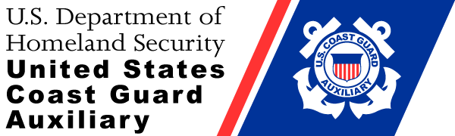

April 6, 2019
Contact: Linda Warren
Public Affairs Officer
803-920-7715
llwcga@gmail.com
http://cgaux.org
News Release
WHAT DOES COAST GUARD AUXILIARY FLOTILLA 12-3 LAKE MURRAY DO FOR THE COMMUNITY?

Chapin, SC – “What does the Coast Guard Auxiliary do, especially inland?” As a matter of fact, 2018 was a very busy and productive year for the Coast Guard Auxiliary, especially Flotilla 12-3 Lake Murray.
While the primary emphasis for the Coast Guard Auxiliary is “Boating Safety”, this one term encompasses many activities that are often not considered by the general public. In addition to boating safety, the Auxiliary supports the Coast Guard in many areas that do not involve law enforcement. The Coast Guard depends on the Auxiliary for support in a total of 26 different categories. Of those 26 categories, Flotilla 12-3 actively supported the Coast Guard in 14, volunteering over 10,804 hours in 2018.
So, what did Flotilla 12-3 do?
 | All Missions | Mission Hours
 | RBS - (99) Recreational Boating Safety | 7,554.05
 | CGOPS - CG Operational Support (07,20,22,26) | 1,242.50
 | UPA - Public Affairs (10) | 507.50
 | Other | 759.60

As a volunteer unit, Flotilla 12-3 served as an invaluable resource for the Coast Guard. Three of our personnel Bob Falsetti, Linda Bowen and Calvin Bowen became Food Service qualified and supported active Coast Guard units on shore and on ships in North and South Carolina. Flotilla personnel volunteered over 226 hours conducting Marine Dealer Visits, supplying safety and regulatory information to them and their many customers. Over 157 hours were devoted to Vessel Safety Checks to ensure community members were using safe equipment. Over 550 hours were devoted to Marine Patrols to encourage safe boating on our lakes. Several Boating Safety classes were conducted to help the general public become aware of safety and regulatory information.
Special mention should be made of those members who devoted an exceptional number of hours in specific areas:
Recreational Boating Safety
Barbara Burchfield
Kenneth Plesser
Festus Burchfield
Al Crothers
John Bradley
Operational Support
Bob Falsetti
Administrative Support
Al Crothers
Marine Patrols
Festus Burchfield
Barbara Burchfield
Public Affairs
Barbara Burchfield
Vessel Safety Checks
Ronald Foreman
While the above individuals led the way, every time a volunteer put on the uniform and volunteered time s/he made a significant contribution to the community and Coast Guard missions as support and a force multiplier. Each program visit and public education class helped more people become aware of safety on the water and the mission of the Coast Guard and Coast Guard Auxiliary.
In addition to the previously mentioned areas, members of Flotilla 12-3 were also involved in Coast Guard Administrative Support, Government Agency Support, Legislative Outreach, Marine Safety, Member Training, Search and Rescue, and Recruiting Assistance.
If you are interested in becoming involved with a very active organization that has many options for people with varied interests, consider the Coast Guard Auxiliary. The website for more information is: http://join.cgaux.org/index.php
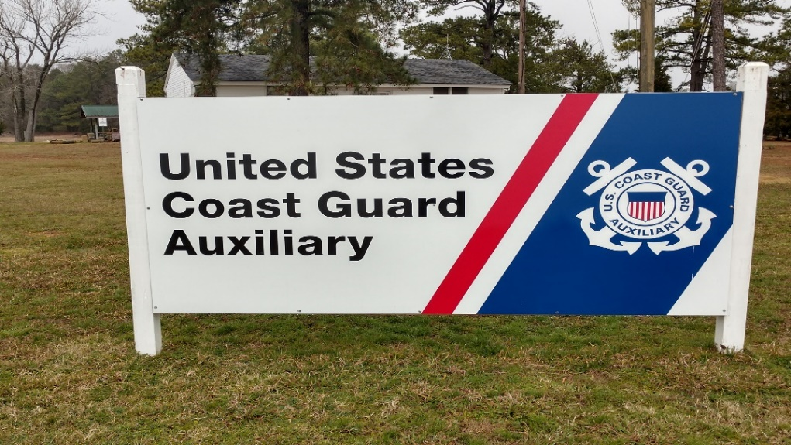
Sign at Flotilla Island, location of the Headquarters for Flotilla 12-3 Lake Murray. Photo by Linda Warren.

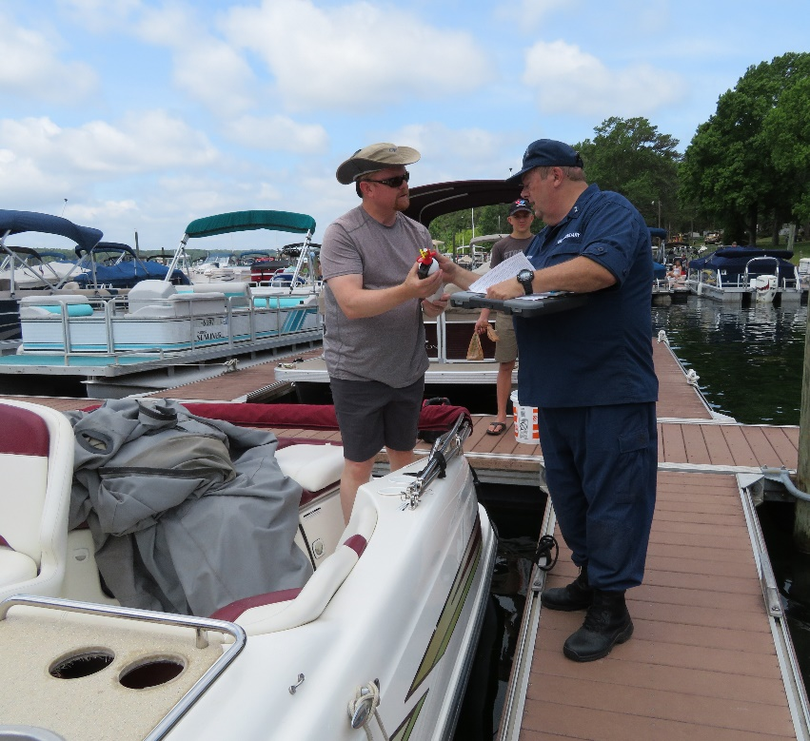
Clay Goodwin, Flotilla Vice Commander conducting a Vessel Safety Check at Jake’s Landing in 2018. Photo by Linda Warren.
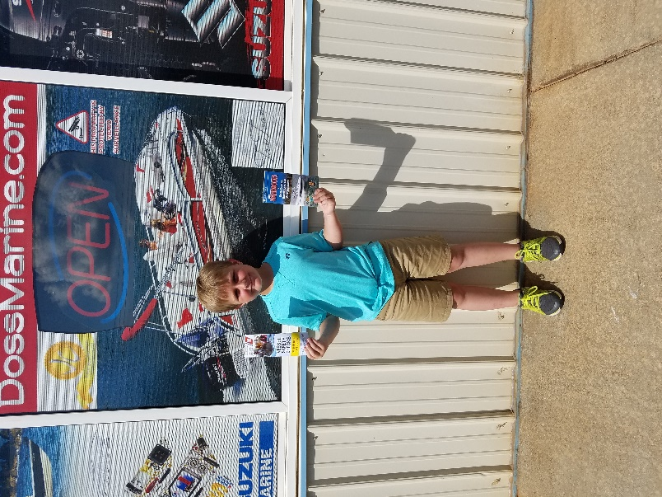
Jackson Blume displaying safety brochures at Doss Marine on June 14, 2018. Photo by Linda Warren.

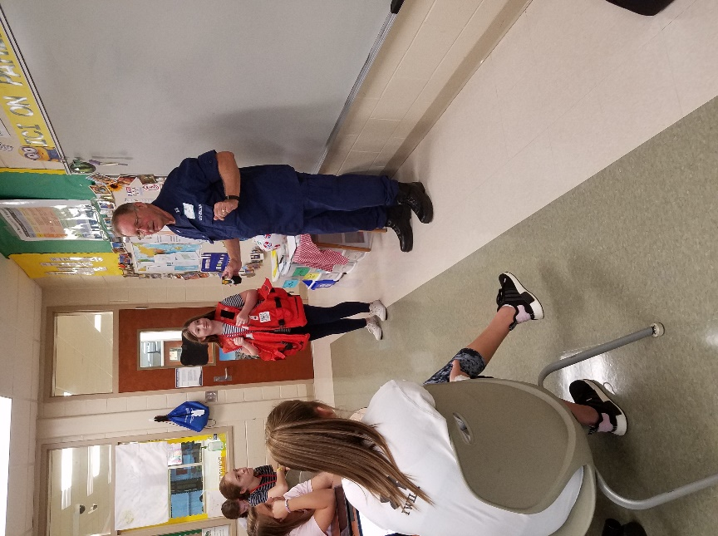
John Bradley, Flotilla Commander conducting a water safety class at a local middle school in 2018. Photo by Linda Warren.

The Coast Guard Auxiliary is the uniformed civilian component of the U.S. Coast Guard and supports the Coast Guard in nearly all mission areas. The Auxiliary was created by Congress in 1939. For more information, please visit www.cgaux.org

###

