Today’s Funeral Trends
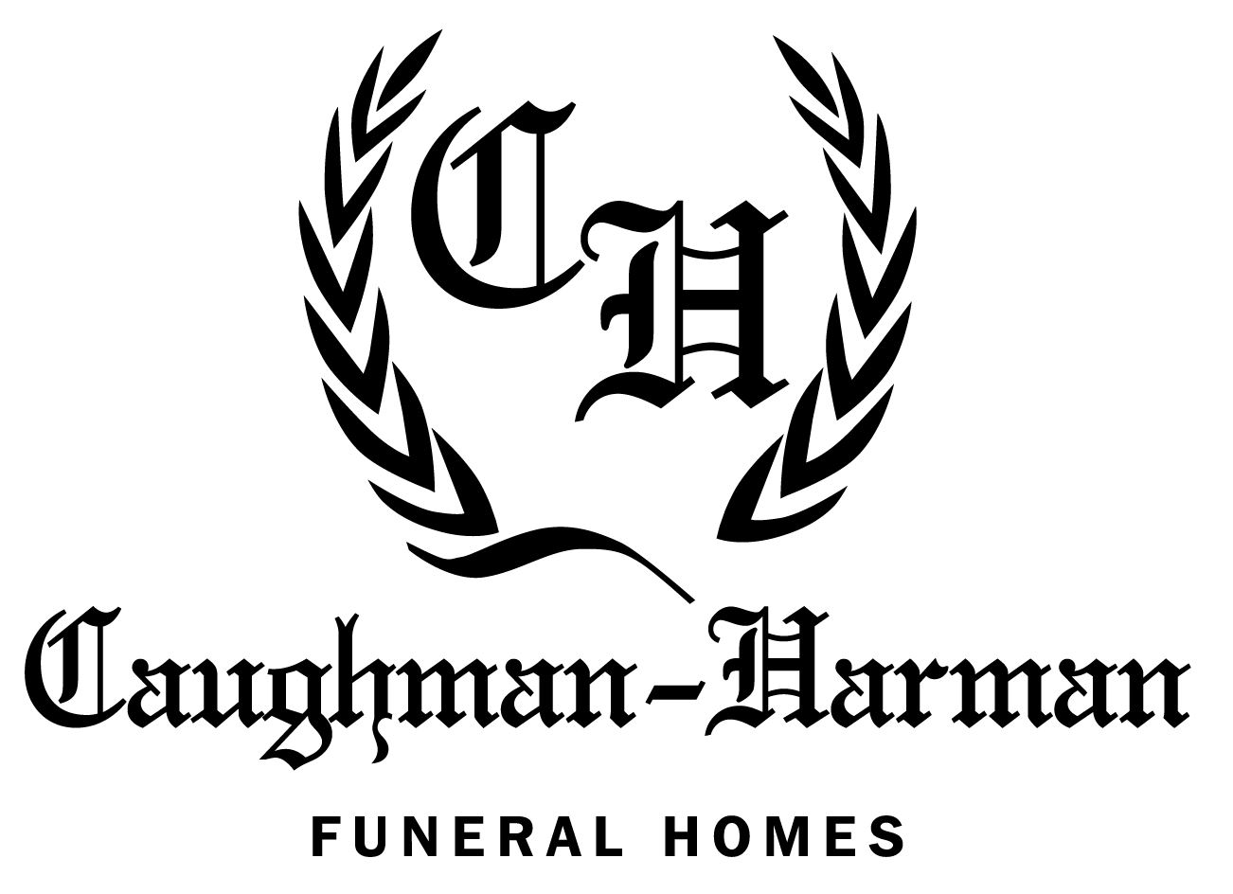

Caughman-Harman Funeral Home
Chapin Chapel

123 Columbia Ave
Chapin, SC 29036
(803) 345-3500
- The Popularity of Personalization
    - As baby boomers age and find themselves having to plan funerals for loved ones and themselves, they are making funeral choices based on values that are different than previous generations. Baby boomers see funerals as a valuable part of the grieving process and are seeking ways to make them meaningful. Today, funeral service consumers are planning funeral services that are as unique as the person who died. The idea of personalization has resulted in an explosion of unique services that reflect the hobbies, passions and interests of someone who has died. Through personalization, funeral services can be more meaningful. Funeral directors can offer ideas on how families can personalize their loved one's funeral and are open to family suggestions and creativity.
- Advance Funeral Planning
    - No one likes to think about funerals, but an increasing number of adults find that preparing for the inevitable is a wise decision. Planning one's funeral in advance allows individuals to do their homework and select a funeral home that will meet the emotional and financial needs of their family. Planning funerals in advance allows individuals to plan a memorable funeral service that reflects their wishes. With advance planning, families today can plan celebrations of life as unique as the individual being remembered. Planning one's funeral in advance does not mean one must prepay for the funeral. Many people who preplan their funeral also choose to prepay because it will alleviate the financial burden for their families. There are several ways to prepay for a funeral and a licensed funeral director can help individuals choose the method that best suits their needs.
- Cremation on the Rise
    - The public's preference for cremation continues to rise. In 2015, NFDA projected that the rate of cremation will exceed that of burial. As the popularity of cremations has grown, so has its acceptance among various religious faiths. Religions that previously frowned upon cremation are now understanding its value to families and adjusting their doctrines to accommodate this choice. Cremation is just one way a family can lay their loved one to rest; it is another option in addition to earth burial or entombment in a mausoleum. Cremation does not preclude a visitation or funeral service. A visitation and/or funeral with the body present can be held prior to cremation. Alternatively, a memorial service with the cremated remains present, can be held after the body has been cremated.

- Meeting Consumer Needs through Technology
    - In recent years, consumers rely on the Internet as a leading resource for information. In response, businesses have increased their presence on the web and funeral service is no exception. In order to enhance service to families and community, most funeral homes now have their own website, which enables funeral homes to easily display their products and services, and, in turn, offers consumers the freedom to conduct research at-will. Many funeral homes can help families create memorial videos which include photographs accompanied by music. These videos can be shown at visitation or funeral service and are a special keepsake to treasure forever. Because visitation and memorial services often take place shortly after a person's death, it may be impossible for all family members and friends, especially those living far away, to attend these functions. Some funeral homes have begun to accommodate those distant loved ones by providing a live online broadcast of the funeral service. These broadcasts can be archived on the funeral home's website for viewing at a later date or made into a DVD the family can keep.
- Green Funerals
    - A green funeral incorporates environmentally-friendly options in order to meet the needs of a family requesting a green service. Depending on a family's preferences, a green funeral can include any or all of the following: a small gathering in a natural setting, use of only recycled paper products, locally-grown organic flowers, carpooling, organic food, no embalming or embalming with formaldehyde-free products, the use of sustainable biodegradable clothing, shroud or casket, and natural or green burial. In natural burial, the body is buried, without embalming, in a natural setting. Any shroud or casket that is used must be biodegradable, nontoxic, and of sustainable material. Traditional standing headstones are not permitted. Instead, flat rocks, plants or trees may serve as grave markers
- The New Face of the Profession
    - Funeral service has traditionally been a male-dominated profession. It also has been a "family" profession, with firms being passed down from one generation to the next. Today, people who didn't traditionally choose funeral service as a career are joining the profession and finding it very rewarding. In fact, many of today's mortuary school graduates do not have family members working in funeral service and have decided to join the profession as a second career. There are many opportunities for people thinking about joining funeral service. Today, more than 60% of mortuary science students in the United States are women. Many of these women have discovered and are attracted to the skills and traits needed as a funeral director, including communication skills, compassion, a desire to comfort those coping with a death, as well as organizational and event-planning skills.

