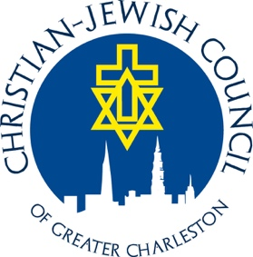

The Christian Jewish Council of Greater Charleston invites you to our
Interfaith Community Thanksgiving Service!

When: Tuesday, November 21, 2017 at 7:00 PM
Where: St. Stephen’s Episcopal Church, 67 Anson Street, Charleston, SC 29401
Parking is available on the street (meters free after 6:00 PM) or in the Gaillard Auditorium parking garage (five-dollar coupon available).

Message by Rabbi Greg Kanter
Kahal Kadosh Beth Elohim (KKBE)



Program is free and open to all!

Light refreshments will be served after the service.

Please bring packaged foods for donation to the Lowcountry Food Bank

The Christian Jewish Council of Greater Charleston (CJC) is an organization that seeks to build bridges of understanding to promote sensitivity, tolerance, respect, and fellowship among all faith groups. The CJC is an IRS 501(3)(c) organization. Donations are welcome and may be made at our website or mailed to the CJC, P.O. Box 30692, Charleston, SC 29417.

www.ChristianJewishCouncil.org | www.facebook.com/CharlestonCJC

