

Jenison Christian Families

**Our Class Activities Fundraiser Starts Today!**

If you want a

**Contact Free**

sale, simply keep the book and send payment back to school

**No better time than now:**

✓

Support our school

✓

Support neighborhood businesses

✓

SAVE your family $$$

Packed with $1000s in savings in over 10,000 cities.

Save on fine & casual dining, local attractions, travel, shopping and

much more!

Popular, in

-

demand savings!

All Books include a

**FREE**

Mobile App! Show your phone and SAVE.



SELL LOCALLY

Ask Family & Friends!

•

Sell the Entertainment

®

Book Membership to

family and friends.

**Take Orders and place**

**Supporter Order Information below!**

•

Return this form and all money collected by the

Sale End Date

**.**

•

Orders will be filled within 2 weeks of the end date.

2

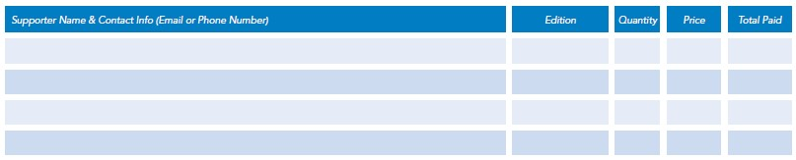

**Seller Name**

:

__________________________________

**Teacher Last Name**

:

_____________________________

**Sale**

**Starts:**

**Wednesday, Sept. 16**

**Group**

**ID**

**:**

**81796**

**Sale Ends**

**Wednesday, Sept. 30**

**:**

**Price**

**$**

**:**

**30**

**Make Checks Payable to**

:



**Experience Life for Less!**

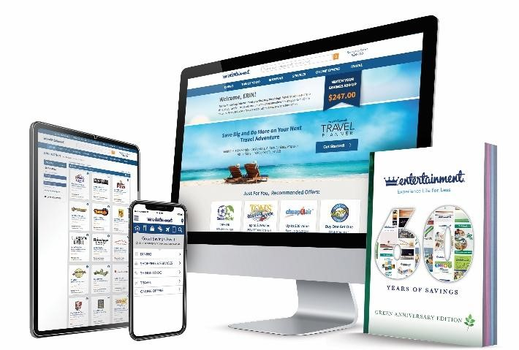

SELL

ONLINE

(

)

no contact

Join our online Raisy™ Online Fundraiser!

•

Go to

**Fundraising.entertainment.com**

and sign up

(

).

follow the instructions in your packet

•

**SHARE:**

email, text and post on social media.

*Perfect for out*

*-*

*of*

*-*

*town friends and family!*

•

Supporters purchase and pay online, then

Entertainment

®

delivers for free!

1

**Jenison Christian School**

**Sell 5 books and get a 6**

**th**

**book FREE**

**Coupon Highlights**:

**Bangkok Taste Thai Restaurant** – Buy 1 dinner, get 1 free

**Dickey’s Barbeque Pit** – 4 coupons including buy 1 plate, get 1 free

**Hungry Howie’s** – 3 coupons

**Activities** (golf, bowling, etc.), **Shopping** (sports, clothing, etc.),**Travel**