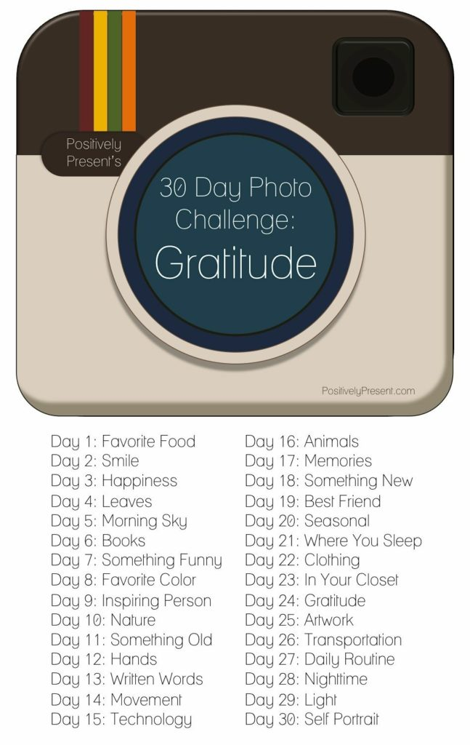

Gratitude Photo Challenge
I did this on Facebook a few years ago. I’m honestly not very good at things that require posting every single day. But now that my kids are of the age where they love posing for photos . . . I think this would be a blast.

