http://www.kanuga.org/assets/images/logo_kanuga.png 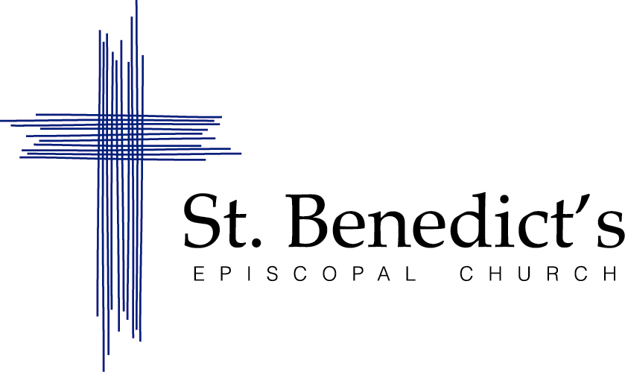

**January 27-29, 2017**

Dear Parish Friends,   
  
Please join us for the **2017 St. Benedict’s Episcopal Church Parish Retreat**! Mark your calendar for the weekend of January 27-29, 2017. The gathering will again be at Kanuga, the beautiful conference center in the scenic Blue Ridge Mountains of Western North Carolina.

For those of you who haven’t been, Kanuga is located in Hendersonville, NC, about 3-1/2 hours from Smyrna. It’s a beautiful, rustic “resort,” and you can learn more about the site at www.kanuga.org. The retreat will begin on Friday evening, and conclude after worship on Sunday.

All are welcome and encouraged to attend – singles and families, young and not so young. In fact, we will give some special attention to building our intergenerational relationships with one another. While our time there will be spent relaxing and re-energizing with our parish community, we will revel in the theme, “Telling Our Stories.”

**We’d like your commitment (and deposit) by September 1, 2016.** In order to finish plans and prepare for our group, we’ll need a final count several months prior to the January retreat. So, our hope is that you’ll put it on your calendar now, and complete/return the enclosed registration form and deposit by September 1. Payment in full will need to be received by November 1 to reserve your spot.

If you have any questions, or would like to volunteer to help with the event, please let us know. We’re looking forward to this time together!

*Warm* regards,

Victoria Patrick Laura Alexander

2017 Retreat Co-chair 2017 Retreat Co-chair

patrickvictoria87@gmail.com gutalexa@hotmail.com

404-234-2777 770-548-9738

St. Benedict’s Episcopal Church   
**Kanuga Parish Retreat** January 27-29, 2017  
**REGISTRATION INFORMATION**

**Keep this page for your records**!

Check-in will begin at Kanuga at 4pm on Friday, January 27, 2017 with supper available 6-7:30pm. The retreat will conclude on Sunday, January 29, 2017 at 1pm.

Rates Per person rates listed below include (double-occupancy) lodging in a cabin, six full meals, professional Kanuga staff, and use of recreational facilities. The weekend starts with Friday supper and concludes with Sunday lunch. There is no tax. Additionally, we rely on program fees to offset our costs associated with fellowship activities, supplies, and programming during the retreat. Optional activities may be offered by Kanuga (later) at an additional cost.

Lodging & Meals Program Fee Total  
Adult (19 years and up) $185/weekend $25/weekend $210  
Youth (10-18 years) $97/weekend $25/weekend $122  
Child (5-9 years) $58/weekend $25/weekend $83*  
Children under 5. No charge. No charge. $0*

Extras: Crib and linens add $7/weekend

*Child care additional (see below).

Payment A deposit of at least 50% of the total payment due is required at the time of registration (by 9/1/2016). The remaining balance is due by 11/1/2016. Those who wish to discuss financial assistance or alternative payment schedules should indicate on the registration form or contact Father Brian. Please make checks payable to St. Benedict’s Episcopal Church.

**Payment calculator:**

____ Adults x $210 = __________

____ Youth (10-18 years) x $122 = __________

____ Child (5-9 years) x $83 = __________

____ Child care (5-9 years) - Saturday Morning x $15 = __________  
*This is recommended and covers child care during the adult program Saturday morning.*

____ Children under 5 (no charge for lodging, meals, or activities)

____ Child care (0-4 years) - Saturday Morning x $30 = __________  
*This is recommended and covers child care during the adult program Saturday morning.*

____ Child care (0-4 years) - Sat Evening & Sun Morning x $30 = __________  
*This is optional and covers child care for the smallest children during social time Saturday evening and worship Sunday morning.*

____ Crib and linens (optional) x $7/each __________

TOTAL __________  
**Deposit of ½ the total is due by 9/1/16.**

Please complete and return the attached registration form and deposit by September 1, 2016. **Note, there are a limited number of slots.** The retreat schedule and specific information will be mailed to registrants in the coming months. Questions? Contact Victoria Patrick (patrickvictoria87@gmail.com; 404-234-2777) or Laura Alexander (gutalexa@hotmail.com; 770-548-9738).

St. Benedict’s Episcopal Church *** **Kanuga Parish Retreat** *** January 27-29, 2017

**REGISTRATION FORM  
Due by 9/1/2016**

Please make check payable to “St. Benedict’s Episcopal Church,” and mail this form and deposit/payment by 9/1/2016 to St. Benedict’s Episcopal Church, ATTN: Kanuga 2017, 2160 Cooper Lake Road, Smyrna, GA 30080.

Family Name: __________________________________

Mailing Address: __________________________________________________________

Phone: ______________________ E-mail: ____________________________

Adult Name(s)

1. ____________________________ 2. ____________________________

Child(ren) Name(s) and Age / Grade

1. _________________________ ____/____ 2. _________________________ ____/____

3. _________________________ ____/____ 4. _________________________ ____/____

Participants/families will share cottages with others. Please list preferences for individuals or families you would like to share a cottage with:

__________________________________________________________________________________

**Payment Worksheet (includes lodging/food plus activity fees & child care):**

____ Adults x $210 = __________

____ Youth (10-18 years) x $122 = __________

____ Child (5-9 years) x $83 = __________

____ Child care (5-9 years) - Saturday Morning x $15 = __________

____ Children under 5 (no charge for lodging, meals, or activities)

____ Child care (0-4 years) - Saturday Morning x $30 = __________

____ Child care (0-4 years) - Sat Evening & Sun Morning x $30 = __________

____ Crib and linens (optional) x $7/each __________

Grand Total: __________

**Payment Options** (check one)

□ Full payment is enclosed.

□ 50% deposit is enclosed now. I/we understand the remainder is due by 11/1/2016.

□ Please contact me. I’d like to make other payment arrangements and/or request financial assistance.

**Deposit of at least 50% of this total is due by 9/1/16.**