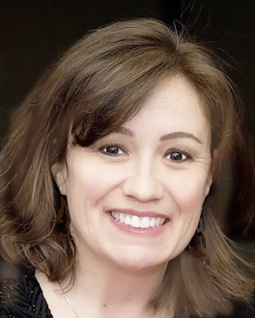

BIO: Diana Duenas
United Chambers of Commerce
Inspirational Women of the San Fernando Valley Award

For almost two decades, Diana Dueñas has been dedicated to helping Valley businesses and non-profit organizations thrive. She has moved not only Valley residents and companies to support local businesses but to get involved, provide volunteer support and to donate to many Valley community service groups.

She has been a longtime, staunch advocate for the Valley’s small businesses, women in business, education, veterans and youth.

She has been cited for her leadership and advocacy by wide range of civic and business leaders from the Mayor’s office to Valley community groups.

Under her leadership, Diana helped build the Encino Chamber of Commerce into one of the most respected Chambers in the San Fernando Valley.

In addition to serving 12 years as the Encino Chamber’s executive director, she has been a committed champion for Grateful Americans Charity, a non-profit helping veterans with PTSD; Yes, I CAN Member, a non-profit focused on stopping the cycle of abuse; The Leukemia and Lymphoma Society; the Valley Leadership Institute, the Fernando Awards Foundation, the United Chambers of Commerce; and the Southern California Association of Chamber of Commerce Executives.

