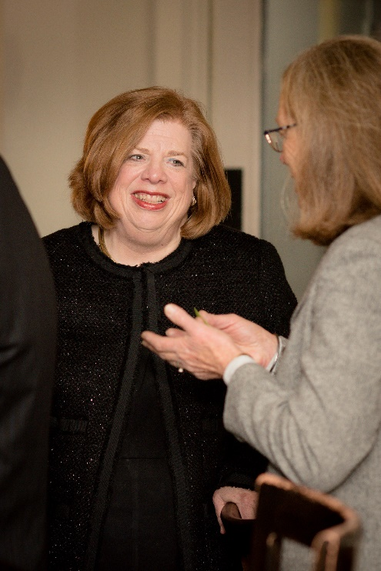
CNYWBA HONORS CAREER OF FOUNDING MEMBER HON. KAREN UPLINGER

The Central New York Women’s Bar Association was honored to join the Honorable Karen Uplinger’s Syracuse City Court colleagues in hosting a reception to honor her on the occasion of her retirement.
The well-attended event took place on December 6, 2018 at the Chop House on Waring. Those in attendance heard warm remarks from Syracuse City Court Judge Theodore Limpert, CNYWBA’s Immediate Past President Bryn Lovejoy-Grinnell, Fifth District Administrative Judge James Tormey and the Honorable Rosemary Pooler, United States Circuit Judge of the United States Court of Appeals for the Second Circuit.

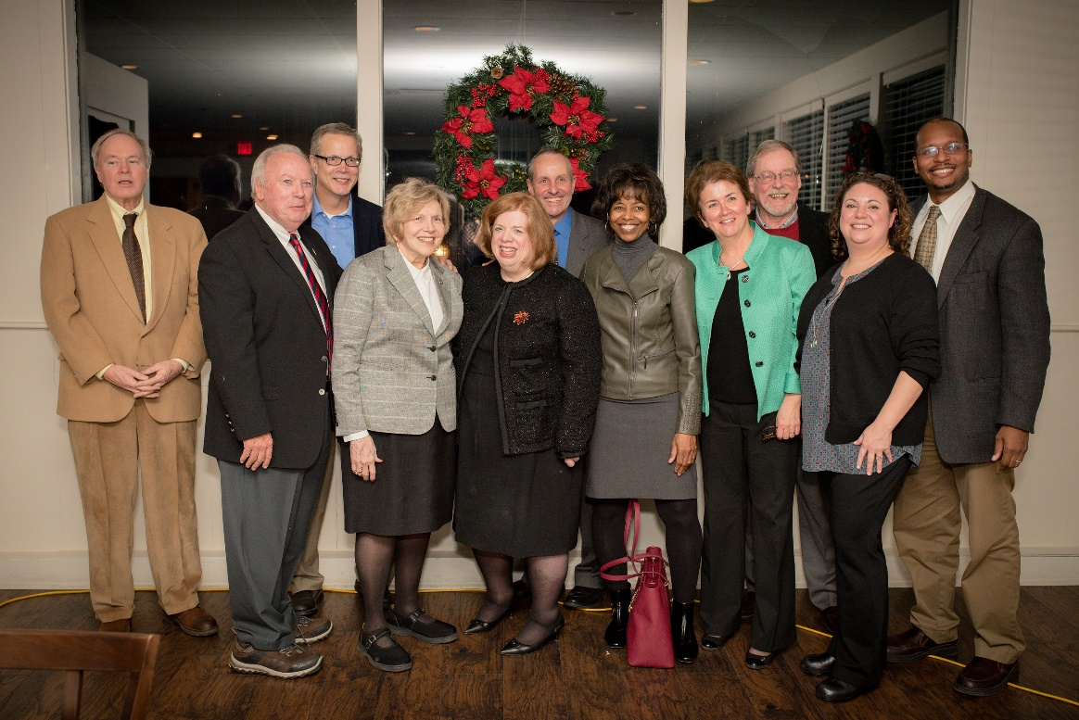
Before being elected to the Syracuse City Court bench, Judge Uplinger was a successful solo practitioner, a Family Court Hearing Examiner and a Syracuse Common Counselor. She is well known for being one of the Onondaga Five, a group of attorneys who led the effort to allow women to receive felony case assignments, attend Onondaga County Bar Association meetings and serve on the OCBA Board of Directors. In 2003, Judge Uplinger and the Onondaga Five were awarded the Women’s Bar Association of the State of New York’s Founders Award.
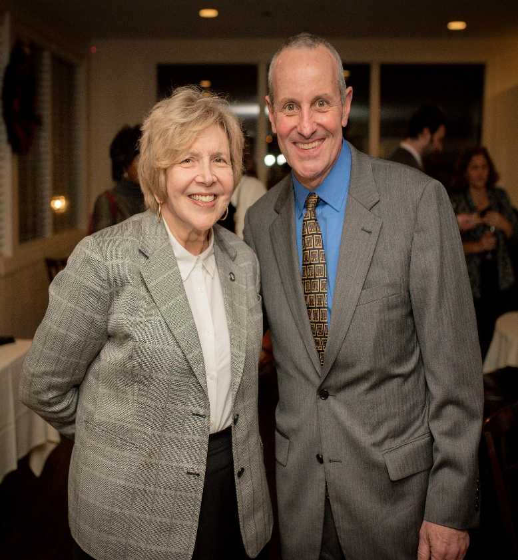
The Central New York Women’s Bar Association celebrates the trailblazing career of Judge Uplinger and thanks her for her continued commitment to the advancement of women in the legal profession.
Pictures from the event can be found here.

