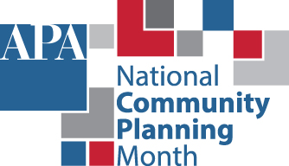

COMMUNITY PLANNING MONTH
PROCLAMATION

WHEREAS, change is constant and affects all cities, towns, suburbs, counties, boroughs, townships, rural areas, and other places; and

WHEREAS, planners can help navigate this change with data-driven insights and expertise that provide better choices for how people work and live; and

WHEREAS, community planning provides an opportunity for all residents to be meaningfully involved in making choices that determine the future of their community; and

WHEREAS, the full benefits of planning require public elected and appointed officials who understand, support, and demand excellence in planning and plan implementation; and

WHEREAS, the month of October is designated as National Community Planning Month throughout the United States of America and its territories, and

WHEREAS, the American Planning Association endorses National Community Planning Month as an opportunity to highlight how planning is essential to every community, and how planners are uniquely positioned to identify solutions to communities’ most difficult housing, transportation, and land use questions, and

WHEREAS, the celebration of National Community Planning Month gives us the opportunity to publicly recognize the participation and dedication of appointed planning commission members who have contributed their time and expertise to the improvement of the (State, City, or County) of ________________ (insert name of state, city, or county); and

WHEREAS, we recognize the many valuable contributions made by the professional community and regional planners of the _________________ (State or City or County) of _____________ (insert name of state, city, or county) and extend our heartfelt thanks for the continued commitment to public service by these professionals;

NOW, THEREFORE, BE IT RESOLVED THAT the month of October 2025 is hereby designated as Community Planning Month in the _____________ (State or City or County) of _____________ (insert name of state, city, or county) in conjunction with the celebration of National Community Planning Month.

Adopted this ___________ day of ______________, 2025.

______________________________________ (SEAL)
Chief Elected Official
___________________________________
Clerk

