Our Organ Project

In recent weeks, we have been hearing a lot of questions about what is going on with the rebuild of the organ. Originally, the new console was to arrive in June and the project would have been finished in late summer or early fall depending upon when the rebuilt reeds came from Schopp’s Sons.

Unfortunately, the pandemic has gotten in our way because for that to happen, not only did R. A. Colby in Tennessee have to be open, but also Schopp’s Sons in Ohio who is rebuilding the reed stops, Walker digital in Pennsylvania who is manufacturing our digital sounds, and Harris that supplies the stop knobs and all of the computer equipment to connect the stops and keyboards with the pipes and Walker Digital equipment. At present, all of those have reopened except for Harris, which is in suburban Los Angeles, a place that is hard hit, and that has stalled the project. Our latest tentative schedule is to have the new console after this Christmas and the job to be finished in the late spring or early summer of 2021, but we still don’t have a reopening date for Harris, so that is uncertain.

We do have pictures of the new console in its current state and here they are:

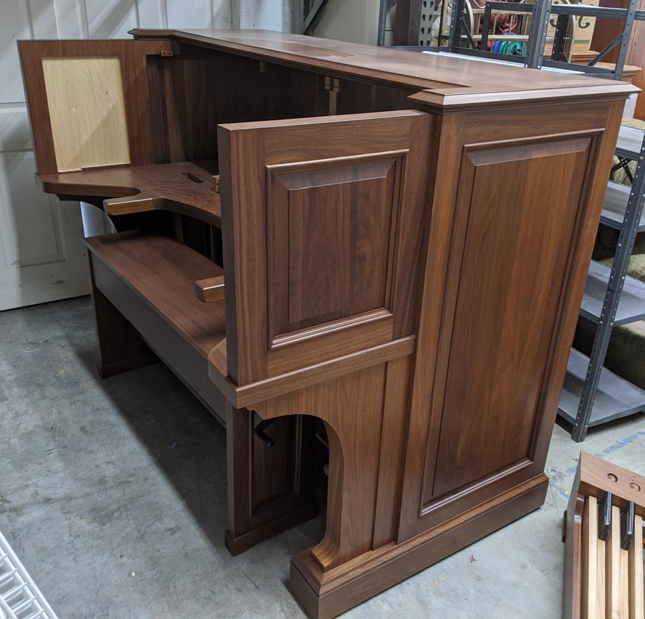

First is the case of the new console. It has been matched to the woodwork of the Chancel and is about 18 inches wider than the current console.

Second is the new bench. Notice the knob on the side. The height of this bench is adjustable so that we won’t have to put various sized boards under the bench to suit different organists.

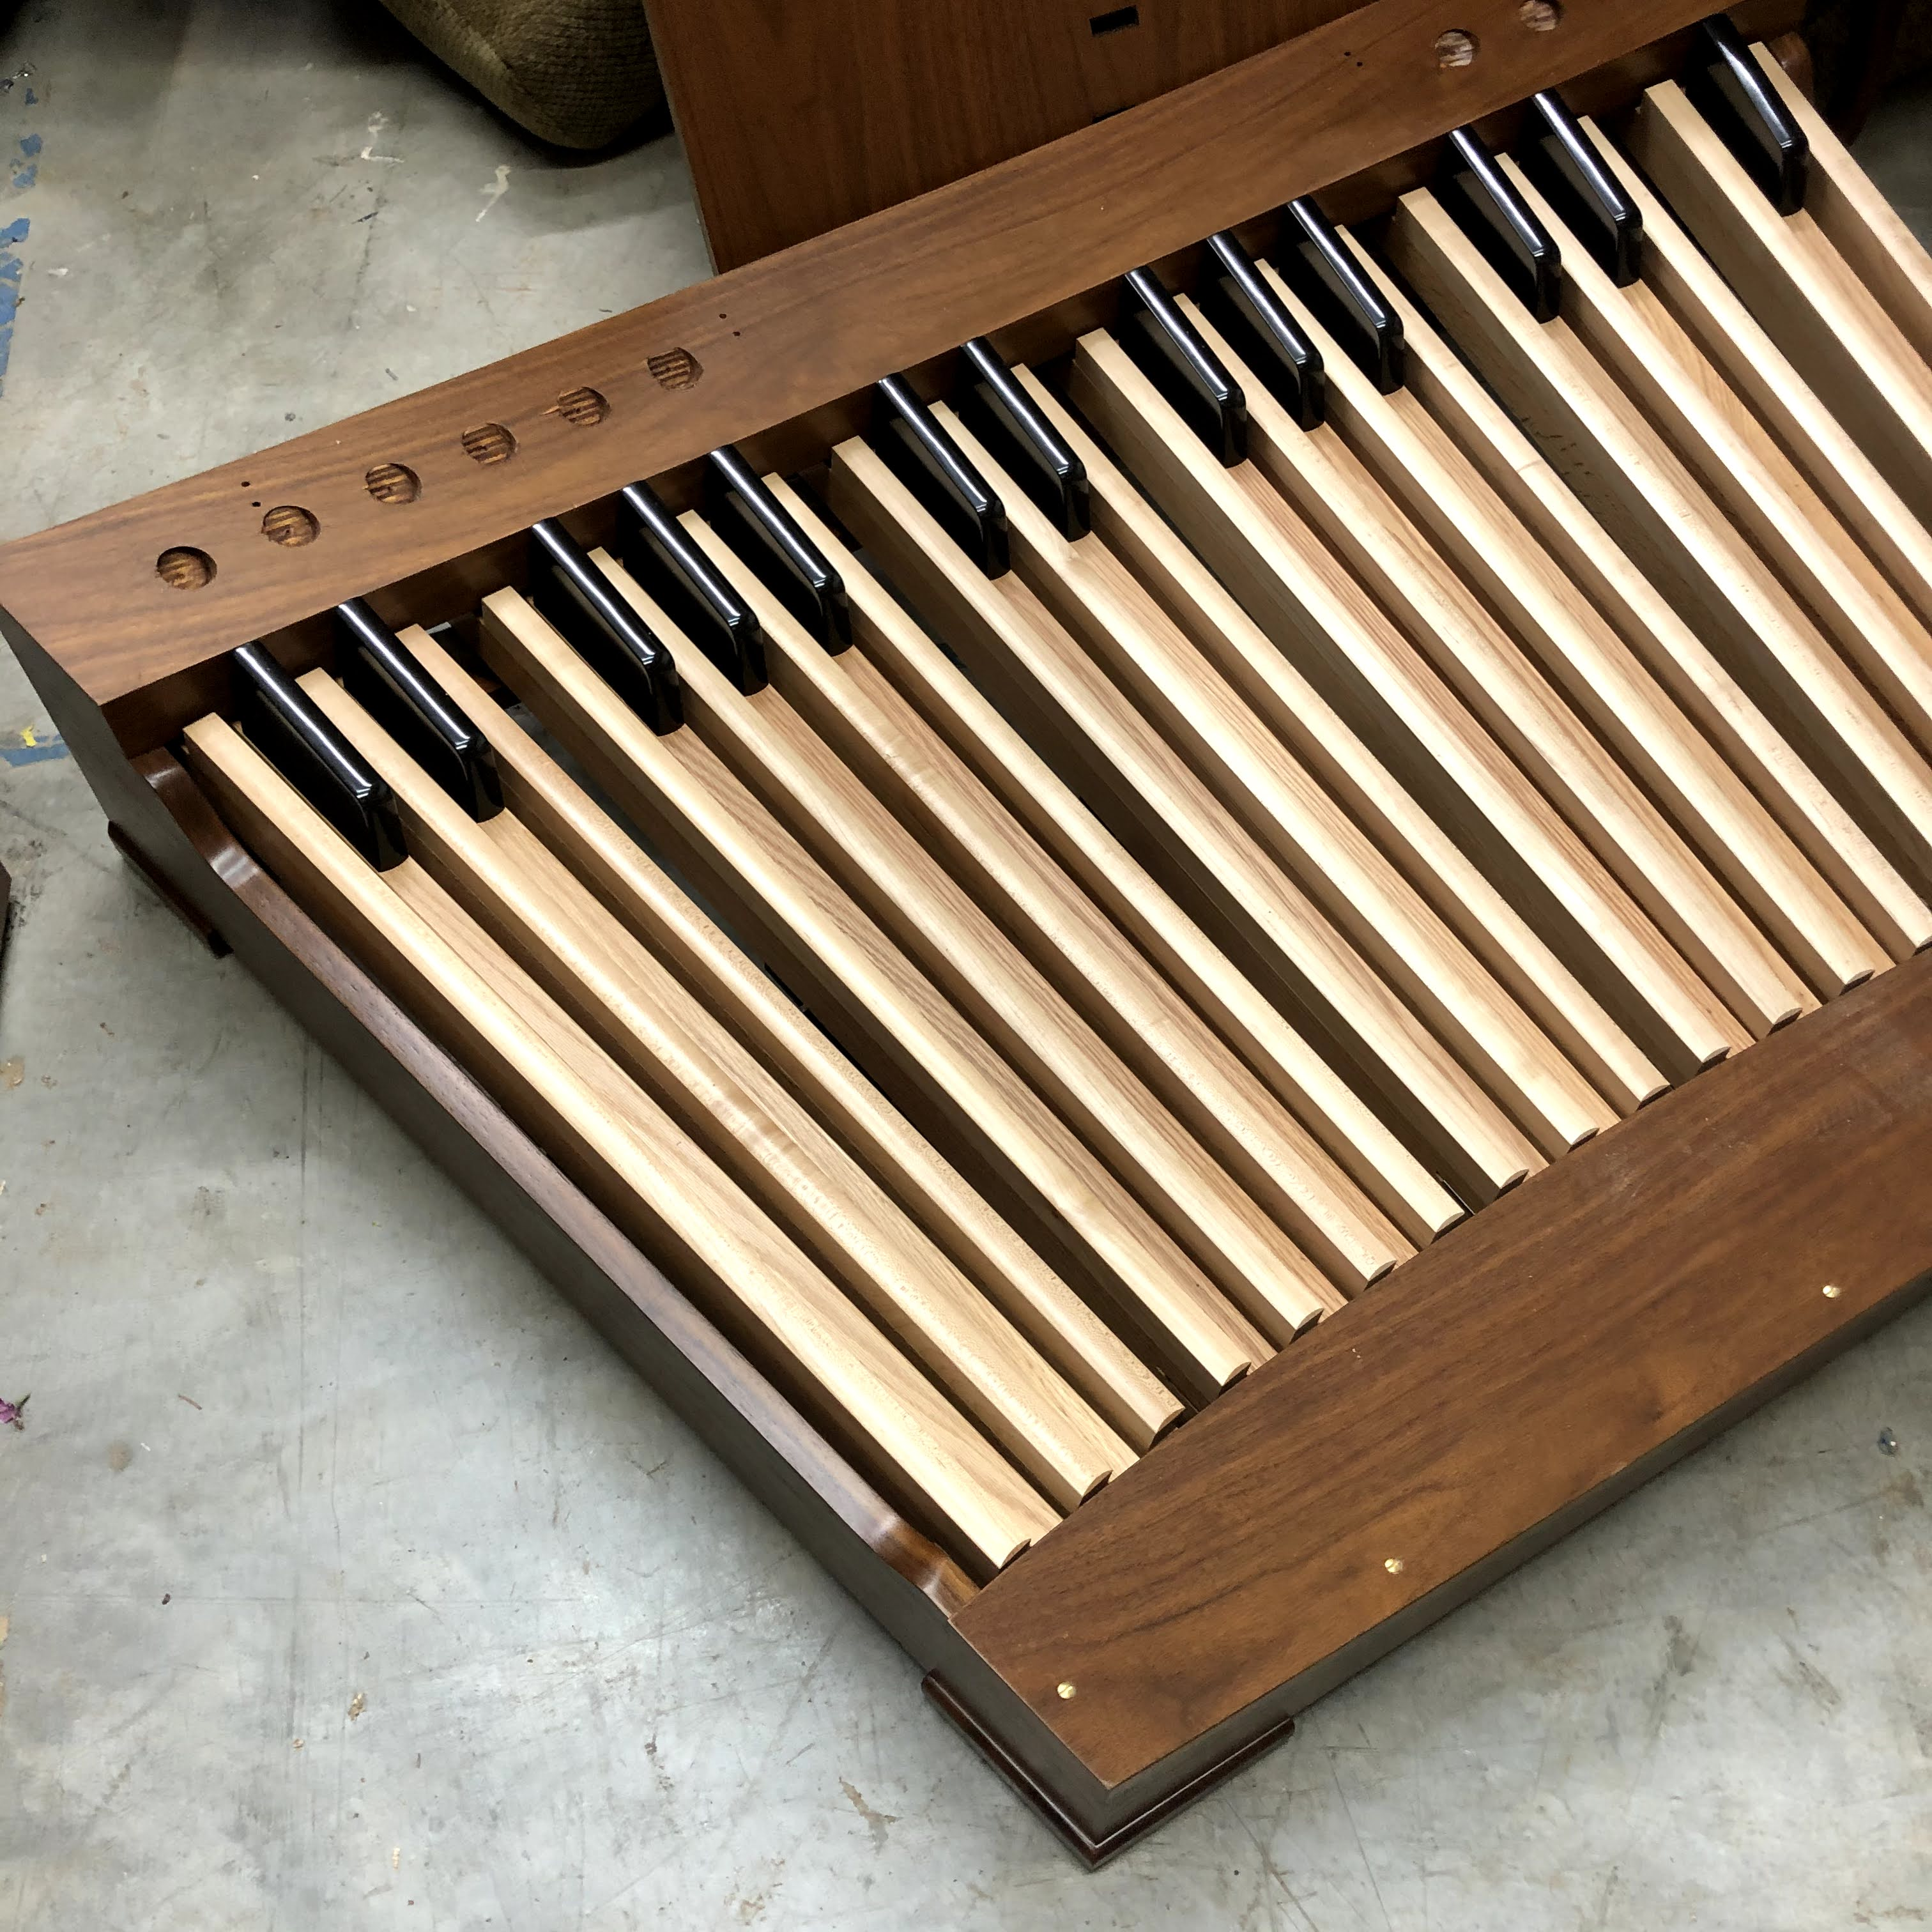

Third is the new pedal board. You can see the holes at the top for some of the toe studs that will come from Harris. Toe studs are buttons that the organist can push with his feet to change which stops play.

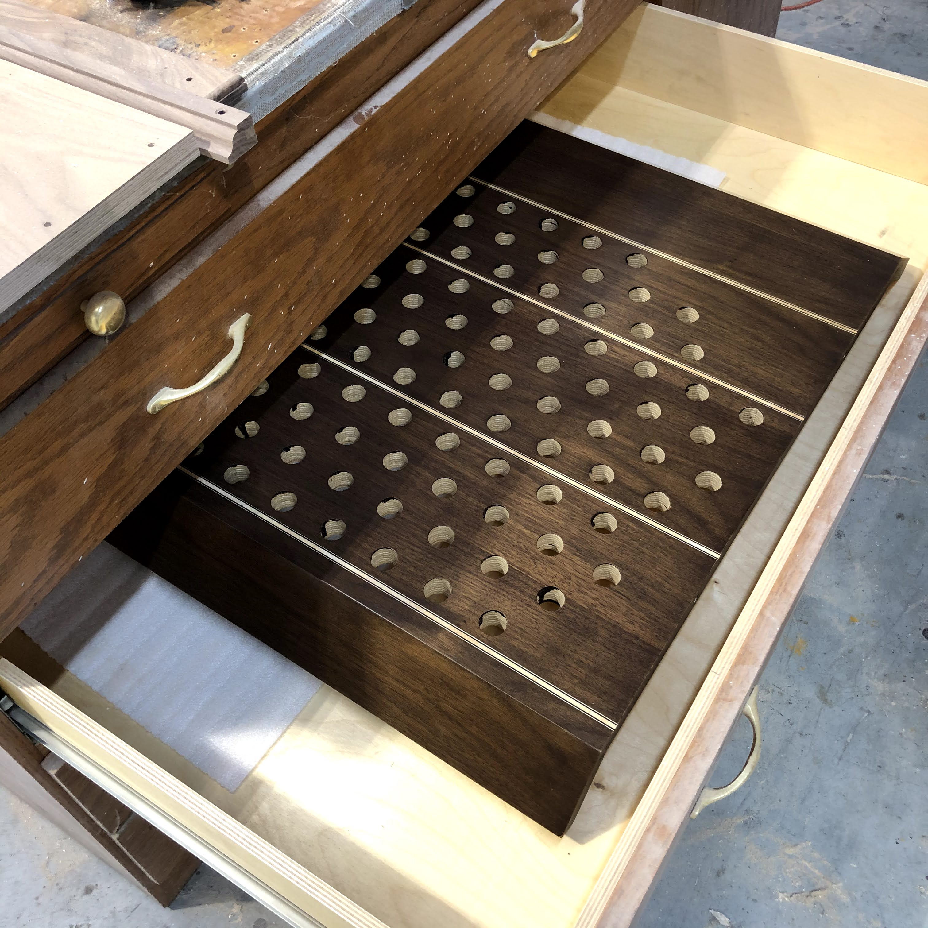

And finally, one of the two stop jambs that are on either side of the keyboards which will have Harris Knobs installed in them so that the organist can choose which sounds play. There will be 151 knobs between the two sides, this one is the left side. They are finished in a darker color than the case which will both make the console look better and make the white stop knobs easier to see.

It is frustrating to have to wait so much longer for the organ, but it’s better to wait to get the best parts than choose to go with cheaper materials. We could choose to use poorer quality equipment instead of the Harris computers, knobs, etc., but anyone who has seen us trying to deal with the equipment that was not well suited in some past repairs would know why we are unwilling to make that choice. Also, we worked very hard to make the design match our needs at St. Giles and taking something less than what we could have with more limited capabilities would make the organ less effective. Sometimes it’s good to wait for the best.

