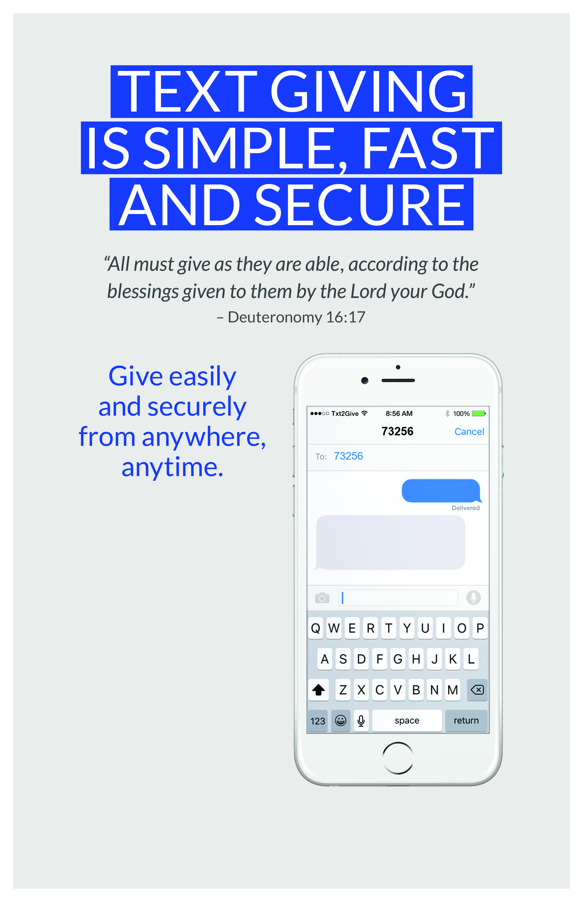

**Text “UUCAnnapolis”**

**And “Amount” To 73256**

And follow the prompts.

UUCAnnapolis 75

You’re almost there. Click https://goo.gl/xhbxvb to

complete your gift to Unitarian Universalist of Annapolis.

If you have questions about giving, please feel free to contact Pam Ausiello, UUCA Business Administrator, 410-266-8044 x110 or pausiello@uuannapolis.org



Your donation will go to our Share the Plate Fund.