MEMO

To: MHLG
From: NAMI
Date: November 30, 2017
RE: NAMI Parity Report “The Doctor is OUT” and Milliman Parity Report
______________________________________________________________________________

Two new reports reveal that the promise of better mental health coverage remains elusive despite parity laws.
Today, NAMI released “The Doctor is Out”, which found that people continue to lack the same access to mental health providers as for other medical providers. When they do find a provider, many are forced to go out-of-network and pay high out-of-pocket costs at much higher rates than for primary or specialty medical care.
“I spend a lot of money going out-of-network for care and then only getting partially reimbursed. It doesn't feel like parity and I use a lot of other specialty medical services and the network for these services is much better than for psychiatrists and psychologists.”
What people with mental illness have been experiencing for years is also confirmed by a report released by Milliman. The Milliman data shows a pattern of disparities in payment rates and access to mental health care under private health insurance plans across 50 states, three years and 42 million lives.
The data is in: the inequities for people seeking mental health care are real.
It’s time to level the playing field. Reach out to your members and allies and ask them to urge your state insurance regulator to ensure your parity rights by conducting random market audits of private health insurers and Medicaid managed care organizations.
Take action.
- Post on Twitter
- Post to Facebook
- Send an alert

Social & Alert Images
For better quality, use attached images

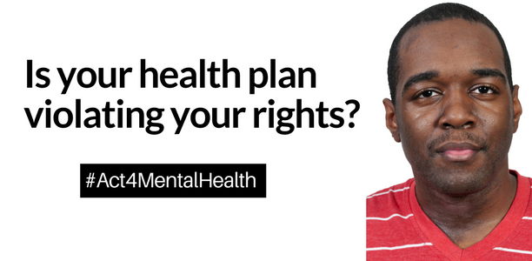
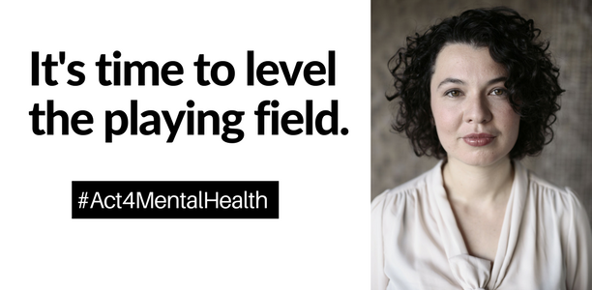
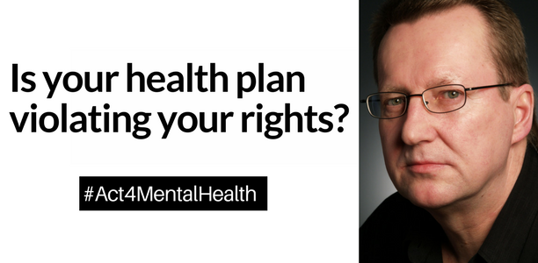
Tweets
The data is in: the inequities for people seeking mental health care are real. Find out more and #Act4MentalHealth http://bit.ly/2irrFNE
Is your health plan violating your rights? Find out what is happening in your state and #Act4MentalHealth http://bit.ly/2irrFNE
When you need mental health care, it should be as easy as going to your primary care provider for a cold. But it isn’t. Learn more and #Act4MentalHealth http://bit.ly/2irrFNE
Facebook
When you need mental health care, it should be as easy as going to your primary care provider for a cold. But it isn’t. America in 2017 can do better. Learn more and #Act4MentalHealth http://bit.ly/2irrFNE
Alert
Subject line: Mental health deserves equal treatment
[Insert preferred image]

The data is in: the inequities for people seeking mental health care are real.
On November 30th, NAMI released its third nationwide parity report, The Doctor is Out. The report found that, despite the federal parity law, people lack the same access to mental health providers as they have for other medical providers.
“Treatment is very expensive, mostly out-of-network, and at least in the area we are in, there is a shortage of psychiatrists.” Cami
More than 1 out of 3 respondents (34%) with private insurance had difficulty finding a mental health therapist, compared to only 13% reporting difficulty finding a medical specialist.
And when people did find a mental health provider, many were forced to go out-of-network and pay high out-of-pocket costs. This happened at much higher rates than when seeking primary or even specialty medical care.
Over 1 in 4 people (28%) receiving mental health therapy used an out-of-network therapist, compared to only 7% needing to use an out-of-network medical specialist.
Now, a report from Milliman also found a pattern of stark differences in payment rates for mental health providers and access to mental health care under private health insurance across 50 states, three years and 42 million lives.

And this means that people with mental illness aren’t getting the care they deserve.

You can help fix this. Call or email [insert name, title and contact info of state insurance regulator from attached list] and ask that they ensure that health plans in our state are not violating your parity rights.

Sample email or phone script:

“A recent report from Milliman with data from private insurance plans revealed what I already know: people must seek mental health care out-of-network much more frequently than for other health care.

It’s time to level the playing field. Please conduct regular market audits for parity compliance on all commercial health insurance and Medicaid managed care plans. Thank you.”

