What The HCPCS is Going On with 505(b)(2) Drugs?
DRAFT

A Brief History of 505(b)(2) Drugs and The Centers for Medicare and Medicaid Services (“CMS”)

To gain approval for a new generic product, pharmaceutical manufacturers have traditionally submitted an Abbreviated New Drug Application (ANDA) to the FDA, which allows for approval if the generic is identical to a branded drug in its active ingredient, dosage form and strength, and route of administration. This way, when a drug patent expires, manufacturers can avoid the time and expense of duplicative clinical trials.

The 505(b)(2) new drug application (NDA) is one of three U.S. Food and Drug Administration (FDA) drug approval pathways and represents an appealing regulatory strategy for many manufacturers. The pathway was created by the Hatch-Waxman Amendments of 1984, with 505(b)(2) referring to a section of the Federal Food, Drug, and Cosmetic Act. Manufacturers can gain approval for a product that is very similar to a brand-name drug but does not have the exact same chemical composition. By referencing an approved drug, pharma companies can shorten the approval timeline, omit years of trials, and bring a new formulation with a different dosage form, strength, or administration route to market. Some 505(b)(2) drugs are therapeutically equivalent in terms of indications; others are not.

The current HCPCS situation for 505(b)(2) drugs started when a Part B Medicare Physician Fee Schedule Rule 2021 proposal regarding 505(b)(2) drugs was issued in late 2020. In that Proposed Rule CMS proposed to install a new coding decision pathway for some 505(b)(2) drugs. Initially, they proposed to group all equivalent drugs into a single drug HCPCS. Here’s what CMS said at the time, which is VERY DIFFERENT than the current code assignment Strategy:

“Some drugs approved under Section 505(b)(2) of the Federal Food, Drug, and Cosmetic Act share similar labeling and uses with generic drugs that are assigned to multiple source drug codes. CMS is proposing to continue assigning certain 505(b)(2) drug products to existing multiple source drug codes. This approach is consistent with our interpretation of the definition of multiple source drug in section 1847A of the Act.”

However, since then, Medicare generic drug coding scheme has been associated with some drug shortages. Recently, generics like carboplatin, cisplatin, IV fluids, and furosemide have been consistently unavailable. This is partially due to competitive prices dropping so low in single HCPCS codes that suppliers can no longer produce these drugs.

After 2020, the HCPCS climate changed with ongoing drug shortages and increased use of unlisted codes (“NOC” which are unspecified/miscellaneous codes, e.g., J9999 or J3490) due to the swell of provider-administered drug approvals, particularly of 505(b)(2) drugs. According to MMIT, 60% of approved NDAs were submitted via the 505(b)(2) pathway.

So, the Centers for Medicare & Medicaid Services (CMS) took steps in Fall 2022 to recognize the value of 505(b)(2) value-added medicines that are not therapeutically equivalent to their reference products by approving distinct HCPCS codes for them based upon FDA equivalence status. An important change to the approval process was that The Consolidated Appropriations Act of 2022 now requires CMS to review 505(b)(2) drugs for HCPCS designation within 180 days of launch. To date (July 2023), 60+ 505(b)(2) products have been assigned a unique code.

As CMS issues new codes for these drugs each quarter, this regulatory process may offer distinct advantages for 505(b)(2) drug products. Yet, with this policy change, there are specific billing issues that HCPs need to be aware of and consider in the billing of 505(b)(2) drugs claims.

Advantages of 505(b)(2) Unique Codes

The most obvious advantage of the unique HCPCS (compared with adding all drugs with the same active ingredient to the same HCPCS) is the ability for each manufacturer to establish their own Average Sales Price for Medicare (and other payers). That is, manufacturers can launch 505(b)(2) without worrying about competitors immediately dropping the price of their new drug. This strategy also affords HCPs the opportunity to compare reimbursements for several drugs with the same or similar indications.

Other benefits include:

- There are less NOC (Unspecified) HCPCS Codes and better, faster billing with unique HCPCS. According to our most recent survey, 20% of practices/clinics will not bill a drug until it receives its own HCPCS. The reason is each NOC code must be manually reviewed by insurers. This causes delays and denials of drug claims and frustration for HCPs.
- HCPs can contrast and compare pricing among drugs that are therapeutically equivalent. The unique HCPCS have their own Average Sales Price plus 6% for Medicare payment and, naturally, each drug has a unique cost. When drugs are lumped into a single code as many of these drugs once were, it is impossible to know the profitability (or not). With pricing changes each quarter, HCPs can decide which products meet the reimbursement goals of their facilities, e.g., top line, bottom line, distributor offers or rebates, etc.
- These products, particularly those 505(b)(2)s that are branded (e.g., Pemfexy, Camcevi, Fensolvi), have programs to assist patients, which generics do not. Due to the quick de-escalation of prices and reimbursements with generics, many manufacturers abandon their Patient Assistance, Commercial Co-pay cards, and Foundation programs for patient access. Many of the 505(b)(2) drugs are branded and maintain these programs which are valued by HCPs, patients, and advocacy organizations.
- HCPs can explore which product fits their facility’s chair traffic. Some 505(b)(2)s have the same active ingredient and approved for the same indications but may have differing infusion times and routes. For example, Bendeka and Belrapso are two 505(b)(2) bendamustines that have the same active ingredients and indications. Belrapso has a 30- or 60-minutes infusion time, while Bendeka’s is 10 minutes. Busy practices generally prefer shorter infusion times as they can serve more patients in a single day, even with lower drug administration payments. Conversely, smaller practices might prefer to keep their infusion suite full and may select drugs with longer infusion times to get more drug administration reimbursement. 505(b)(2) offer flexibility to meet every facility’s needs.
- Some 505(b)(2)s can help participating practices minimize risk in the Enhancing Oncology Model (“EOM”) because some drugs in particular indications are classified as ‘novel’ therapies. While there is no penalty for NOT using Novel Therapies in the EOM, the Novel Therapy Adjustment (“NTA”) is an upward adjustment for each of the approved in the EOM 7 tumor types to each 6-month episode. The adjustment is to account for the use of innovative drugs in certain indications without a negative impact on the targeted benchmarks by tumor for that period. A CMMI NTA example is enclosed in Appendix 1. The American Society of Clinical Oncology (ASCO) has said this about the NTA: “The NTA applied at a cancer type level would have resulted in more instances where practices would have qualified for a benchmark adjustment. We believe that the EOM approach to NTA applied at a cancer type level is more favorable for participating practices and provides valuable financial protection when incorporating clinically appropriate novel therapy for cancer treatment.” There are 505(b)(2) oncologics on the EOM Novel Therapies List such as pemetrexed, bendamustine, and bortezimib. One might not expect these therapies to be novel, but they are!

With any new coding and billing policy, even if favorable, our experience tells us that there is usually billing and payment confusion. And 505(b)(2) coding is no exception. To minimize confusion and maximize clean claims, we outline some of the pitfall’s practices may experience in billing 505(b)(2) drug and strategies to prevent them:

- Matching National Drug Codes to HCPCS can be tricky. Currently over 68% of payers require NDC codes. Incorrect NDC codes have been a billing problem for the last several years. For any given chemical compound, there may be multiple unique HCPCS codes that correspond to certain NDCs. For example, Vancomycin has 3 HCPCS codes and 19 NDCs (See Appendix 2). Some of these NDCs are generics and some 505(b)(2)s. It is hard to know which 11-digit NDC matches to a HCPCS when there are multiple choices, The HCPCS is never conveyed on the package or label. A mismatch can cause a claim to be denied and/or cause extra steps to payment.
- Keeping up with the quarterly load of codes is hard on providers. CMS issues codes each quarter; plus, manufacturers gain additional 505(b)(2)s approvals on an ongoing basis. Providers must constantly change their computerized charge documents to reflect these changes. The last thing stretched offices and clinics need is more administrative tasks.
- 505(b)(2) drug prices are a challenge for HCPs as they can fluctuate wildly from quarter to quarter. Additionally, drug costs change as do discounts and rebates from distributors. Choosing the right drug for a practice or clinic may be a daunting task as the best price for 505(b)(2) may change again the very next quarter, while the Average Sales Price for Medicare reimbursement may also increase or decrease. Moreover, Alchemy Healthcare, a company that tracks pricing for drugs, has indicated there have been MAJOR errors in NDC alignments from all four pricing compendia.
- 505(b)(2)s with unique HCPCS are also new for non-Medicare payers. Payers adopt new HCPCS in varying time frames. The large payers, like United, CVS/Aetna, and CIGNA, usually adopt new codes quickly. Smaller payers and Medicaid do not—another issue for HCPs. But, even if the HCPCS is adopted, with all 505(b)(2)s, generics, biosimilars and branded drugs HCPCS, it is dubious that all payers have correctly adopted all changes for 60 codes since the beginning of 2023. This may be causing adjudication delays and unnecessary claim denials.

To ease these administrative issues for their customers, manufacturers of 505(b)(2) drugs should ensure that practices and clinics have the tools they need to successfully be paid. We suggest the following:

- Ensure that a one-page cheat sheet is distributed to customers. Through our surveys, we have learned that this is the preferred information source for busy HCPs. This sheet should include applicable ICD-10-CM codes, NDC codes, HCPCS plus HCPCS units per vial, administration CPT codes, and links to the most current Average Sales Price information. If the product is a Novel Therapy for the Enhancing Oncology Model, this should be documented as well.
- Update non-Medicare payers, particularly large commercial plans regarding the appropriate HCPCS and NDC crosswalks for your product. It is very frustrating for HCPs when the payer does not recognize a code or has the wrong NDCs cross-walked to a code or pays at wrong price making them ‘underwater’. Providing accurate information to payers will assist practices and clinics in generating clean claims and distinguish one 505(b)(2) from others.
- Provide the right tools for updated pricing and coding information. Most providers do not have subscriptions to the pricing compendia and/or the FDA database. A pricing website, BuyandBill.com is updated every quarter and offers free look up that has pricing by NDC and HCPCS code. Manufacturers can also use this tool to ensure that the very latest and correct information regarding their product(s) is in the public domain.

APPENDIX 1
NOVEL THERAPY CALCULATION

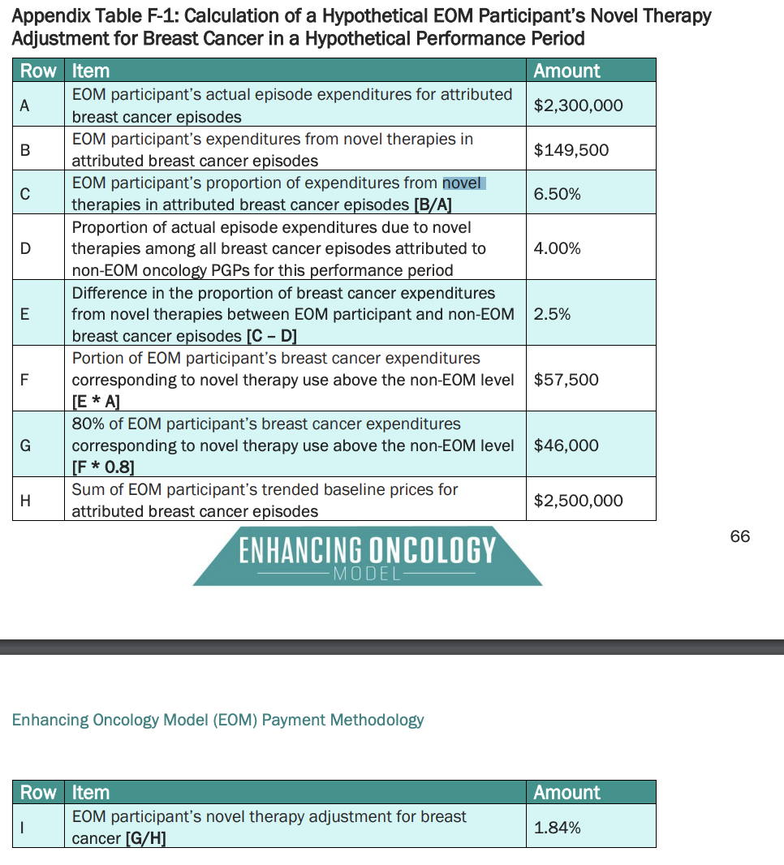

- Line H = Predicted Expenditures for Episode (Experience Adjustor* Clinical Adjuster for Tumor Type*Trend Factor*NOVELTHERAPY ADJUSTMENT)

Reference: https://innovation.cms.gov/media/document/eom-payment-methodology

APPENDIX 2
NDC, Prices, and HCPCS for Vancomycin

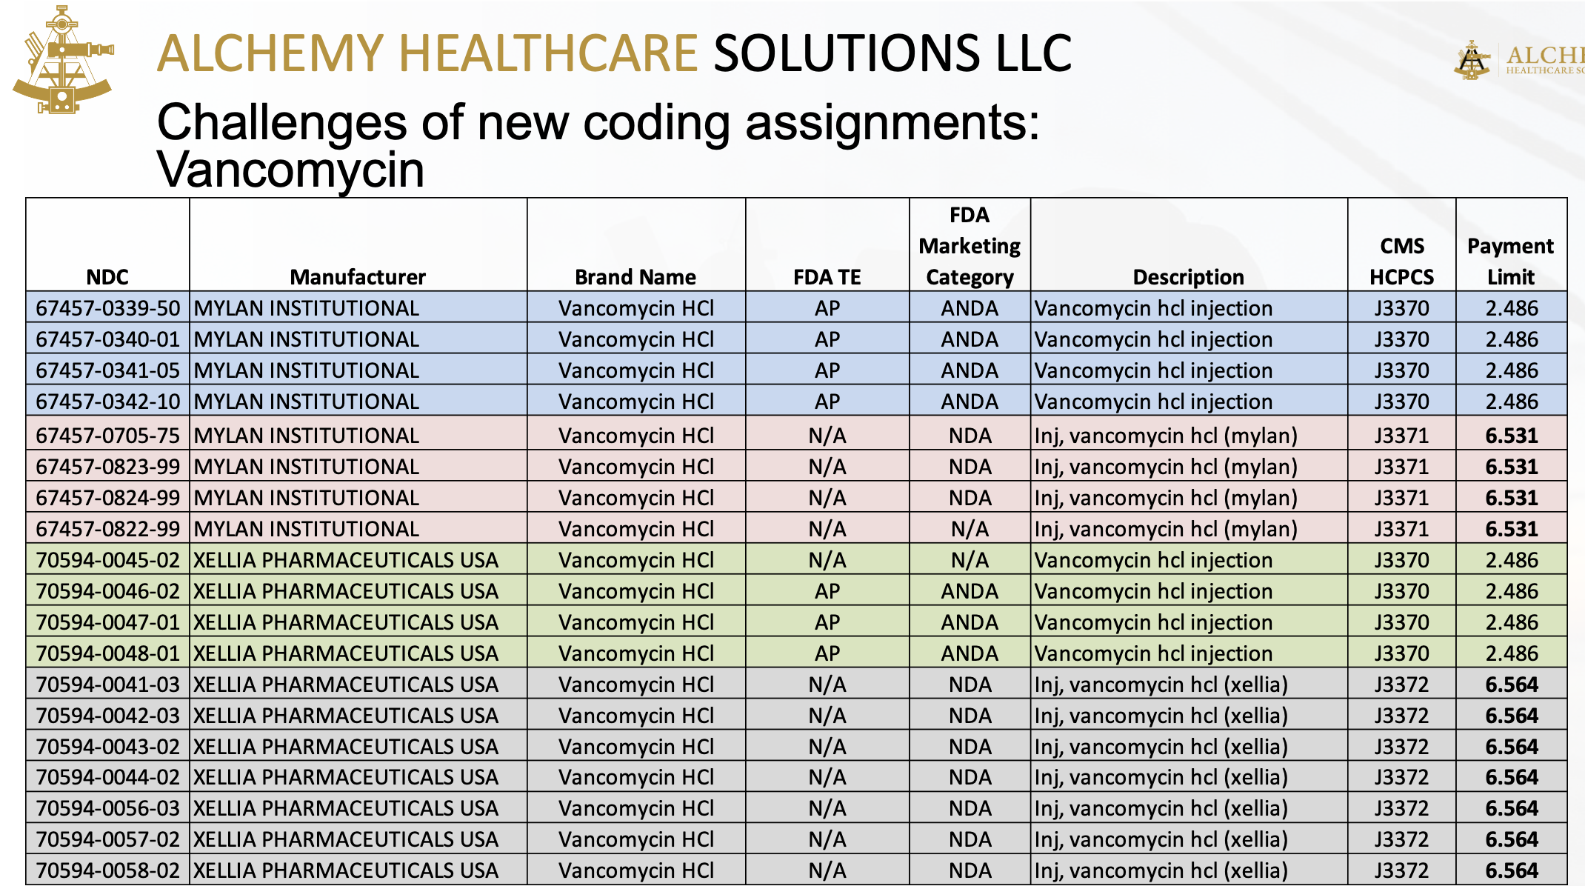

Reprinted with Permission of Alchemy Healthcare Solutions LLC

https://premierconsulting.com/resources/what-is-505b2/#:~:text=The%20provisions%20of%20505(b,developed%20by%20the%20NDA%20applicant.
https://www.govinfo.gov/content/pkg/FR-2020-08-17/pdf/2020-17127.pdf, page 190
https://www.mmitnetwork.com/thought-leadership/new-hcpcs-codes-for-generics-what-payers-and-manufacturers-should-know-to-ensure-accurate-reimbursement/
onPoint Oncology E-Reimbursement News Annual Survey, 2023
https://ascopubs.org/doi/abs/10.1200/JCO.2023.41.16_suppl.6651
https://www.mmitnetwork.com/thought-leadership/new-hcpcs-codes-for-generics-what-payers-and-manufacturers-should-know-to-ensure-accurate-reimbursement/
From Alchemy Health/onPoint presentation August 8, 2023: “What the HCPCS is going on with 6505(b)(2)
E-Reimbursement News Annual Survey, onPoint Oncology, Inc, July 2023, N=123

