New Connections
Capital Campaign
Faith Commitment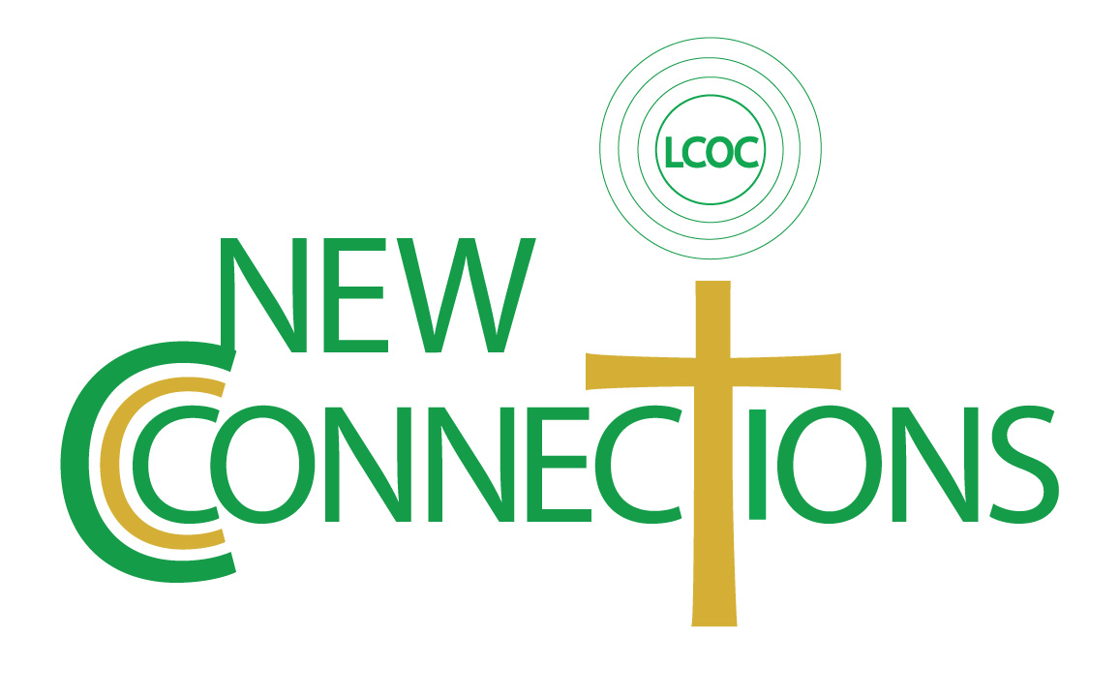nt Card

How I/We Plan to Give to our New Connections Campaign
Upfront Gift of $________________
And/or the following
3 Annual Gifts of $________________
6 Semi-Annual Gifts of $________________
12 Quarterly Gifts of $________________
36 Monthly Gifts of $________________
150 Weekly Gifts of $________________
I will pray for the life and mission of our church
I will invite and welcome others to our congregation

Print Name: _______________________________ Signature: _________________________
Date: ___________________________

New Connections Giving Guide
$252,000 over 3 years from 45 participants
1 $ 175/wk or $ 700/mo or $ 8,400/yr = $ 25,200 3yrs
2 $ 125/wk or $ 500/mo or $6,000/yr = $ 18,000 3yrs
3 $ 100/wk or $ 400/mo or $4,800/yr = $ 14,400 3yrs
5 $ 75/wk or $ 300/mo or $ 3,600/yr = $ 10,800 3yrs
6 $ 50/wk or $ 200/mo or $ 2,400/yr = $ 7,200 3yrs
8 $ 25/wk or $ 100/mo or $1,200/yr = $ 3,600 3yrs
10 $ 10/wk or $ 40/mo or $ 480/yr = $ 1,440 3yrs
10 $ 5/wk or $ 20/mo or $ 240/yr = $ 720 3yrs
$__ /wk or $ ___/mo or $ ____/yr = $ _____ 3yrs

