Stewardship Article for October Newsletter

Thanks to the generosity of a Thrivent Action Team and members of the congregation, we were able to decorate and pack up 200 snack sacks with juice, healthy snacks, and a message of love from LCOC for the children staying in ACTS shelters. These will serve as after school snacks to not only nourish the bodies of these children, but also hopefully lift their spirits. This along with the outdoor neighborhood clean-up (braved in the rain by the hardier members), along with a shared worship service and potluck luncheon with the Mustard Seed congregation made for a blessed God’s Work/Our Hands Day. May the Holy Spirit continue to bless these efforts and guide us in continuing service. Special thanks to Lloyd and Colette Lyngdal, June and Jim Jamieson, Mark Gimmi, Pastor, and Jo Ann and Roger Rudy for their work on the Action Team, and event coordination!
We are coordinating with the Evangelism Team to put together New Neighbor kits to welcome those new to the community, show God’s love and hospitality, and connect with them. The kits will consist of a roomy tote with the LCOC logo, name, and website address filled with a ceramic mug thanking God for them, a prayer square, pen, and notepad, along with a letter of welcome from Pastor Darcy and a flyer about LCOC. Most of the items for the first batch of these are in hand and when completed, we will be forming a plan to learn of new neighbors and how best to distribute these kits. This is just one way we hope to grow our community of faith here and follow God’s command and our mission to Gather, Grow, Give, and Go.
We have enjoyed visits from Jennifer Brooks from Neabsco Elementary School and Beth Seidler from ACTS and learned more about how we can continue to serve in those ministries. The opportunities are many and we encourage everyone to get involved as they are able-using their gifts, time, and resources for these ministries that impact so many. Ways to get involved? Volunteer at the school, participate or donate to the I Walk for ACTS, help with our ongoing food drives for both organizations, and be generous in supporting Operation Turkey. The deadline is earlier this year, so please pick up your list of Thanksgiving items as we work to provide for three families at the school and as many as possible at ACTS. Monetary donations are also appreciated and will be used to purchase turkeys.
Stay tuned for more ways to invite others and offer gracious hospitality and to serve, bless, and be a blessing as we move through fall and beyond with Untrim-a-Tree, Breakfast with Santa, LCOC’s 50th Anniversary in 2019, Chili Cook-off, Rise Against Hunger, and so much more. All of these are marvelous ways to share with others and grow in our talents, faith, and fellowship while providing opportunities to make new connections towards our goal of 50 new, actively engaged people at LCOC. People want to be part of something bigger and are often just waiting to be asked. Please be part of this! Feel free to contact me or other council members about joining in a project-no one has to do it all, but as the old saying goes, “Many hands make light work.”
Please continue to share your gifts and talents as the Spirit leads in the variety of ministries provided through LCOC. Thank you also for your generosity in your financial commitment and consider using the Vanco option which can be accessed online at: https://www.eservicepayments.com/cgi-bin/Vanco if you haven’t already done so. Please consider becoming a Thrivent member as well and if you already are a member and use Thrivent products, make use of the Action Team funds that are available to help fund LCOC’s ministry projects. Even if you do not have Thrivent products such as insurance or investments, you can set up an Associate Membership for just $20 per year and become eligible for one Action Team. This seed money really makes a difference and helps us increase the scope of our service projects.

Let us continue to share our love and gifts and make new connections through the Holy Spirit every day, and everywhere we go. And, if you have been participating in the 40 Prayer Challenge, keep drawing a circle around the community, and LCOC as we seek direction and serve to glorify God.
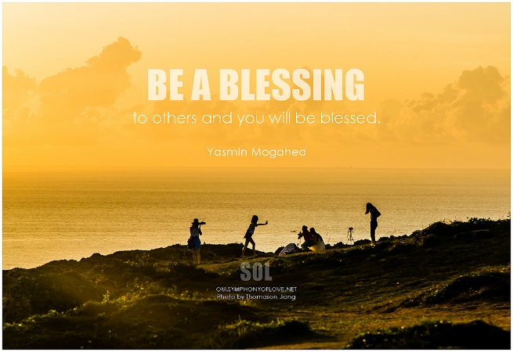

With love, Patti Beattie

