Optimizing Your Zoom Experience

Important!!
- You cannot have both the audio on your laptop/tablet/desktop computer “On” and the audio on your phone “On” at the same time; an “echo” will occur.
- If you and someone else in your home are both attending an LCOC service, and you are using separate devices, you must be physically separated to avoid a reverberating “echo”.

Your Zoom Microphone and Video Settings
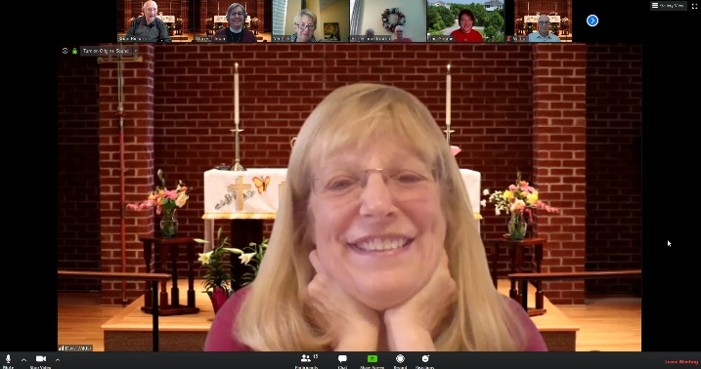
The microphone and video icons are in the lower left corner of the Zoom window. If you do not see them, simply move your cursor into the window and they will appear.

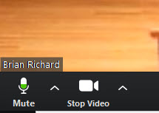
If your microphone is unmuted/active and your Video is active, the icons will look like this.

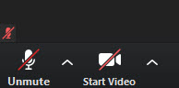
If your microphone is muted/not active and your video is off, there will be a red slash across the icon.

- Attending LCOC services by Zoom on a Computer or Smart Phone
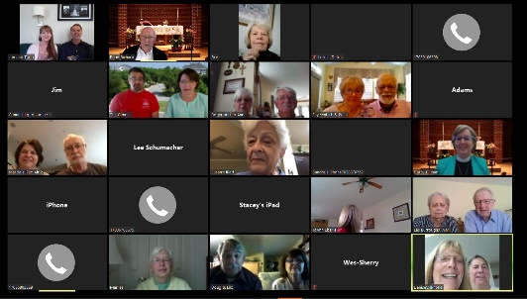
1. When joining before the service starts:
- Join Zoom “With Video” and everyone will
see you.

- Join Zoom “Without Video” and only your name will appear; you will still be able to hear and see Pastor Darcy and anyone else with their video and microphone on.
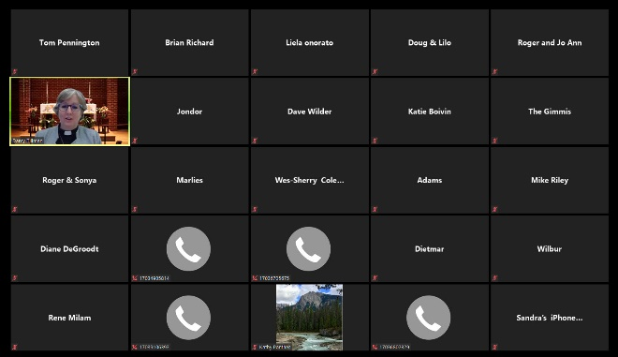
- Join Zoom with “Computer Audio” and your microphone will be on/active.

2. When the Service Starts:
- Stop your video (Red slash)
- Mute your microphone (Red slash)
- Your computer screen will look like this:

3. When joining after the service has started:
- Please MUTE YOUR Microphone, ASAP! If your microphone is on, you may interfere with what is being said in the service.

- Turn off your video, your name will still be seen.

- Unless you have a speaking part in the service, please leave the microphone muted/Off and the video off. The assisting minister or reader will say the congregation’s part and you are invited to speak it at home.

- Attending LCOC services using a non-Smart Phone

- When joining before the service starts:

  - Join Zoom with the telephone audio on.

- When the Service Starts:

  - Mute your phone

3. When joining after the service has started:
  - Please MUTE YOUR phone, ASAP! If your microphone is on, you may interfere with what is being said in the service.

- Unless you have a speaking part in the service, please leave the microphone muted/Off and the video off. The assisting minister or reader will say the congregation’s part and you are invited to speak it at home.

View Options on Zoom
There are two view options in Zoom. Speaker View allows only the person host or person speaking to be seen on the screen. Gallery View allows all participants to be seen on the screen at one time. If their video is on there picture will appear. If their video is off, only their name will appear.
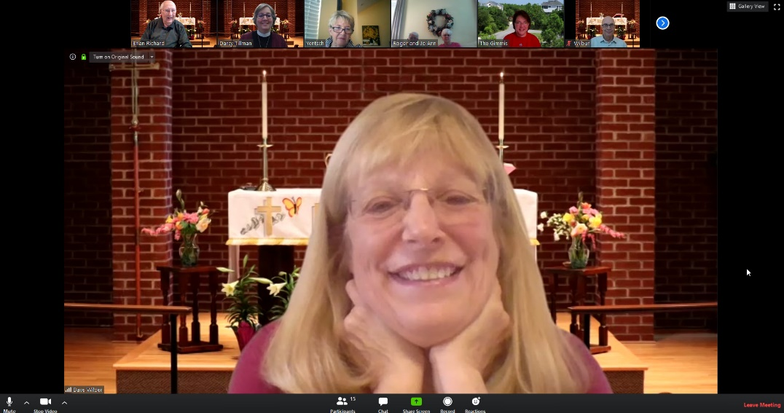
To select the view you prefer, left click on the selection in the upper right-hand corner of the Zoom screen.

When the view selection is in the Speaker View, as above, the view selection at the top right corner will read Gallery View. This means that if you wish to leave the Speaker View, you need to select Gallery View.

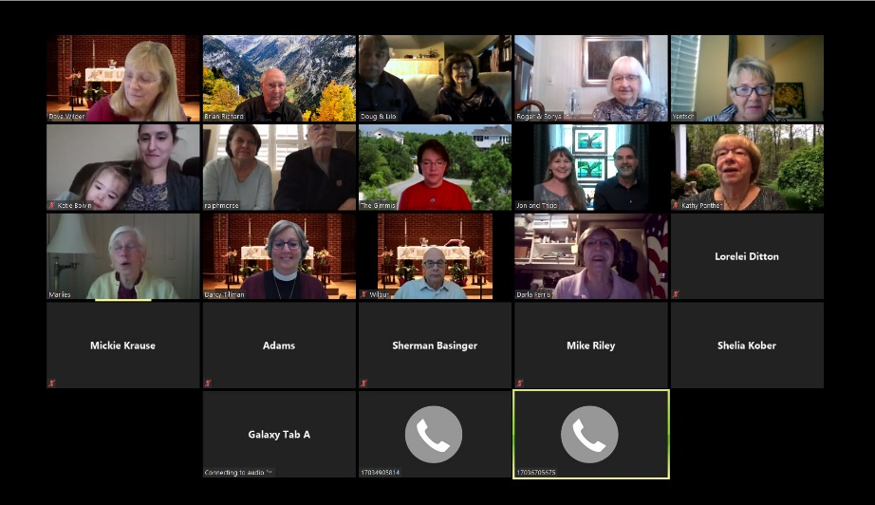

If you are in Gallery View, the view selection in the upper right corner will read Speaker View. If you wish to leave Gallery View, you need to select Speaker View.

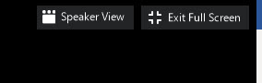

To Exit Full Screen
It is possible to reduce the size of the picture on your Zoom screen. The default will be full screen which may mean that some of the gallery windows might cover something you are trying to read. There are two ways to reduce the picture size. In the upper right-hand corner of the Zoom window, next to the View Selection, is another selection to change the screen size. If you select Exit Full Screen,
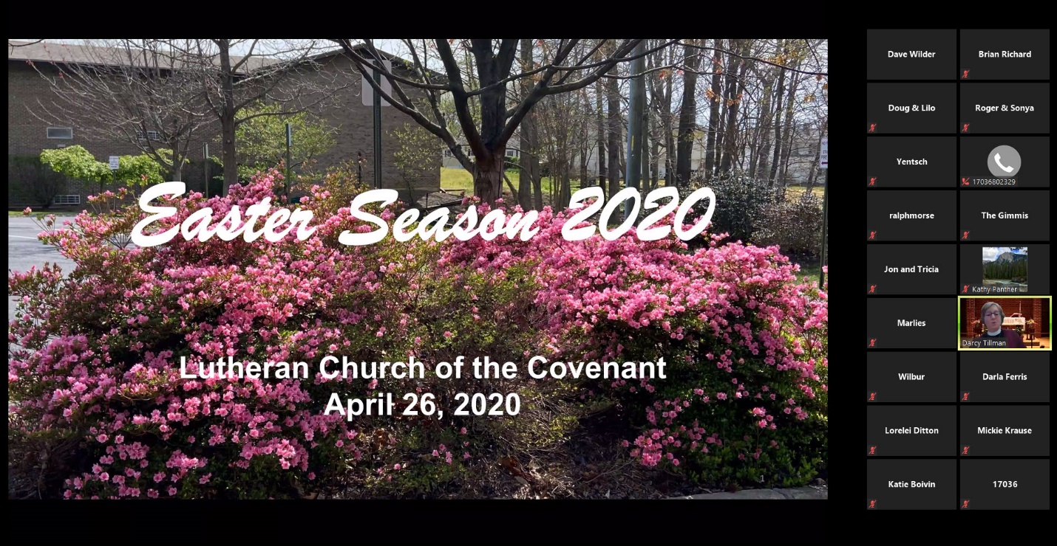
the picture size will reduce giving you more space around the screen. The resulting screen will appear like this:

This selection can also be made by hitting the ESC (Escape) key on your keyboard, probably located at the upper left corner of the keyboard.

