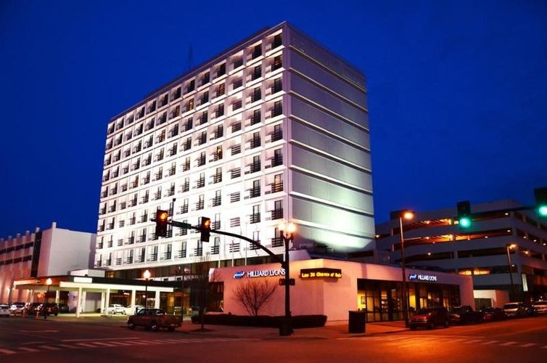
27thAnnual West Virginia
Rural Health
Conference

Country Roads:
Moving WV Rural
Health Forward

Sponsored by:
The West Virginia Rural Health Association


October 8-11, 2019
DoubleTree Hotel
Huntington, WV

Featuring Conference Partner Symposiums
October 8, 2019

REACHH-Family Resource Center WV Oral Health Coalition

WV Grandfamilies

Welcome
A message from our WVRHA President:
It is my pleasure to welcome you to the 2019 Rural Health Conference and to Huntington, West Virginia! Our conference theme this year is “Country Roads: Moving WV Rural Health Forward”, and that is exactly what we hope to accomplish during this event. We will highlight best practices from around the state and beyond in rural health care, and showcase those in rural health who are making a positive difference. The conference will encourage dialogue that will both inspire and excite us, and should re-energize us for the tasks ahead as we seek to improve the rural health safety net for our families, neighbors, and communities.

One of my favorite traditions at the conference is the inclusion of rising young health care students who will be “taking over the
reins” from us in the future. I hope you will be
especially mindful that these young people are
taking time out of their incredibly busy academic
lives to listen and learn from us. It is my sincere
hope that collectively we might provide them with
guidance, wisdom and food for thought as they
make their way into their chosen professions.

This conference represents a lot of hard work and
The inspired vision of many people who are deeply
committed to rural health care. I want to thank the
conference planning committee and the WVRHA
Executive Director and her staff for all the work that
goes into making a successful conference. If you’ve
come to the annual conference before, we welcome
you back and invite you to give us feedback. If you are new to the conference this year, we are so pleased to have you join us, and we hope that this will be the start of an annual tradition for you. I would love a chance to chat with each of you, so please stop by and say hello and let me know how we are doing with the conference. Please remember the silent auction, the reception and the poster presentations by our students. Thank you and we look forward to our time together in the beautiful city of Huntington!
Debbie Curry
WVRHA President

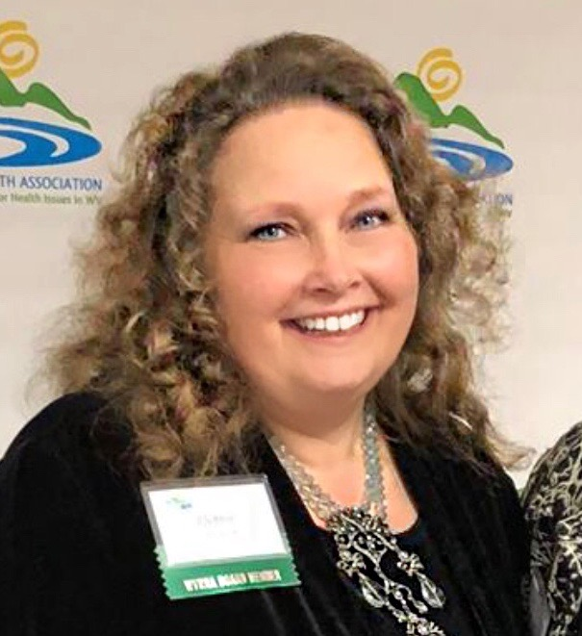

27th Annual
West Virginia Rural Health Conference

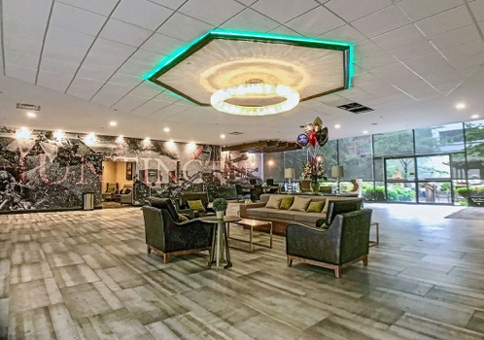
About the Conference
The West Virginia Rural Health Conference provides attendees with education and information about innovation, best practices and leadership in rural health. The conference includes state and national rural health updates along with providing attendees the opportunity to network with others interested in improving rural health care in West Virginia.

With support from the Claude Worthington Benedum Foundation, the WV Higher Education Policy Commission, Bernard McDonough Foundation and other generous sponsors, the conference gathers individuals and groups interested in the health of rural residents. The 2019 conference agenda is the collaborative result of statewide partners seeking the best speakers to address current topics of interest in rural health.

Please join us at Double Tree Hotel (formerly the Pullman Hotel) located in downtown Huntington, West Virginia, as we continue our efforts to improve access to quality health care for the citizens of West Virginia.

Intended Audience
The broad range of conference sessions will be of interest to allied health professionals, physicians, nurse practitioners, nurses, dentists, physician assistants, pharmacists, dietitians, social workers, attorneys, gerontologists, emergency service personnel, insurance agents, academicians, students from a variety of health professions, government officials, business and community leaders, extension agents, community planners, community health care volunteers, non-profit organizations, and others involved in rural health.

NEW This Year!
- October 8, 2019 - Symposiums featuring educational tracks by our Conference Partners: WV Oral Health Coalition, WV Grandfamilies, and REACHH-Family Resource Center.
- Separate registration fee of $50 for this one-day symposium required.

Conference Objectives
- Provide information about best practices across the state and nation for improving the provision of rural health care for all citizens of West Virginia.
- Identify population management, leadership and workforce challenges as well as how to increase recruitment and retention.
- Identify best practices centered on rural health workforce and emerging issues relevant to rural health.
- Encourage further discussion and collaboration across all levels of health systems and rural health infrastructure.

Special Events
CONFERENCE RECEPTION
The West Virginia Rural Health Association invites attendees to the opening reception to celebrate the 27th Annual West Virginia Rural Health Conference. The event will be held on Wednesday, October 9, 2019 from 6:00 p.m. to 7:30 p.m. on the Mezzanine.
SILENT AUCTION
The West Virginia Rural Health Association will host the 15th Annual Silent Auction in the Kentucky Room.
The auction opens Wednesday and closes Thursday evening. Successful bids must be paid for and items picked up on Friday morning. Proceeds support West Virginia Rural Health Association activities, advocacy and programs. Please plan to visit and place a bid on your favorite items.
RURAL RESEARCH POSTER DISPLAY
A rural health research poster display will be held on the Mezzanine on Wednesday, October 9, 2019 Researchers will be with their posters and available to address attendees on Wednesday evening between 6:00 – 7:30 p.m. Student/resident oral presentations will be Wednesday, October 9, 2019 from 4:15 – 5:30 p.m. on the Mezzanine.

WV Rural Health Association Membership
The West Virginia Rural Health Association (WVRHA) is a non-profit, grassroots, member-driven organization with the mission “to unite people, communities and organizations to strengthen rural health in West Virginia.”
WVRHA will be holding a membership drive during the conference. If you are interested in joining WVRHA or updating your membership, please see the WVRHA staff at the registration desk during the conference. Additional information about the WVRHA can be found at http://www.wvrha.org.

Annual Meeting

The WVRHA membership will meet on Thursday, October 10, 2019 from 5:30 – 6:30 p.m. in the OHIO Room. All attendees are invited.
Lodging
Conference participants (excluding scholarship recipients and speakers) are responsible for making their own hotel arrangements by contacting: The Double Tree Hotel, 1001 3rd Avenue, Huntington, WV
Room Reservations: 304.525.1001.
Please ask for WVRHC Room Block Group. This block of rooms will be held until September 23, 2019.
Room rate is $129.00 per night (excluding applicable taxes, fees, and hotel parking).
If making online reservations at The Double Tree Hotel, go to: www.doubletree3@hilton.com



Questions?
Contact Debrin Jenkins, WVRHA Executive Director, at 304.890.7017 or email debrinwvrha@gmail.com.

Continuing Education
Applications for continuing education for physicians
(DO, MD & PA), nurse practitioners (NP, RN & LPN), psychologists, social workers, pharmacists, dentists, dental hygienists, gerontologists, counselors, CHRE, and attorneys have been submitted.

2019 WV RURAL HEALTH CONFERENCE REGISTRATION
WVRHA
PO Box 2073, Shady Spring, WV 25918
debrinwvrha@gmail.com

PLEASE CHECK ONE
EARLY BIRD CONFERENCE REGISTRATION CONFERENCE REGISTRATION
Prior to September 15th after September 15th
$50 Partner Symposiums October 8, 2019
$250 Full Conference October 9-11, 2019
___ $300 Both
___$75 Partner Symposiums October 8, 2019
___$300 Full Conference October 9-11, 2019
___$375 Both

IF ATTENDING SYMPOSIUM – PLEASE CIRCLE ONE
WV Grandfamilies / REACHH-Family Resource Center / WV Oral Health Coalition

Rural Health Awards Luncheon is included in your registration fee!

CONFERENCE PAYMENT (PLEASE CHECK ONE)
Check (Payable to WVRHA) Total Enclosed $ ________________Security Code:____________
Credit Card: MC VISA Card # Exp. Date: Cardholder’s Name: Cardholder’s Signature:
- Please send an invoice to the address provided below.

If you are a health professional or advocate, please print your profession
(such as health administrator, dentist, nurse, nurse practitioner, physician
assistant, physician, public health employee, social worker, etc.) here:

REGISTRATION INFORMATION (BUSINESS INFO PLEASE)
Last Name/First Name & Credentials |  |  | Do you plan to apply this training toward your employment requirements, continuing education credit, certification, or credentialing? Yes No N/A
Employer/Practice Site Name
Work/Practice Site Address |  | City |  | County | State | Zip code
Phone # | Email address

Please check all that apply: I am a _____Rural Health Conference Exhibitor_____ Rural Health Conference Sponsor
_____ Student _____ Resident _____ Faculty (campus-based or field) _____ A member of WVPBRN

Continuing Education
Continuing education credits are anticipated for physicians (Allopathic & Osteopathic), attorneys, nurse practitioners, physician assistants, nurses, psychologists, social workers, pharmacists, dentists, dental hygienists, gerontologists, counselors, and, certified health education specialists (CHES).

Attendees may attend any presentation at the Symposiums or the Main Conference as seating allows! Please bring a light jacket or wrap as we cannot control the temperature in the meeting rooms.

Registration Reminders
Early Conference registration fees of $250.00 per person for the Main Conference and $50 for the Symposiums is due on or before September 15, 2019. After September 15th, the registration fees will be $300.00 per person for the Main Conference and $75 for the Symposiums. The fee includes all conference materials and meals as listed on the conference schedule. ALL REGISTRATION FEES MUST BE PAID BEFORE THE CONFERENCE.

One-Day Registrants (excluding Symposium attendees) will be placed on a list and contacted by September 15, 2019 if seats are available. Late fees will not apply to One Day Registrants. Please contact Debrin Jenkins to have your name placed on the list.

PLEASE RETURN REGISTRATION FORMS (via mail or email to)
WVRHA
PO Box 2073
Shady Spring, WV 25918
debrinwvrha@gmail.com

Cancellation Policy for Participants
A $50 non-refundable processing fee will be retained for cancellations made before September 15, 2019. After this date, there will be no refunds for cancellations. However, attendee substitutions will be permitted with advance notice to Debrin Jenkins until October 1, 2019.


27th Annual
West Virginia
Rural Health Conference

EXHIBITOR AND SPONSOR INFORMATION

Sponsor Opportunities

Blue Ribbon Sponsor $5,000
- Full page ad
- Signage at event
- 1 vendor table
- 5 conference registrations

Red Ribbon Sponsor $3,000
- ½ page ad and signage at event
- 1 vendor table
- 4 conference registrations
Green Ribbon Sponsor $1,500
- ¼ page ad and signage at event
- 1 vendor table
- 3 conference registrations

Ad Only Sponsors
- ¼ page ad $400
- ½ page ad $800
- Full page ad $1,200

Exhibitor Package and Information

Exhibitor Package is $600 and includes:
- 6-foot draped table/space with one chair
- One exhibitor registration with full conference access
- A one-eighth page listing in the conference program

Confirmations and Ad Copy
The billing contact representative listed on the registration form will receive an electronic confirmation when your registration has been processed. For ad copy, please provide “camera ready” graphics in 300 dpi JPG, TIFF or PDF file with ad as actual size before September 15, 2019.

Exhibit Hours and Setup
Rural Health Conference Exhibitors may pick up their Exhibitor packages at the conference registration desk. Exhibitor setup starts on Tuesday, October 8th at 8:00 a.m. The Exhibit Tables open to conference attendees at 9:00 a.m. and is open during all conference hours. Exhibit break down is scheduled for Friday, October 11th at 12:00 pm. If your organization requires shipping information for the property, please contact Double Tree Hotel, 1001 3rd Avenue, Huntington, WV 25701, or call 304.525.1001.
Payment & Cancellation
Sponsor and Exhibitor applications must be completed and submitted along with payment for processing by September 15, 2019. Payment may be made by check or credit/debit card. See application form for more details.

Cancellation of Exhibitor space must be received by WVRHA prior to September 15, 2019 to receive a refund less a $50.00 processing fee. Refunds will NOT be made for cancellations received after September 15, 2019.

27th Annual
West Virginia Rural Health Conference
Sponsor/Exhibitor Registration
Sponsor Opportunities (mark selection)
- Blue Ribbon $5,000
- Red Ribbon $3,000
- Green Ribbon $1,500
- Exhibitor Package $600
- Ad Only $400 or $800 or $1,200

Exhibitor Package $600
- 6-foot draped table/space with one chair
- One exhibitor registration with full conference access
- A one-eighth page listing in the conference program. For ad copy please provide “camera ready” graphics in 300 dpi JPG, TIFF or PDF file ad as actual size.

Company/Contact Information: (Please type or clearly print information as it should appear on all printed materials.)
Company Billing Contact
Exhibit Representative (1)
Address
City/State/Zip
Phone Fax
Email Address

Please be advised you are responsible for bringing ALL supplies for setup.
If your exhibit requires electricity, please check here
Wireless internet is available throughout the building free of charge. The facility requests that no materials be affixed to walls. Double Tree Hotel, Huntington offers additional equipment rentals, if needed. Fees associated with such rentals are the responsibility of the exhibitor.

Method of Payment:
- Check # Enclosed Amount $ _________
Payable to: West Virginia Rural Health Association
- Send Invoice
- Credit Card # Security Code:______ Expiration Date:

I understand that by signing below I am guaranteeing payment and reserving exhibit space at the 2019 West Virginia Rural Health Conference & Symposiums being held October 8-11, 2019 at Double Tree Hotel, Huntington, West Virginia. I understand that any cancellations received after September 15, 2019 will NOT be refunded.

Authorized Representative Date

You will receive a confirmation email to the address provided upon receipt and processing of your registration form.

Return Completed Form with Payment by September 15, 2019 (via mail or email to)

WVRHA
PO Box 2073
Shady Spring, WV 25918
debrinwvrha@gmail.com

Conference Partner Symposium Schedule

Tuesday, October 8, 2019
Time | Event/Session | Speaker(s)
9:30 am. – 12:00 pm | CONFERENCE REGISTRATION
9:00 am | EXHIBITORS SET UP
11:00 am. – 12:15 pm | OHIO, PENNSYLVANIA, MARYLAND, & VIRGINIA ROOMS  OPENING REMARKS / LUNCH  KEYNOTE: Sarah Heppner, HRSA/FORHP Policy Research Division Director | Sarah Heppner, MS
12:30 pm - 1:30 pm | CONCURRENT SESSIONS I
Session A  WV Grandfamilies | PENNSYLVANIA ROOM  The Past, Present and Future of Grandfamilies in West Virginia | Bonnie Dunn, MS
Session B  WV Oral Health Coalition | OHIO ROOM:  Wood County Schools/Mid-OHIO Valley Health Department Mobile Health Services Unit | Mary Beth Shea
Session C  REACHH Family Resource | VIRGINIA ROOM  From the Hills & Hollows of Rural West Virginia to International Services | Doris Selko, MS, JoAnn Miller  & Jennifer Adkins
1:30 pm – 2:30 pm | CONCURRENT SESSIONS II
Session D  WV Grandfamilies | PENNSYLVANIA ROOM  Supporting the Learning Children Who Have Experienced Toxic Stress | Nancy M. Cline, MS
Session E  WV Oral Health Coalition | OHIO ROOM  An Assessment of a Mobile Dentistry Program to improve Oral Health | Tiffany Summerlin
Session F  REACHH Family Resource | VIRGINIA ROOM  Forensic Interviewing & Counseling Services Addressing Unmet Needs | Felisha Hartwell, MSW

Tuesday, October 8, 2019
2:30 pm – 3:00 pm | BREAK
3:00 pm – 4:00 pm | CONCURRENT SESSIONS III
Session G  WV Grandfamilies | PENNSYLVANIA ROOM  Handle With Care | Andrea Darr
Session H  WV Oral Health Coalition | OHIO ROOM  Over ALL Health: State Public and Rural Health Collaboration | Jason Roush, DDS &  Gina Sharps, MPH
Session I  REACHH Family Resource | VIRGINIA ROOM  Vicarious Trauma Training Benefits Service Delivery | Patricia Grady, MSW
4:00 pm – 5:00 pm | OHIO, PENNSYLVANIA, MARYLAND, & VIRGINIA ROOMS  CLOSING REMARKS  Michelle Oswald, Program Manager, Centers for Medicare & Medical Services | Michelle Oswald, MA


Main Conference Schedule

Attendees may attend sessions from any of the three tracks

Wednesday, October 9, 2019
Time | Event/Session | Speaker(s)
9:30 am - 4:00 pm | CONFERENCE REGISTRATION
9:00 am | EXHIBITORS SET UP
11:00 am. – 1:00 pm | GRAND THEATER (first floor)  LUNCH / OPENING REMARKS  KEYNOTE: Maintaining and Enhancing a Physician Workforce for West Virginia | Debbie Curry, JD  Joseph Shapiro, MD: Dean MUSOM
1:30 pm - 2:30 pm | CONCURRENT SESSIONS I
Session A | OHIO ROOM  Update Community Paramedicine in WV | James Mason, MPA &  Monica Mason, FNP
Session B | PENNSYLVANIA ROOM  Breaking the Silence: Domestic Violence in Rural Populations | Melissa Jensen, MS
Session C | VIRGINIA ROOM  Decision Support Tool for Evaluating Practice-Based Research Opportunities | Adam Baus, PhD, MA, MPA &  Martha Carter, DHSc, MBA, APRN, CNM
2:30 pm – 3:00 pm | BREAK
3:00 pm – 4:00 pm | CONCURRENT SESSIONS II
Session D | OHIO ROOM  Decreasing Nursing Shortage with Junior Nurse Academy – OHIO ROOM | Sandra Wynn, MS
Session E | PENNSYLVANIA ROOM  Introducing One of Twenty-Two Accredited Tobacco Treatment Training Programs | Susan Morgan, DDS, MAGD, CTTS  Lauren Swager, MD, CTTS
Session F | VIRGINIA ROOM  How Would Medicaid Work Reporting Requirements Impact Rural West Virginia? | Kelly Allen, MPA
4:15 pm – 5:45 pm | OHIO ROOM  STUDENT PRESENTATIONS
6:00 pm – 7:30 pm | MEZZININE  WINE & CHEESE RECEPTION & STUDENT POSTERS – EVERYONE WELCOME!
 | DINNER ON YOUR OWN

Thursday, October 10, 2019
Time |  |  | Event/Session | Speaker(s)
7:30 am – 8:30 am |  |  | GRAND THEATER (first floor) - BREAKFAST  Essential Tools to Address the Opioid Epidemic in West Virginia
 | 8:45 am – 9:45 am |  | GRAND THEATER (first floor)  OPENING SESSION / KEYNOTE  Substance use prevention: ICE Collaborative and the Icelandic Prevention Model | Alfgeir Kristjansson, PhD
10:00 am – 11:00 am |  |  | CONCURRENT SESSIONS III
Session G |  |  | OHIO ROOM - Unlocking Potential: Engaging Young People in Community Change | Aliana Havrilla, MPIA
Session H |  |  | PENNSLYVANIA ROOM  An Educational Intervention for Skin Cancer Prevention with Hospital Staff | Amy Bruce, DNP, MSN
Session I |  |  | VIRGINIA ROOM - Marketing Matters | Gray Peretti
11:00 am – 11:15 am |  |  | BREAK
11:15 am – 12:15 pm |  |  | CONCURRENT SESSIONS IV
Session J |  |  | OHIO ROOM - Building Community Capacity and Creating Opportunity through CDE’s | CD. Beckett, DO, Joe Brouse,  Hannah Vargason, MPP, & John Reger, Facilitator
Session K |  |  | PENNSYLVANIA ROOM - WV Health Connection: Clinic/Community Linkages for Addressing Priority Health Disparities | Adam Baus, PhD, MA, MPA & Samantha Shawley-Brzoska, PhD, MPA
Session L |  |  | VIRGINIA ROOM  The Health & Education Intersection: Policy Reform for Healthier Students | Kelli Caseman, MA
12:30 pm – 2:00 pm |  |  | GRAND THEATER (first floor)  WELCOME REMARKS & AWARDS LUNCHEON  KEYNOTE: Essential Tools to Address the Opioid Epidemic in West Virginia | Robert Plymale, WV Senator  Garrett Moran, PhD, MPA, MS
2:30 pm – 3:30 pm |  |  | CONCURRENT SESSIONS V
Session M |  |  | OHIO ROOM  Breaking Our Addiction to Short-Term Thinking: Lessons From Five Wellville Communities | Rick Brush, MA
Session N |  |  | PENNSYLVANIA ROOM - Breastfeeding in the Mountain State: A Key for Better Beginnings and Better Health for West Virginians | Molly McMillion, RN
Session O |  |  | VIRGINIA ROOM - Take Back Our Health West Virginia | Jessica Wright, RN, PMH, CHES
3:30 pm – 4:00 pm |  |  | BREAK
4:00 pm – 5:00 pm |  |  | CONCURRENT SESSIONS VI
Session P |  |  | OHIO ROOM - Wild Wonderful Healthy West Virginia: Lessons Learned on the Ground | Chris Reed, Carrie Brainard, Geary Weir
Session Q |  |  | PENNSYLVANIA ROOM - The Body Screening | Emmanuel Dimitri Tito
Session R |  |  | VIRGINIA ROOM - Code Black: When Stress Outweighs Your Limited Resources | Amy Bair, PhD, PMP, BCB
5:00 pm – 6:00 pm |  |  | OHIO ROOM - WVRHA MEMBERSHIP MEETING – EVERYONE WELCOME!
 |  |  | DINNER ON YOUR OWN

Friday, October 11, 2019
Time | Event/Session | Speaker(s)
8:30 am – 9:00 am | OHIO, PENNSYLVANIA, MARYLAND, & VIRGINIA ROOMS  CONTINENTAL BREAKFAST
9:00 am – 10:00 am | OHIO, PENNSYLVANIA, MARYLAND, & VIRGINIA ROOMS  KEYNOTE: Federal Policy Update | Maxwell Isaacoff, JD
10:00 am – 10:30 am | BREAK & HOTEL CHECK OUT
10:30 am – 11:30 am | OHIO, PENNSYLVANIA, MARYLAND, & VIRGINIA ROOMS  KEYNOTE: Don’t Get Above Your Raisin: The role of Appalachian culture and resource scarcity in integrated health care approaches | Marianna Footo-Lintz, PhD
11:30 am - Noon | OHIO, PENNSYLVANIA, MARYLAND, & VIRGINIA ROOMS  CLOSING REMARKS | Debbie Curry, JD

Cancellation Policy

A $50 non-refundable processing fee will be retained for cancellations made before September 15, 2019. After this date, there will be no refunds for cancellations. However, attendee substitutions will be permitted with advance notice until October 1, 2019.

Registration Reminders

Early Conference registration fee of $250.00 for main event and $50 for the Symposiums per person is due on or before September 15, 2019. After September 15th, the registration fee will be $300.00 per person for main conference and $75 for the Symposiums.. The fee includes all conference materials and meals as listed on the conference schedule. One-Day Registrants will be placed on a list and contacted by September 15, 2019 on the availability of seats (late fees will not apply to one-day registrants).

ALL REGISTRATION FEES MUST BE PAID BEFORE OR AT THE CONFERENCE WITH APPROVAL OF WVRHA DIRECTOR.

RETURN REGISTRATION FORMS (via mail or email to) WVRHA
PO Box 2073
Shady Spring, WV 25918
debrinwvrha@gmail.com

