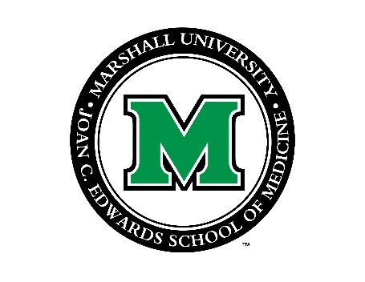

## Marshall University Endo-Cardio ECHO

Marshall University has partnered with Project ECHO® (Extension for Community Healthcare Outcomes). The goal of this program is to increase the capacity of primary care providers to safely and effectively treat chronic, common, and complex conditions associated with **endocrinology** and **cardiology** issues. The ECHO clinic is held the **first Tuesday of each month at 12:00** with alternating endocrinology and cardiology sessions.

What is Project ECHO?

The ECHO model is not ‘traditional telemedicine’ where the specialist assumes care of the patient, but instead a guided practice model where the primary care provider retains responsibility for managing the patient. During a teleECHO™ clinic, using video technology, primary care providers in multiple locations present patient cases to a multidisciplinary team of specialists to determine treatment. These specialists serve as mentors, training community providers to provide care in clinical areas that were previously outside their expertise. Over time the primary care providers operate with increased independence as their skills and self-efficacy grow. A teleECHO clinic is, essentially, virtual grand rounds. Primary care providers from multiple locations connect at regularly scheduled times with a team of specialists using low cost, multi-point videoconferencing. During teleECHO clinics providers present patient cases to specialist expert teams who mentor the providers to manage patients with common, complex conditions. These case based discussions are supplemented with short didactic presentations to improve content knowledge and share evidence based best practices.

Free CME

Participation in teleECHO clinics is free. Participants who join teleECHO clinics receive **free CME** for the total time spent participating, including didactics and patient-case presentations.

Technology Requirements

The technology can be as simple as an individual using a laptop, a hand-held mobile device, a small room set-up for 1-2 people or a videoconferencing room to allow the participation of groups. At Project ECHO in New Mexico, we utilize a cloud-based, system called Zoom (<http://zoom.us>). This system has a number of benefits, including the ability to run on lower-speed Internet connections. Zoom works well on mobile devices such as iPhones, iPads and Androids, requires no appliances and has web-conferencing features like chat and sharing.

Please contact Jennifer Plymale ([plymale@marshall.edu](mailto:plymale@marshall.edu)) if you are interested in participating in this ECHO clinic.