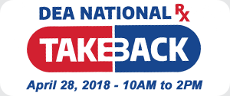
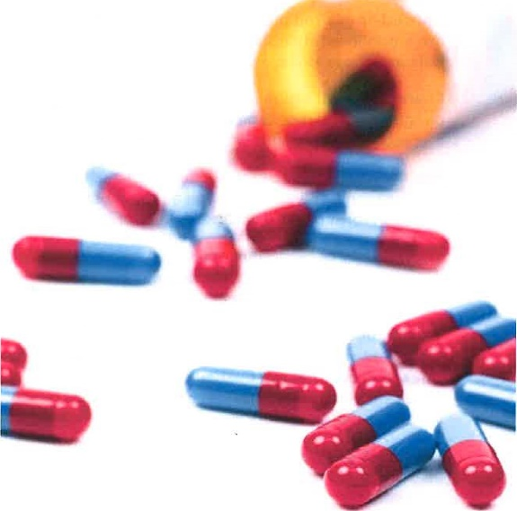
If you don't properly dispose of the unused or expired prescription drugs in your home,
they might find a new one.
Visit DEATakeBack.com for a collection site near you.

To Find Behavioral Health Treatment Services Click Here
Or Call SAMHSA’s National Helpline
1-800-662-HELP (4357)
1-800-487-4889 (TTY)
Free and confidential information in English and Spanish for individuals and family members facing substance abuse and mental health issues. 24 hours a day, 7 days a week.
