Celebrating Small Business Season

We’re gearing up for another holiday season amid COVID. Luckily, the virus numbers are down, and people are venturing out more these days. It’s time to market the importance of shopping local or shopping small.

While Small Business Saturday is a good start, why stop there?

We need more than one day to celebrate how special small business is, don’t we? We need at least a season to celebrate what makes small business different. Here are some ideas on how you can do that:

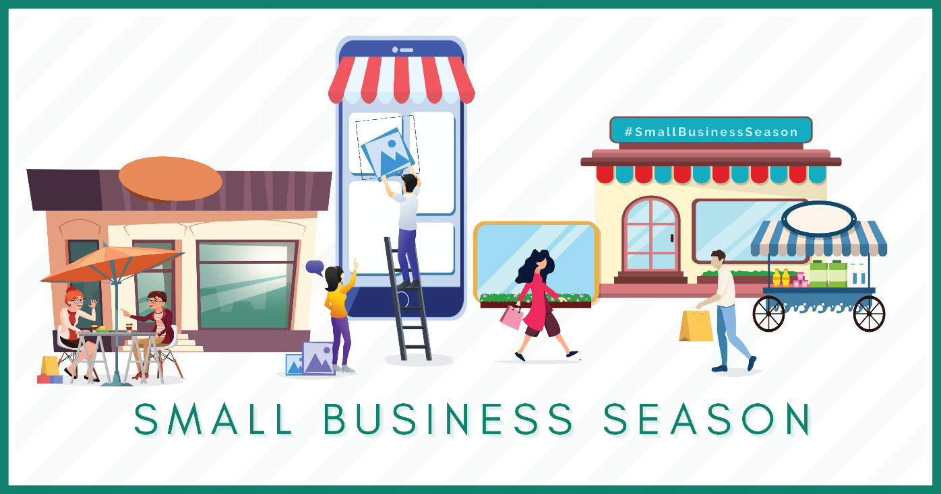

Size Matters: Shop Small
You may not be able to compete with 4 AM openings or TV giveaways, but there are a lot of small business benefits you should be marketing.

Here are a few to use in your social media and ad campaigns:

- Tell your story. Small businesses have great stories. Make sure the world knows how you got started and what inspired you. Talk about your challenges and struggles as well as what you love. This will help customers identify with you and think of you the next time they need what you sell.
- Tell their story. Has your business helped someone in your area? Maybe you sponsored a high school band trip or you helped a customer do something amazing. Tell the world about the incredible things that others are doing in your community. Ask those whom you’ve helped to ring in on the role you played in aiding them in attaining their dreams. Afterall, people want to do business with those they like.
- Know that the rising tide lifts all boats. Work with other small businesses to support each other in your marketing efforts. Tag one another. Review each other. Help get the word out about how important it is to shop small, even if you never mention your business specifically.
- Share pics of how far you’ve come. Everyone loves an underdog story, one where the hero struggles against all odds to eventually win. Tell yours in pictures.
- Be the expert. You can find almost anything online from services to directions, but a small business helps you find both in the same place. For instance, if someone wants to take on a new hobby, they can go to a local business and learn everything they need to start, what they need right away and what’s more helpful once they get a little more versed in what they are doing. It’s hard to get that assistance online. Play this advantage up to your audience. Let them know how you help and how much you love it.

Does this list of things you could be doing to market yourself seem overwhelming? It doesn’t have to be. You have an advocate already in your corner who can help you do all of this. No, it’s not your significant other or that stranger on Fivrr. It’s your local chamber of commerce. Most chambers already have a shop small or shop local campaign and activities going on in your area.

Get in touch with them and find out what they’re working on. They’ll be glad to help and know exactly what it takes to reach people in your service/shopping area.

Christina R. Metcalf (formerly Green) is a marketer who enjoys using the power of story and refuses to believe meaningful copy can be written by bots. She helps chamber and small business professionals find the right words when they don’t have the time or interest to do so.
Christina hates exclamation points and loves road trips. Say hi on Twitter or reach out on Facebook.

