BeMedWise TAYMM Social Media Toolkit

About Us:
- BeMedWise Mission: Promote the safe use, storage and disposal of medicines for better health.
- How we achieve our mission: Provide vetted information on medication safety
via multiple media:
Social Media
Website
Webinars
Newsletter
Graphics
- Vision statement: Improved health outcomes through responsible medication practices.

Webinar Post:

Post between Sep.20th-Sep.27th

Help us kick off @bemedwise 36th annual Talk About Your Medicines Month by registering for this brief presentation all about Understanding Medicine Labels. Every October, BeMedWise hosts TAYMM in order to bring awareness to medication safety and adherence.

This year’s theme is “Understanding Medicine Labels- Making Sense of Your Meds. The ability to understand your medicine labels will help you maximize the benefits while minimizing the risks of your meds - a vital part of maintaining health. Please sign up now as space is limited.

[Insert Webinar Link Here]

[Images Down Below]

Post between Oct. 1st and October 10th

@bemedwise ‘s #TAYMM is finally here!

Make sure to check out their page dedicated to this year’s “Talk About Your Medicines Month’, which is FULL of resources, toolkits and more!
https://www.bemedwise.org/talk-about-your-medicines-month/

#TAYMM

IMAGES

WEBINAR:

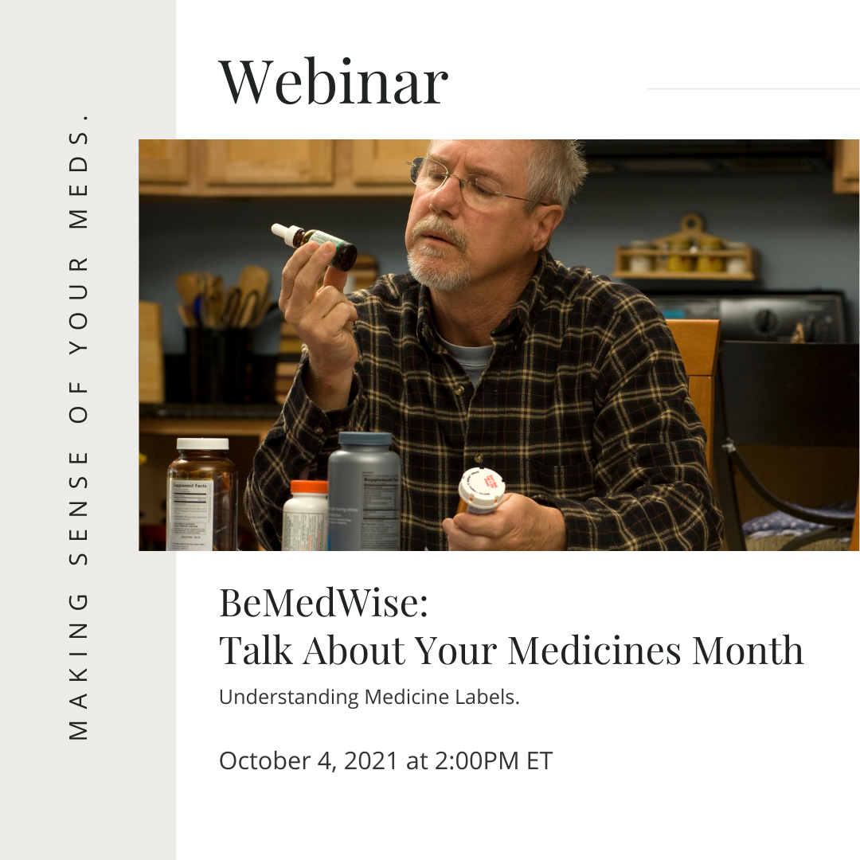
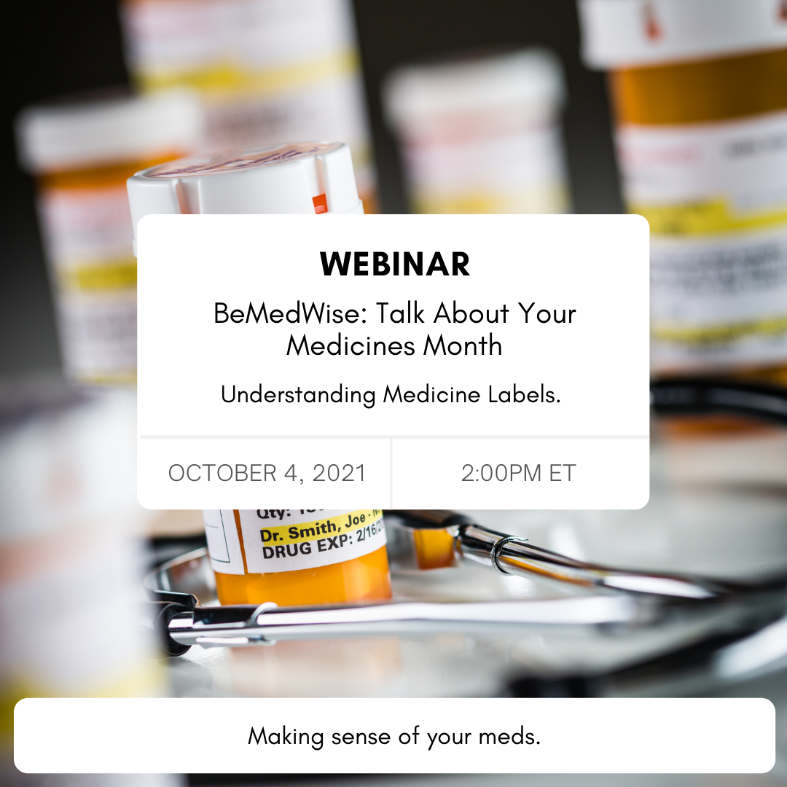

SECOND POST

