POST | CAPTION OPTION
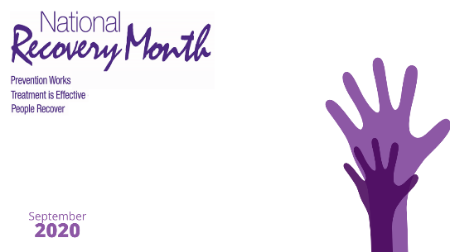 | Raise awareness of Recovery month in your zoom meetings by using this free background
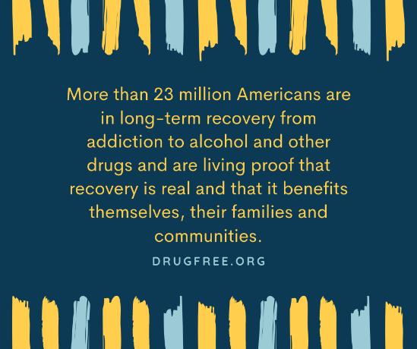 | https://drugfree.org/newsroom/news-item/survey-ten-percent-of-american-adults-report-being-in-recovery-from-substance-abuse-or-addiction/  #CentralOregonRecovery
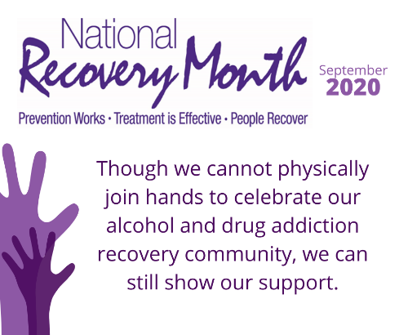 | It's not too late to join us in displaying this year's Hands Across Prineville demonstration by getting creative and decorating your printable cut out hand and displaying it in the window of your business or home. #CentralOregonRecovery #HandsAcrossPrineville
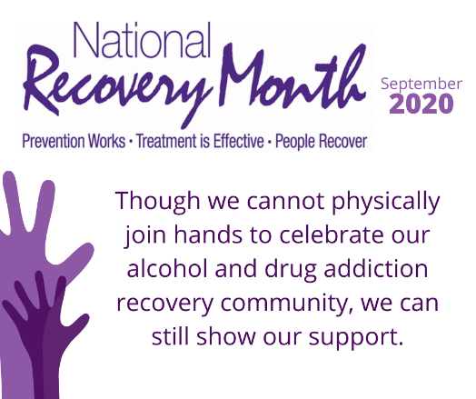  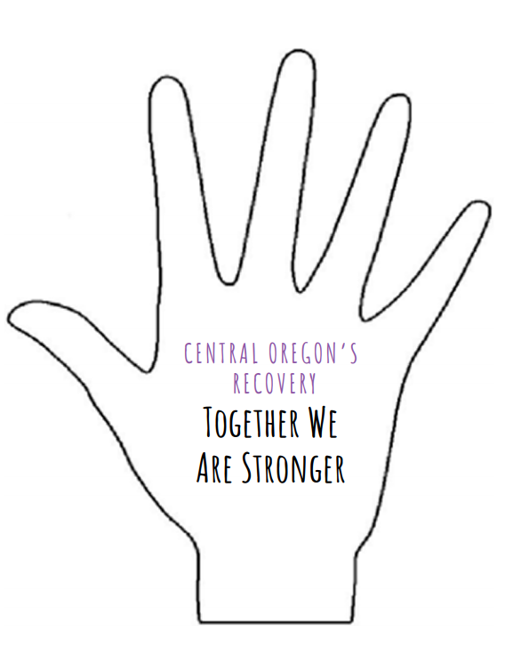 | Please join us in displaying this year's Hands Across Prineville demonstration by getting creative and decorating your printable cut out hand and displaying it in the window of your business or home. #CentralOregonRecovery #HandsAcrossPrineville
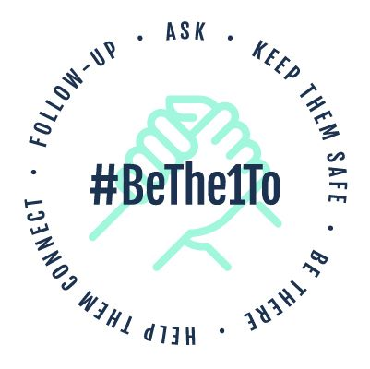 | Find more information on how to #bethe1 by visiting https://www.bethe1to.com/resources/
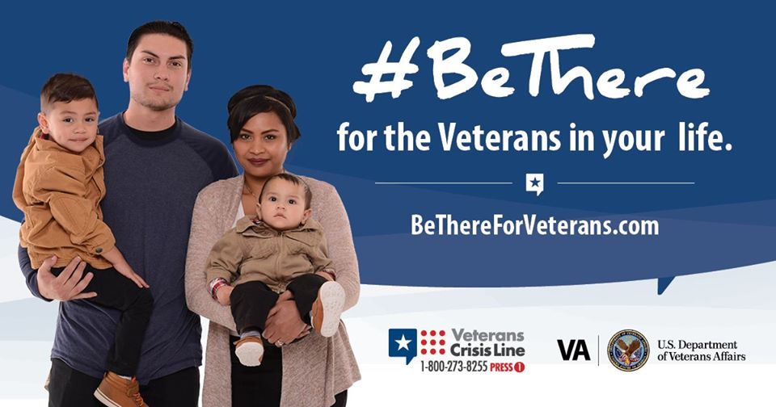 | We all play a role in supporting Veterans, but sometimes it’s hard to know where to start. Learn how to #BeThere for the Veteran in your life: www.bethereforveterans.com
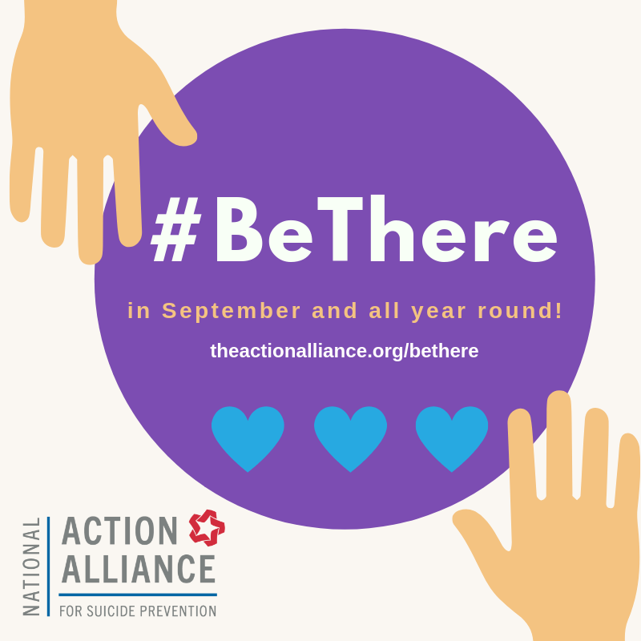 | You can #bethere for someone, by recognizing the signs of suicide, letting them know that you care, and assisting them to reach out for help. Help is available, hope is a reality. Call the National Suicide Prevention Hotline at 1-800-273-8255.
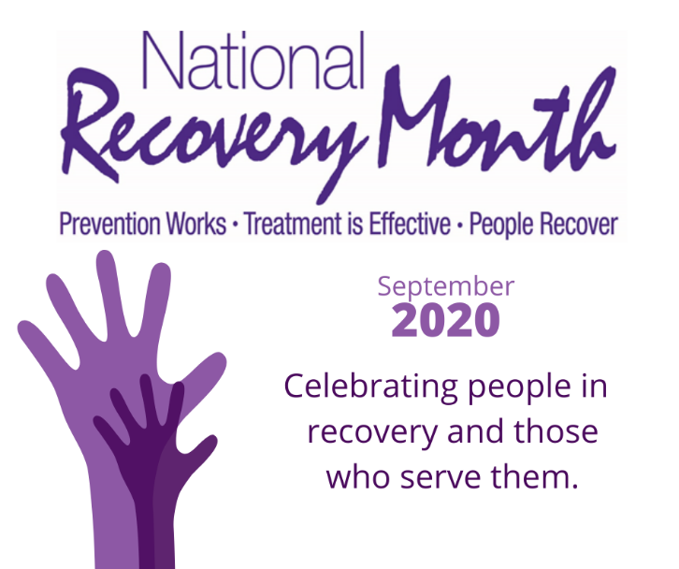 | Join us this month in celebrating National Recovery Month! Recovery Month celebrates the gains made by those in recovery, just as we celebrate improvements made by those who are managing other health conditions such as hypertension, diabetes, asthma, and heart disease. #CentralOregonRecovery

