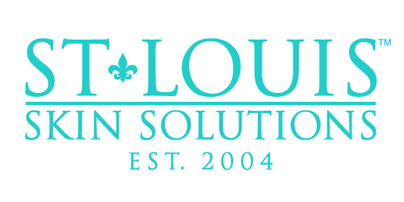

Vitamin B12

What is Vitamin B12?
Vitamin B12 is an essential nutrient that helps the body with the formation of healthy red blood cells and DNA, cell metabolism, nerve and brain health and function, and improving energy levels. Dietary sources of Vitamin B12 include meat, poultry, fish, and dairy products. People with vegetarian and vegan diets, along with older adults and those with digestive tract issues, may be deficient in this important nutrient. Vitamin B12 deficiency is not uncommon, and if left untreated can lead to unpleasant symptoms such as fatigue, muscle weakness, anemia, nerve damage, and mood disturbances.

What are the benefits of Vitamin B12 injections?
Vitamin B12 injections are the most effective way to re-administer the nutrient into the body. By injecting it directly into the muscle, it is easily absorbed into the bloodstream and distributed throughout the body to help prevent or reverse a deficiency. Regular Vitamin B12 injections can help promote a boost in energy, mood, metabolic function, and brain function!

What are the risks of Vitamin B12 injections?
There are virtually no risks associated with Vitamin B12 injections! Even those who are not deficient can experience the benefits of Vitamin B12 injections, and they are even safe for women who are pregnant and breastfeeding! In rare cases, some people may experience side effects due to an allergic reaction or sensitivity.

Why should I get a Vitamin B12 injection at St. Louis Skin Solutions?
Here at St. Louis Skin Solutions, our staff loves getting regular Vitamin B12 injections! These injections help us feel re-energized and get us ready for anything! This is the perfect add-on to any treatment for a Monday pick-me-up, a mid-week boost, and is even a great way to kick off the weekend! Any of our licensed injectors or medical assistants would be happy to add this on to your next treatment.

